3. Follicle Kinetics

Graham Cam

Learning objectives

On completion of this topic, you should be able to:
- Describe the techniques that are routinely used to measure cell kinetics, wool growth rates and wool quality
- Explain the application and limitations of each technique
- Outline the basic biochemical and molecular mechanisms underpinning wool growth rates in the mature wool follicle

Critically assess scientific papers and related professional literature on factors influencing wool growth and fleece quality and the methods used to quantify the responses.

Introduction to the topic

Earlier topics have examined skin structure and function, cellular structure and chemical composition of the wool fibre. By now, you should be familiar with the concept that one of the determining characteristics of mammals is that they possess hair (or wool) follicles and mammary glands, both of which are ectodermally derived skin appendages. The hair or wool of mammals is the fully keratinised product of events occurring within the hair (wool) follicle and once this differentiation event has taken place, the keratinised fibre is no longer metabolically active. The hair (or wool) follicle on the other hand is one of the most highly metabolically active structures in the mammalian body plan and undergoes some of the most dramatic physical changes, not only, during initiation and morphogenesis in embryonic skin, but also throughout the functional lifetime of the follicle as it rotates through the phases of the hair cycle (anagen, catagen and telogen). This morphological pattern of change is generally the same for all follicles with the major difference being the temporal pattern, which varies with species, age, gender, spatial distribution and metabolic status of the animal. The morphological transformation that precedes the formation of a new fibre involves the most complex developmental biology and is not unlike a recurring organogenesis comprising both growth and differentiation of the follicle. Such regenerating organs are rare in the adult mammal. Thus, the hair follicle has been in recent years, viewed in a new light by molecular and developmental biologists and their interest in this structure has accelerated our understanding of the mechanisms that control follicle morphogenesis and the hair cycle. Even with these new insights into the biology of wool and hair growth, the factors influencing fibre growth rates and fibre quality continue to require rigorous quantitative analysis if their potential economic value, to the wool sector, is to be assessed.

This topic examines the techniques commonly used to measure the effects of endogenous and exogenous factors on the rate of cell division and thus ultimately on the rate of wool growth and fleece quality.

Key terms and concepts
Morphogenesis of skin appendages, follicle morphogenesis, hair cycles, anagen, catagen, telogen, close-clipping, defined skin patch technique, radioisotope labelling, autoradiography, dye banding, cell division, interphase, mitosis, prophase, anaphase, metaphase, telophase, strathmokinetic techniques, mitotic inhibitor, DNA synthesis, nucleoside labelling, cell kinetics.

3.1 Measurement of wool growth

Shearing
In its most general sense, wool production can be defined in terms of the rate of fibre growth and the overall quality of the fleece. The crudest measurement of wool production is by shearing the entire sheep and determining the total weight of the fleece. A representative sample or series of samples from the fleece are subject to a variety of measurements from which yield, clean fleece weight, mean fibre diameter, staple and fibre length and fibre strength are derived.

As shearing is not a precise operation, close examination of a shorn animal will reveal that the remaining fleece varies considerably in length. Thus, each animal will have a different proportion of fleece collected for analysis, making comparisons between animals inconsistent. The inability to achieve a uniform level of shearing is a function of many factors two of which are; variation in the skill of individual shearers and the degree of skin wrinkles between individual animals. A high skin wrinkle score makes shearing more difficult, which can result in a higher retention of fleece and a higher degree of second cuts. The accuracy of this method increases, however, as the interval between sampling increases, particularly where shearing is performed annually or biannually. When wool samples are required over a period of days or even weeks whole body shearing is completely unsuitable for accurate measurement of parameters such as length growth rate.

Close clipping a defined skin patch
A more suitable method, prone to less error, is to estimate wool production from a pre-determined unit area of skin over a defined unit of time. An area on the midside of the animal, lying over the third last rib and centred between the mid-line of the back and belly, is the accepted representative region for determining the mean values for wool production and wool quality. The sample area is generally 70 – 100 cm² and the wool is close-clipped with Oster animal clippers (John Oster Manufacturing Company, Milwaukee, Wisconsin, USA) fitted with a #40 cutting head. The most accurate method of tracking the sample area over time is by applying tattoo ink to the four corners of the midside patch. A uniform sample area allows comparisons from one body region to another on the same animal as well as between animals.

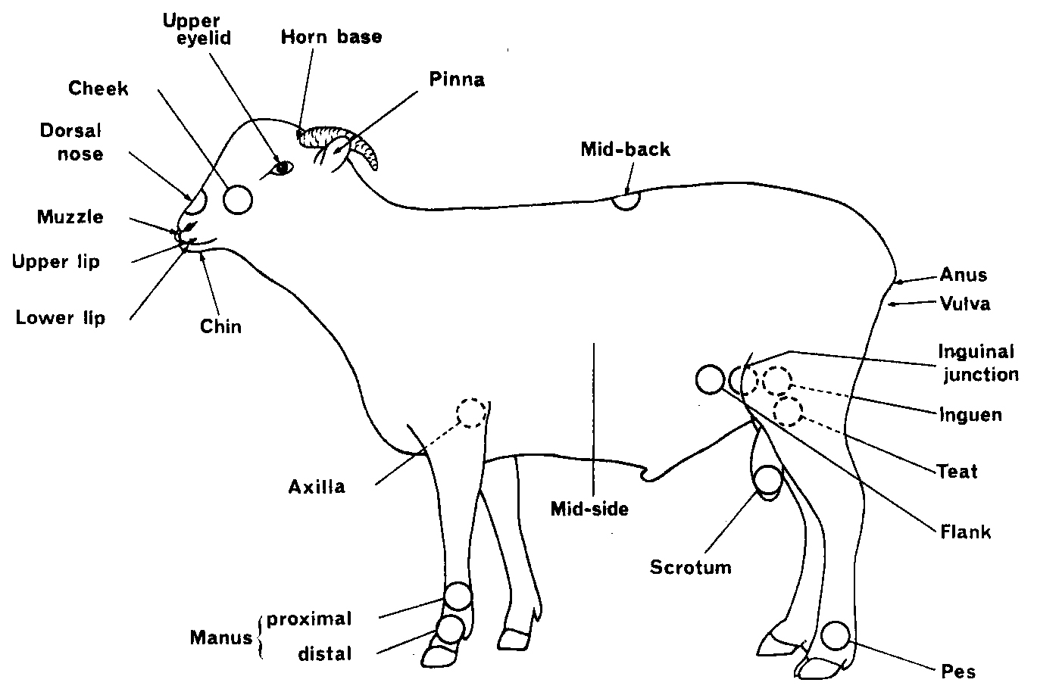
Figure 3.1 Composite diagram depicting position of mid-side patch and dye banding region on Merino ewe. Source: Lyne and Hollis (1968)

Lateral view of a sheep indicating the relative position of the 100 cm³ of the mid-side patch (■), which is centred over the third rib, midway between the back and belly of the animal. The horizontal line (▬) through the centre of the patch indicates the position adopted for dye banding.

However, even with close clipping a defined area of skin, there are factors that reduce the accuracy of the technique. Ensuring that all the wool fibres are clipped at a uniform distance from the skin surface is more controlled than with shearing the whole animal but the mechanics of the procedure inevitably introduces some degree of error. The Oster clippers are not capable of cutting the fibres level with the skin surface and Williams and Chapman (1966) have estimated that approximately 1.5 mm of staple remains above the skin surface following clipping. In addition, forcing the clippers through the fleece will pull a proportion of fibres from their resting position in the follicle, prior to cutting by the clipper head, introducing an error in fibre length measurements. Even with these factors taken into consideration, the technique is not sufficiently accurate with the short staple lengths that arise from less than 7 days of wool growth. There is also evidence that clipping triggers a change in the rate of wool growth as a result of environmental factors, such as temperature (in this case cold) on the exposed skin.

The effect of temperature on wool growth
A number of researchers have studied the effects of external temperature changes on wool growth (Bennett et al.,1962; Doney and Griffiths, 1967; Slee and Ryder, 1967, Downes and Hutchinson, 1969). These studies were performed in climate-controlled rooms where the ambient temperature was accurately controlled but the sub-dermal temperature was dependent upon the thickness of the fleece, which acts as a layer of insulation between the external environment and the wool follicles. Nevertheless, these experiments indicated that a reduction in the ambient temperature correlated with a reduced fibre length growth rate.

In order to more accurately relate changes in wool growth with skin temperature (and thus follicle temperature) Lyne, Jolly and Hollis (1970) performed a series of experiments with small heat-exchange chambers inserted subdermally into the midback of a Merino sheep. The chambers were constructed of Perspex in the shape of a disc measuring 40 mm in diameter and 4 mm thick. A maze of channels connected to an inlet and outlet tube allowed water, at a pre-determined temperature, to be pumped continuously through the chamber over a number of days. With a 4⁰ C increase in the normal subdermal temperature there was no change in the mean length growth rate, although there was a significant but small decrease in fibre diameter. As found in previous studies, a decrease in skin temperature (in this case a reduction of 5⁰ C subdermally), resulted in a dramatic decrease (12%) in mean length growth rate but without any change in fibre diameter.

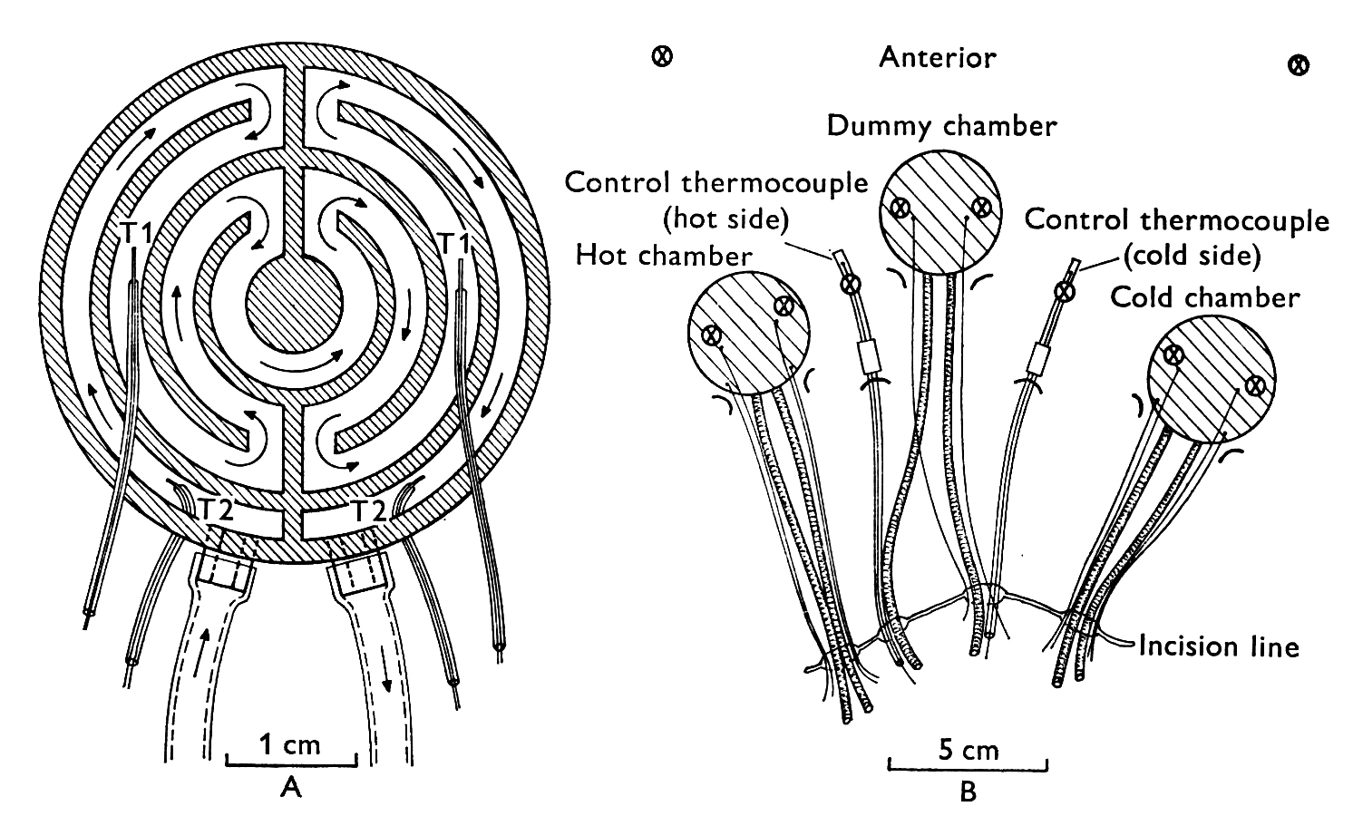
Figure 3.2 Heat Exchange Chamber Apparatus. Source: Jolly and Lyne, (1970).

A. Diagram of the heat-exchange chamber apparatus (40 mm x 6 mm) used by Jolly and Lyne (1970) to induce local subdermal temperature changes in sheep skin. Arrows indicate direction of water flow; T1 and T2 indicate paired thermocouples at the points of water entry and exit.

B.Heat-exchange chambers with attached thermocouples with two additional thermocouples embedded in back skin of a sheep. Wool samples were taken from 10 positions (marked as )

In a subsequent experiment, Jolly and Lyne (1970) repeated the experiment with a unit that comprised a heating, cooling and control chamber for simultaneous temperature manipulation. Once again, a moderate increase in the subdermal temperature produced a small increase in the mean length growth rate. As the subdermal temperature increased further, there was a marked decrease in wool growth with cessation of growth above 50⁰ C. Fibre diameter, also decreased with temperatures up to 45⁰ C but interestingly, temperatures at 48⁰ C and above produced a marked thickening in the fibre. In contrast to raised subdermal temperatures, cooling of the skin always caused a reduction in mean length growth rate, which became more pronounced as the temperature decreased. Wool growth over the control chamber remained unchanged.
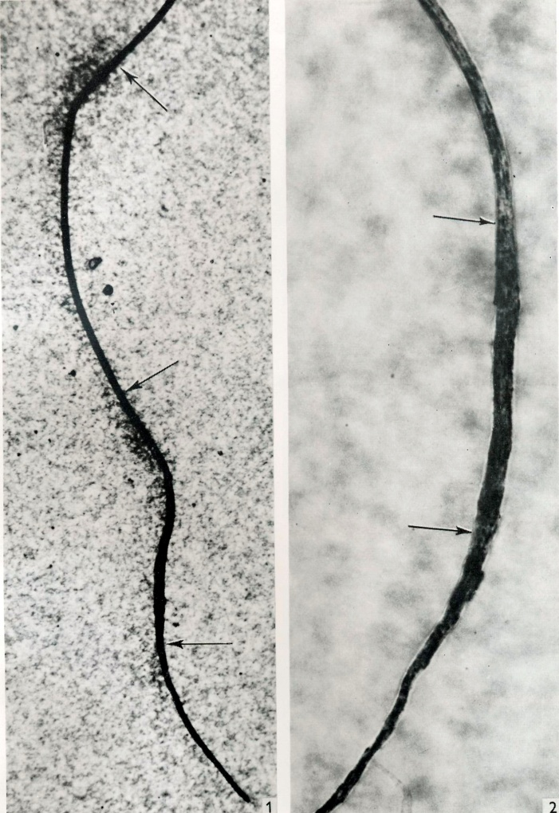
Figure 3.3 Fibre grown from skin over a hot chamber. Source: Jolly and Lyne, (1970)

1. Autoradiogram of a wool fibre (60x) collected from skin overlaying the hot chamber experiment of Jolly and Lyne. The upper arrow indicates the start of the first control period; the middle arrow indicates the end of the control period and the start of the heating period; the lower arrow indicates the end of the heating period and start of the second control period. Note the concentration of silver grains corresponding to the ³⁵S-cystine injections, which mark the start/end of the treatment period.

2. Section of another wool fibre (172x) depicting the increase in fibre diameter (area between the arrows) when a temperature of 48⁰ C was applied to the heat-exchange chamber. Fibre diameter above the upper arrow and below the lower arrows equate to growth during control periods (that is fibre growth at normal body temperature).
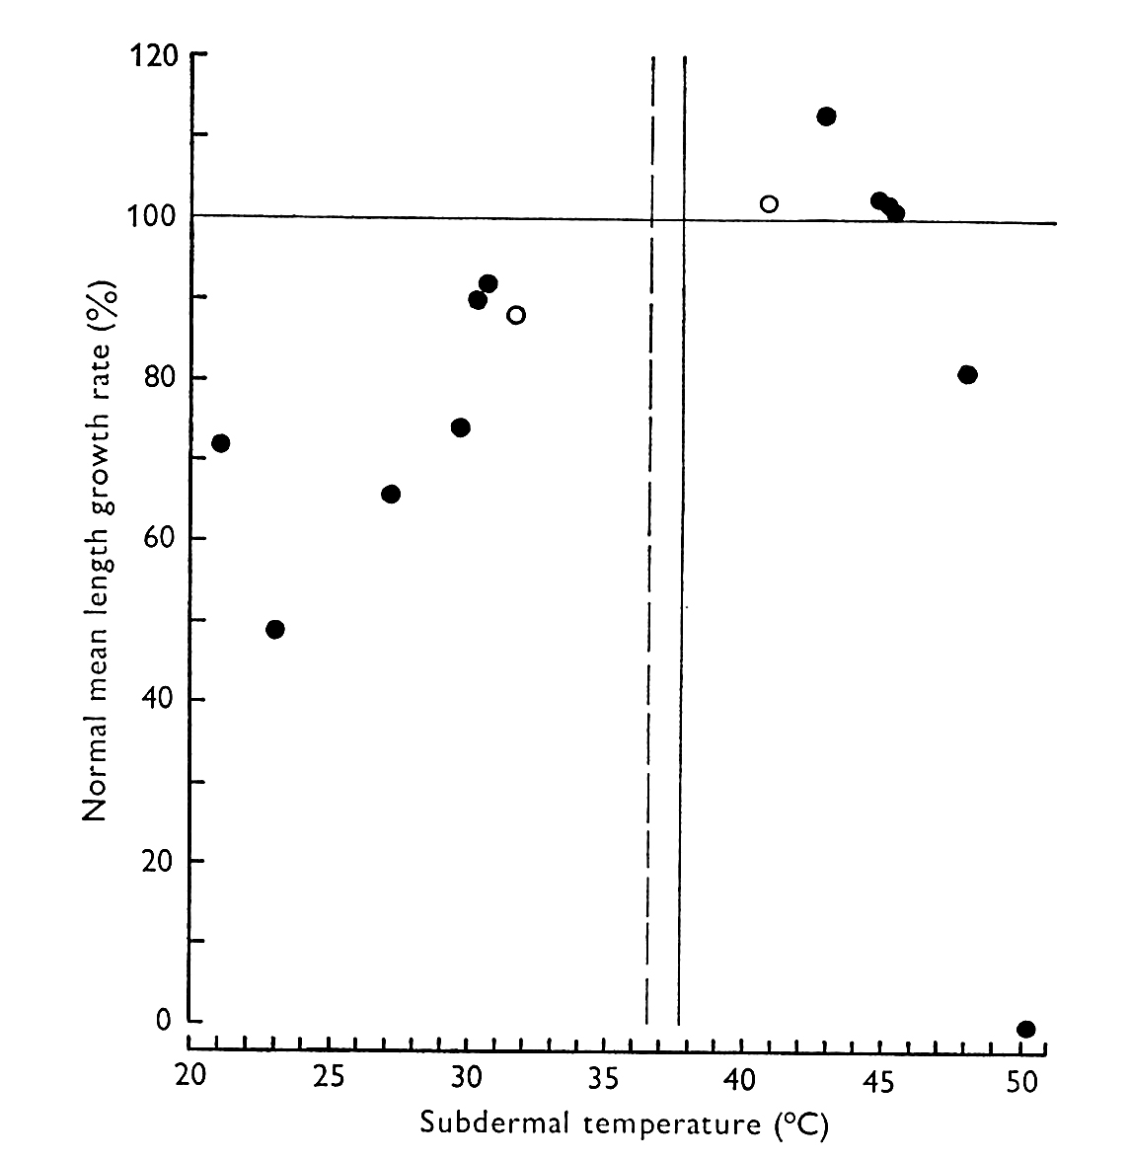
Figure 3.4 Normal mean growth rates of wool fibre versus subdermal temperature.
Source Jolly and Lyne (1970)

Diagram depicting the relationship between mean length growth rate of wool fibres, expressed as a percentage of normal growth rates, and subdermal temperature for the sheep skin in the two Lyne experiments. The vertical solid and broken lines represent subdermal temperatures for the control periods in the two experiments.

A reduction in skin temperature due to close clipping of the sample area is the most likely scenario and a potential source of experimental error when estimating the rates of wool growth in cool to cold climates.

Estimating growth rates with radioisotopes

For the reasons discussed above, methods other than the rather tedious and time-consuming close clipping technique were developed by wool biology researchers. One of these methods uses radioisotopes for a more precise measurement of wool growth. The use of radioisotopes for the measurement of the length growth rate of individual fibres relies on the periodic administration of amino acids labelled with a radioisotope, followed by autoradiography of the fibres. This technique, first described by Rouget (1959) and Downes and Lyne (1959, 1961), relies on a labelled amino acid being rapidly incorporated into the growing fibre and has been successfully applied, over many years, to hair growth experiments in several mammalian species.

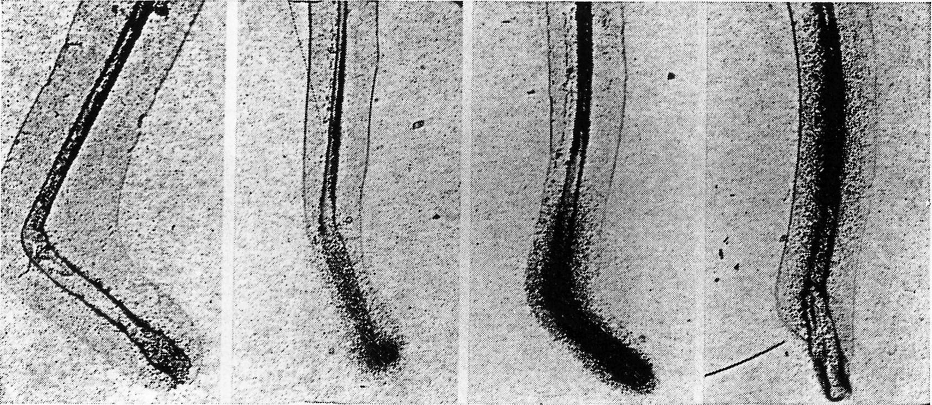
Figure 3.5 Plucked Wool Follicles Following the Administration of Radiolabelled Cystine. Source: Downes et al (1967).

Autoradiograms of wool fibres plucked at 3 min, 1, 4, and 30.5 h (L→R) after intravenous injection of ³⁵S-cystine. Incorporation of ³⁵S-cystine into the fibre corresponds to the intense region of dark silver grains, localising to the bulb and then migrating to the pre-keratogenous zone at 3 min and 30.5 h post injection.

When ³⁵S-cystine or ¹⁴C-cystine is injected into the circulatory system of sheep, the radioactive cystine is readily detectable in the upper portion of the bulb within a few minutes. Earlier studies in mice demonstrated that the ³⁵S-cystine was incorporated into the hair follicle of mice just below the point where hardening or keratinisation of the newly forming hair is completed. Downs et al (1967) clearly showed the same results in the sheep, where after one hour the ³⁵S-cystine was located throughout the non-keratinised part of the forming wool fibre and remained stably incorporated in the emerged fibre. As predicted, no ³⁵S-cystine is incorporated into the fibre past the zone of keratinisation as all metabolic activity in this part of the fibre has ceased. Individual wool fibres plucked from the skin of the sheep several days after the cystine injection, showed a characteristic intense area of silver grains on the autoradiogram, trailing away to a less defined signal as the rate of cystine incorporation declines. This signal reduction is as a function of diminishing levels of cystine in the circulation. When a second dose of radiolabelled cystine is injected, a few days later, another intense band of radioactivity with its trailing signal can be seen lower in the newly plucked fibre. The distance between two bands for a known interval between two injections gives the mean fibre length growth rate. One limitation of the method is the fact that the ß-emitting particles from the ³⁵S-cystine penetrate deep into the emulsion of the autoradiography film, which inevitably produces a fuzzy image. Provided the operator consistently chooses the same point on each image to represent the time of cystine injection, all measurements of fibre length growth rate will contain a consistent minimal error. The accuracy of the measurements, including fibre diameter for a given time point, can be improved by magnifying the image through a projection microscope.

The advantages of this method over the fleece clipping techniques are:

- Accurate length growth rate measurements can be made for individual fibres, from any body region and between animals, within 2-3 days of the ³⁵S-cystine injection.
- Growth rates of adjacent fibres or fibres from quite diverse body regions (that is, those growing wool or hair) can be compared with a relatively high degree of accuracy.
- Minimal disturbance to the sampling sites. Fibres do not have to be collected until the completion of the experiment. As the ³⁵S-cystine remains permanently incorporated into the fibre structure, the detection period is a function of the half-life of the radioisotope.
- Successive short lengths can be measured along each individual fibre.
- The relationship between changes in fibre diameter and length growth rate can be accurately determined since radiolabel incorporation acts as a temporal and spatial marker.
- As cystine readily crosses the placenta, follicle activity and the rate of wool growth in foetal lambs can be investigated (Paduceva, 1961, 1962)
- Measurements on wool bundles or staples can be determined as efficiently as with individual fibres.

Whilst fibre length growth rate is readily measured between 3-7 days due to separation of the ³⁵S-cystine bands on the autoradiograph, an experienced operator can obtain meaningful measurements after a 1-2 day interval following the cystine injection. In experiments where longer time intervals are anticipated, particularly those greater than three months, isotopes such as ¹⁴C-cystine are often used since ³⁵S-cystine has a half-life of 87 days. Using an isotope with a longer half-life allows the intravenous dose of cystine to remain relatively small (10 microcuries), reducing costs and minimising health risks to the animal and experimenter. As with close clipping, a mid-size patch has been determined as the ‘standard’ for comparing fibre growth between animals, breeds or experiments where specific body region comparisons are not important. This also has the advantage of allowing even lower intradermal and subcutaneous doses (0.1-0.5 microcurie) to be used successfully.

Autoradiogram of a large sheep vibrissa depicting the method of Downes at al 1967 for measuring the length of wool growth over a 3 day interval with two doses of ³⁵S-cystine.

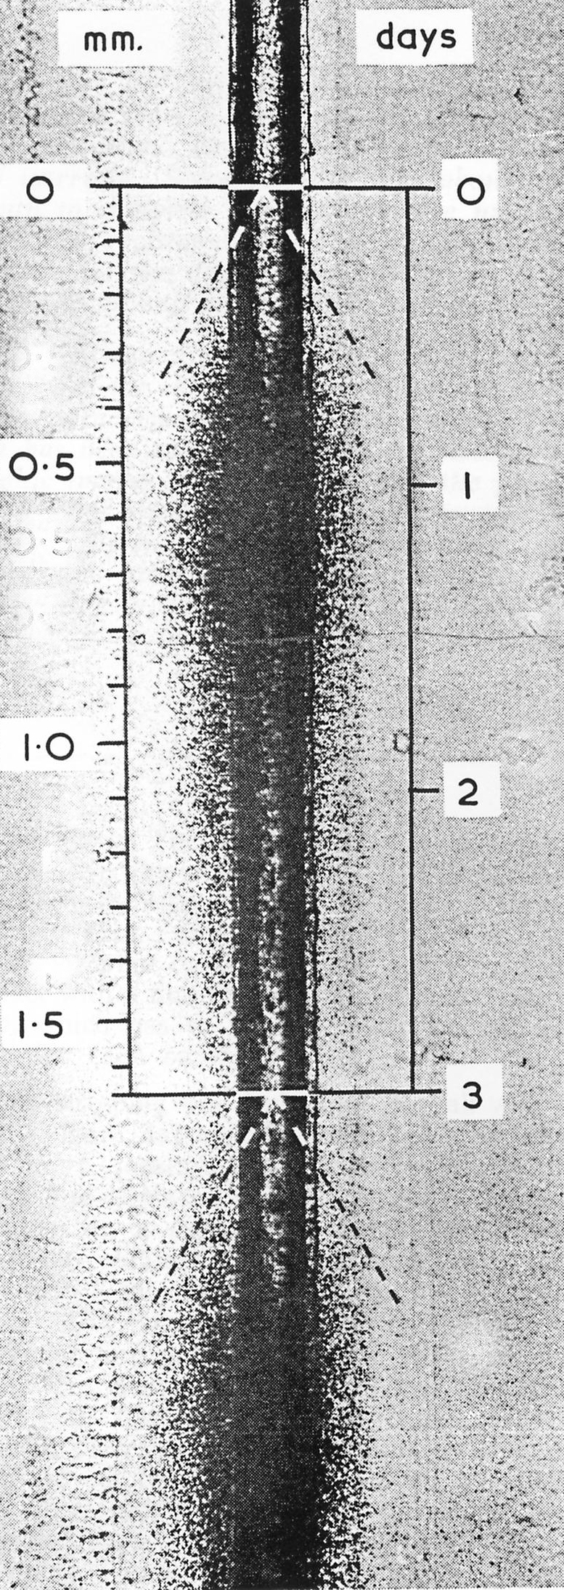
Figure 3.6 Autoradiogram of Radiolabelled Sheep Vibrissa Follicle.
Source: Downes et al (1967).

As with any fleece harvesting technique, the protocol for fibre sampling requires careful consideration. Plucking fibres from the skin will inevitably lead to some sheared fibres, particularly those with small fibre diameters. The preferred method of collecting fibres is close clipping two or more weeks after the final cystine injection, which will allow the most recently labelled part of the fibre to emerge past the skin surface. Downes et al (1967) has suggested that for a true mean growth rate for a specific population of fibres, data should be collated from the measurement of several hundred fibres. The subsequent autoradiography for several hundred fibres can be somewhat laborious as the fibres must be cleaned and mounted on microscope slides. Following cleaning of the fibres in petroleum ether, the fibres are often stained in picric acid for 30 minutes to make the measurements of fibre diameter easier. Picric acid stains the keratinised region of the fibre as a vivid yellow. After staining, several fibres (10-20) are immersed in 1-2 ml of 10% aqueous glycerol/albumen and arranged side by side on a microscope slide. The albumen solution is dried by heating to 40⁰ C in an oven for 1-2 days and then a protective film of 0.5% pyroxylin in ether/ethanol (75:25) is applied before repeating the drying process. Once dry, the slides are placed in contact with autoradiography film for a period that is determined empirically for each experiment. The accuracy of the measurement can be increased by using low fog, fine grain x-ray film to improve image quality. At the completion of the process, the portion of film corresponding to the sampled fibres are excised and mounted on a microscope slide so that the autoradiographic images are superimposed over the appropriate fibres. A full-length cover glass is used to seal the film permanently in place. Fibre length measurements used to calculate fibre length growth rates and mean fibre diameter are made with the use of a light microscope.

This technique continues to be used to establish the effects of factors as variable as nutrition, climate, hormone, growth factor and drug interactions on wool growth.

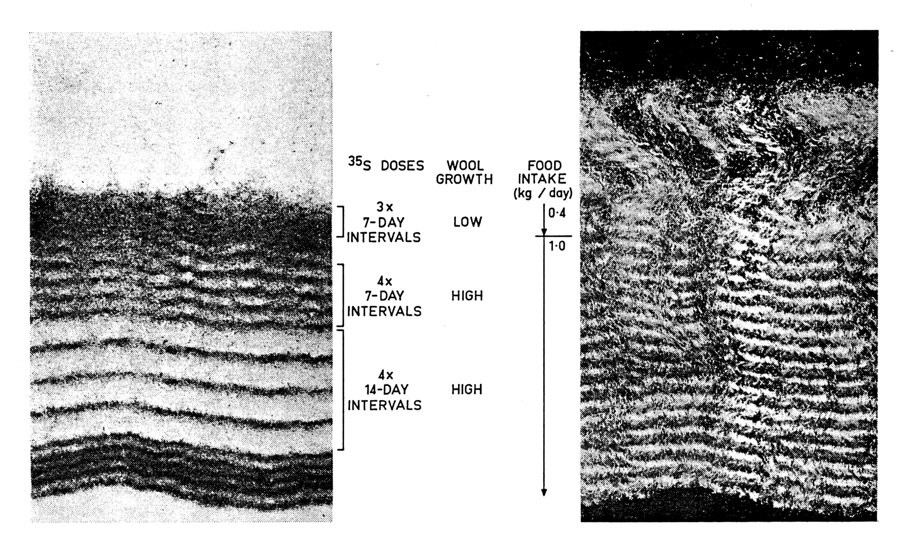
Figure 3.7 Autoradiogram of a clipped wool fibre bundle. Source: Downes et al (1967)

Left: Autoradiograph of wool staple following 19 intravenous injections of 35S-cystine at varying time intervals. The first four doses were injected at 7 day intervals into an animal on restricted food intake and thus low wool growth. The following two sets of 35S-cystine injections were at a higher plane of nutrition with a subsequent increase in wool growth clearly visible by a larger distance between the dark bands on the autoradiogram. The average length growth rate and fibre diameter increased from 230 to 300 μm/day and from 14 to 19 μm, respectively.

Right: Note that the corresponding wool staple image is longer than the autoradiogram as the animal was carrying several months of growth prior to treatment.

Estimating growth rates using dye banding

Dye banding is an alternative technique for fleece growth studies and has been used when large numbers of animals are involved in field trials. Chapman and Wheeler (1963) reported that sheep can be processed at the rate of one every 1-2 minutes with as little as 300-500 μl per dye band. One advantage of dye banding the fleece over the incorporation of radioisotopes into the fibre structure, is that the handling and processing of the fibres is generally faster and the measurement phase of the technique is considerably cheaper. There are however limitations to this technique when compared to the incorporation of radioactive isotopes.

The method is no less tedious than radioactive incorporation as the dye (DBR) must be dissolved in cold water (or hot water and then allowed to cool) before the addition of concentrated hydrogen peroxide, which acts as an oxidising agent. The use of hydrogen peroxide, particularly in a concentrated form, imposes OH&S issues for the operator. The dye solution darkens with time and loses its dyeing efficiency requiring a fresh solution for each experiment. The dye also requires delivery to the skin surface through a finely drawn heat-treated glass pipette, which is easily broken during the delivery process. Thus, reserve pipettes must be prepared ahead of the experiment. In more recent experiments, McCloughry (1997) has applied another suitable dye using a shortened 21-gauge needle with a round polished end, circumventing the need for a finely drawn glass pipette. On a positive note, the Durafur Black R dyed fibres retain their colouration for several months and the dye does not bleed when aqueous detergents or organic solvents are applied to the fibres during the scouring process. Unlike ³⁵S or ¹⁴C incorporation however, dyeing of the fibres can be adversely affected by a high suint content and where the fleece exceeds 35 mm in length.

In general, dye banding is co-localised to 100 cm² tattooed mid-side patches. When the banded staples are used in conjunction with fleece weight estimates, the volume of wool produced for a given period can be estimated. Rather than dying the entire patch, researchers generally apply the dye to a 10 cm anterior-posterior line of open wool. Care should be taken with coarse woolled sheep with high suint content, as the dye will readily migrate along the length of the fibre if the dye solution is applied too liberally. Excess dye solution is readily removed by drawing back into the pipette immediately upon application. The dye can also enter the follicle canal although only to a depth of about 50 μm. It appears that the secretion of sebum (wool wax) acts as a barrier to the dye penetrating deeper into the follicle canal.

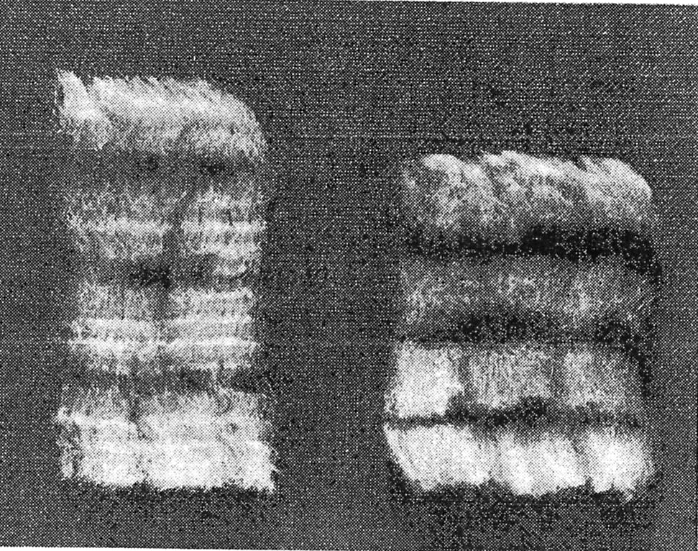
Figure 3.8 Dye banded wool staples. Source: Chapman and Wheeler (1963)

Three dye bands applied to the wool at skin level, at intervals of six weeks, to two Merinos with different growth rates; the staple from the animal on the right has a slower fibre growth rate.

The frequency of dye application is also a limitation with this technique. Intervals of less than three weeks give unsatisfactory separation of bands and 4-6 weeks appears to be the optimal minimal interval between dying. In semi-acid environments fading of the band near the tip of the fleece becomes excessive after 7 months and thus shearing at 6 monthly intervals is generally required. The dye banded staples are easily removed by close clipping with Oster animal clippers ensuring an even depth of wool remains behind without the need for second cuts. The staple structure will remain intact for subsequent measurement, if the staples are carefully removed from the surrounding fleece and rolled in a sheet of paper or sealed in a paper envelope the exact size as the staple. When estimating wool growth, calculations must take into account that approximately 1.5 mm of wool staple remains above the skin surface after close clipping, and this wool is readily dyed.

Staple length measurements from each sheep can be made for each time interval by determining:

- The distance along the fibre from the skin surface to the lower margin of the previous dye band or
- The distance between the trailing edges of adjacent dye bands.

Estimating clean wool weights are somewhat laborious, requiring multiple immersions in several changes of degreasing solvent. The wet staple is accurately cut along the bottom of the dye band before the solvent is evaporated and the vegetable material removed with forceps. The staple sub-samples are then oven dried, weighed and converted to a percentage of either total fleece weight or clean fleece weight (oven dried) from the tattooed mid-side patches.

Langlands and Wheeler (1968) estimated clean dry fleece weight as the product of the greasy fleece weight and the clean wool content from the mid-side patch (scoured according to Chapman 1960). Mean daily wool production y was calculated according to the equation:
y = (AB) / (CD)
where A is the weight of clean wool in the mid-side patch or between successive dye bands
B is the clean fleece weight
C is the number of days between dye bands
D is the weight of clean wool in the mid-side patch that has grown between shearings or the weight of the dye band staple below the initial dye band

McCloughry (1997) has modified the dye banding technique by using a commercially available hair dye cream (Schwarzkopf® Igora-Roya-NFI Black; mixed with Oxigenta 6% activator immediately prior to application). Whilst the cream dye is only active for one hour after mixing, it offers several advantages over the traditional Durafur Black R solution. In the McCloughry experiment, the cream
dye consistently produced a finer band at skin level than the corresponding Durafur Black R. This allows length growth rate to be measured over shorter intervals or in animals with inherently lower rates of fibre growth. Another positive feature of the cream dye is its safe formulation for use in humans, thus minimising the health risks to the experimenter and animal imposed by using Durafur Black R.

Cell biology techniques for estimating wool growth

In the previous sections, we have reviewed two techniques that estimate wool growth by directly measuring fibre growth over a defined time interval. Both these techniques have produced useful data in the study of wool growth, but neither technique can adequately address the events occurring at the level of the follicle. The rate of wool production is a function of many interactions including nutrition, genotype, photoperiod (Schinkel, 1961, 1962; Black and Reis, 1979) all of which alter both the rate of keratin synthesis in the keratogenous zone of the follicle and the rate of cell division in the follicle bulb. Actively dividing cells in the follicle bulb rapidly undergo one of several differentiation pathways that direct cells into forming one of the cellular components of either the follicle or the wool fibre. As the follicle bulb contributes the cells that ultimately give rise to the wool fibre it is not surprising that researchers have explored cell biology as an approach for expanding our knowledge of wool growth. Thus, establishing cell cycle times and the proportion of follicle bulb cells undergoing cell division in response to various stimuli, such data generate a greater understanding of the mechanisms driving fibre growth.

In general, the rates of cell division and the duration of cell cycling can be determined by measuring endogenous markers of cell activity or by cell perturbation protocols.

Endogenous markers of cell activity can include

  - Total DNA content
  - Histone mRNA quantification
  - Mitotic Index (condensed chromatin)
  - PCNA quantification

The total amount of deoxyribonucleic acid is useful where cell numbers have been quantified. The assumption with the approach is that cells undergoing division will have progressed through DNA replication. Therefore, these cells will have two copies of genomic DNA compared to cells in interphase, which have one copy of DNA. Modern techniques use fluorescent labelling of cell nuclei to analyse DNA content in cell populations. Cells in G2/M phase will have twice the fluorescence as quiescent and G1 cells. As cells in S phase are actively synthesising DNA they will have intermediate values of fluorescence. Unfortunately, this technique is applied most readily to experimental situations where the cells are in suspension rather than in situ and flow cytometry is used to monitor fluorescence. Even when cells are in suspension, the results can be skewed if the fidelity of the fluorescence of an individual cell is compromised. This can occur if cells adhere to one another or pass through the laser detector simultaneously. Another limitation is that it is difficult to know the time of entry into and the duration of the mitotic phase for each of the cells processed.

Histones are proteins primarily synthesised during S phase as a function of DNA replication and chromatin condensation. In fact, the rates of DNA synthesis, histone synthesis and chromatin assembly (the newly synthesised DNA bound by histone proteins) is tightly co-ordinated. In many cells the levels of histone mRNA will increase as much as 30-50 fold. There are, however, many histone proteins synthesised in cells and not all histones are S phase regulated. For example, the histone H5 in erythroid cells is not S phase regulated and thus an increase in histone levels does not necessarily equate to cells in S phase. Furthermore, the quantification of total histone synthesis is not readily achievable in tissue sections.

PCNA – proliferative cellular nuclear antigen is also known as cyclin. PCNA is an essential protein for DNA replication. In combination with another protein known as Replication Factor C (RFC), PCNA binds DNA Polymerase and maintains the association of the polymerase with its template during the DNA replication process, allowing an uninterrupted synthesis of kilobases of DNA. The synthesis of PCNA, increases in early G1 and reaches peak levels during S phase. It has been used as an indicator of cell proliferation but quantification of PCNA is not straight forward. In fact, immunohistochemistry of tissue sections, using various fixation protocols have reported two basic forms of PCNA protein. In cells fixed with organic solvents PCNA is strongly associated with the nucleus, where DNA synthesis is occurring, whereas in cells fixed with aldehydes the localisation of the PCNA signal is more generalised and occurs throughout the cell cycle.

A second approach for monitoring cell division and cell cycle activity is by applying techniques that use exogenous chemicals that either arrest cellular activity or act as markers, without disrupting normal cell function.

These include:

  - Incorporating a labelled nucleotide or nucleotide analogue into the DNA during replication
  - Arresting cell division by chemical intervention

The classical method for detecting DNA synthesis in cells is by the incorporation of ³H-thymidine into newly replicated DNA, followed by autoradiography. Whilst this method has generated a wealth of information about proliferation in a wide variety of tissues and cell types, radiation exposure for both experimenter and animal remains an OH&S issue. Radioisotopes are also prohibitively expensive for large animal experiments. Furthermore, autoradiography of the tissue sections may take weeks to months for the signal to develop and the technique generally requires the sections to be overlaid with a photographic emulsion.

Estimating cell kinetics using nucleoside labelling
An alternative approach to ³H-thymidine for studying follicle cell kinetics is the immunological detection of a thymidine analogue known as 5-bromo-2’-deoxyuridine (BrdU). When BrdU is injected into the circulation of an animal, it is incorporated into the DNA of cells undergoing DNA synthesis (S-phase) with the same kinetics as endogenous deoxyuridine. Cells labelled with BrdU are detected readily using an antibody (polyclonal or monoclonal) with high specific activity for the nucleoside analogue. Thus, this technique provides an opportunity to measure the proportion of cells in S-phase at a particular time, as well as estimating the length of the cell cycle.

In order to estimate the rates of mitosis (that is, cell division), there are a number of assumptions that have to be made. The method requires that the initial or pulse injection labels all S-phase cells for a short period only and that the pool of injected BrdU is exhausted during the time that the labelled nuclei are counted. This period is generally some 4-8 hours after the pulse injection. Using data from mouse experiments (DeFazio et al, 1987) Hynd and Everett (1990) estimated that the 40-fold lower dose of BrdU used in their experiment would not result in a local BrdU precursor pool during the measurement period, but such a pool cannot be ruled out. Assuming that there is no precursor pool of nucleotide, the number of labelled nuclei is recorded at 4 hours and then again at 8 hours. An increase in labelled nuclei should therefore be the result of cell division during the second 4 hour period.

In a later study, Adelson et al (1991) investigated the pattern of cell division and differentiation of wool follicle bulb cells, using BrdU and 5-fluoro-2’-deoxyuridine (FdU) in Merino and Romney ewes, held at a constant plane of nutrition. Fibre length growth rates were also measured using the method of Downes et al (Figure 3.9), except that the animals were injected with ³⁵S-methionine or ³⁵S-cysteine. Adelson et al used FdU to enhance the action of BrdU as an S phase marker, by inhibiting thymidilate synthetase. Inhibiting this enzyme ensures that the synthesis of endogenous thymidine monophosphate is kept to a low level resulting in a high specific activity of BrdU in the cellular nucleotide pool.

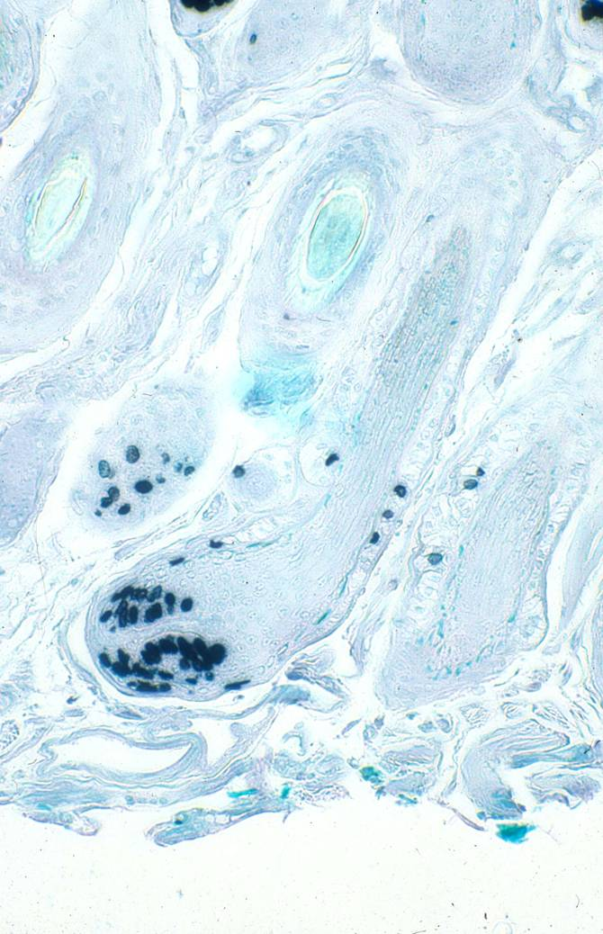
Figure 3.9 Wool follicle bulb showing nuclei labelled with BrdU.
Source: Adelson et al (1991)
Nuclei that have incorporated BrdU into their DNA appear dark as compared to those that are not labelled with BrdU. Green arrows indicate many nuclei in two follicle bulbs; note the location of labelling in the bulb. Orange arrow indicates a small number of labelled nuclei in the ORS.
The authors reported that BrdU/FdU cocktail profoundly affected fibre morphology. At the light microscope level, these changes included a disruption of the fibre’s cuticle pattern, textural changes in the fibre cortex and altered dye banding characteristics following methylene blue staining. The experimental regime clearly showed cells that incorporated the Brdu/FdU into their DNA were responsible for the fibre perturbations when they migrated to the keratogenous zone. The BrdU/FdU labelled nuclei were found to express a marker for orthocortical cell differentiation (HIT96 antigen) to a lesser extent than normal cells, when cellular differentiation was activated in the keratogenous zone. The altered methylene blue staining was attributed to a decrease in the amount of paracortex specific protein.

Numerous other investigators have reported that BrdU can inhibit cellular differentiation as a function of incorporation into nuclear DNA. Despite these dramatic morphological changes and thus altered regulation and differentiation in the developing fibre cortex, Brdu/FdU had only a minor effect on the mean fibre length growth rate (Correlation Coefficients for lines of best fit for two labelling periods were r=0.98 and 0.97). Further, the rates of cell migration were similar to those reported in previous studies by Chapman (1971) and Chapman et al (1980) where ³H-thymidine labelled cells moved through the zone of keratinisation between 2.5 days (60h) to 4 days (90h). Adelson et al (1991) observed labelled nuclei in the keratogenous zone of the fibre between 55-119h after injection of the BrdU/FdU label. This is in agreement with other studies reporting that BrdU had no effect on the rate of cell proliferation or on the cell cycle (Miura and Wilt, 1971).

Thus, for short term studies, BrdU is an inexpensive non radioactive method for visualising S phase nuclei. Nevertheless, its effect on cellular differentiation must be taken into consideration where cells are tracked for long periods and differentiation comes into play. The use of ³H-thymidine might be the preferred for long term studies, although cost and the extended time for autoradiography are definite draw backs.

Estimating cell division rates using mitotic inhibitors
The rate of cell division or the mitotic rate of cells in the germinative region of the follicle bulb can be determined through chemical intervention of the normal cell cycle. The alkaloids such as colchicine, colcemid and vinblastine are known to be potent cell cycle inhibitors. When administered intravenously to an animal, these alkaloids will arrest mitotically active cells at metaphase. These suspended metaphase nuclei can readily be identified and counted using histochemical stains that are specific for deoxyribonucleic acid.

The antimitotic drugs act by binding to the spindle microtubules and prevent polymerisation of the spindle apparatus. Without a functional spindle apparatus, the chromosome pairs cannot separate into the two half-formed daughter cells and thus the parent cell remains suspended in metaphase and the cell cycle is arrested. The rate of cell division is calculated by examining microscopic skin sections of wool follicles bulbs. The number of arrested cells divided by the number of bulbs in the section as a function of the time elapsed since the alkaloid injection can be expressed as n cells⁻¹ bulbs⁻¹ h⁻¹ skin section thickness⁻¹ (that is, the number of arrested cells per bulb per hour per skin section of known thickness in microns).

As with most perturbation experiments, there are secondary drug actions that need to be considered by researchers undertaking such experiments. Some of these include whether:

- Alkaloid administration affects the entry rate of cells into mitosis
- Alkaloid administration affects the rate of normal metabolic processes in these cells.
- Metaphase arrest proceeds in a linear fashion throughout the sampling period.

There is evidence that DNA synthesis is depressed (see Hynd et al., 1986) by colchicine and that there is a lag between drug administration and metaphase arrest and the breakdown of colchicine-arrested cells over time. Bertalanffy (1964) compared the incorporation of tritiated (³H-) thymidine with colchicine as a means for estimating the rate of cell division in a variety of tissues. He found that both approaches gave comparable results. However, it was imperative that the skin samples from the colchicine experiment were collected during the linear phase of metaphase arrest.

The major disadvantage with colchicine administered intravenously is the highly toxic dose that is required for efficacy, and in early studies sheep died during or post- experimentation. Not only is this ethically unacceptable, a measure of normal cellular activity is highly unlikely when colchicine reaches a toxic cellular level. Such an undesirable outcome has been largely overcome by studying a more localised effect of colchicine as a result of intradermal injection of the alkaloid. Hynd showed that mitotic arrest cells accumulated linearly up to several hours after injection, with the period corresponding to the dose level (i.e. a high dose = a longer period). A significant advantage of this experimental regime over intravenous administration of colchicine is that several estimates of follicle cell activity and wool growth measurements can be gathered from a midside patch without adversely affecting the health of the animal.

Hynd et al., (1986) also noted that using colcemid in place of colchicine gave a mitotic rate some 13% higher than for colchicine. This may be due to the less toxic affects of colcemid on cultured cells. Frazer (1963) reported a greater viability of cultured sheep follicle cells with colcemid as compared to colchicine. Similarly, Hell and Cox (1963) noted little reduction in DNA synthesis in cultured cell lines with colcemid, whereas colchicine significantly reduced DNA synthesis. Whilst Hynd et al (1986) concluded that colcemid most likely yields a more realistic follicle mitotic rate, it must be kept in mind that these techniques provide a relative measure of follicle cell kinetics rather than an absolute measure.

Other factors to consider in such experiments relate not only to the time of sampling but also to the level of nutrition and feeding regime. As in previous experiments performed by Schinckel (1962) and Wilson and Short (1979), Hynd et al (1986) found that different planes of nutrition correlated with differences in wool growth rates, which were reflected in the rates of cell division. Hynd et al (1986) also noted a dramatic fluctuation in follicle mitotic rates throughout the day in control sheep. Diurnal fluctuations in several mammalian tissues have been reported (Bullough, 1965; Sigdestad et al., 1969 ) with a peak during the night and nadir during the day, although there is also evidence that tissues with inherently high mitotic activity do not display a diurnal fluctuation. Wool follicle bulbs should fulfil the criterion of high mitotic activity, but Hynd et al (1986) noted a diurnal fluctuation in mitotic activity for the sole animal in the experiment. There is some evidence that the feeding cycle and thus the supply of nutrients may influence the rate of mitosis. Regardless of the cause(s) of the observed rhythm, it is important to ensure that feeding is ad libitum, the plane of nutrition constant between animals (where nutrition is not the parameter under investigation) and that the skin samples are collected at the same time of the day throughout the experiment.

As a conclusion to this module, Table 3.1 summarises some of the findings of a study conducted by Hynd 1989 on the effects of a low- and high-protein diet on wool follicle kinetics in three breeds, strongwool Merino, finewool Merino and Corriedale. As revision, examine this paper to reveal how many of the techniques described throughout this module were used to generate the experimental data. At the same time you should critically analyse the experimental design and make dot point notes on how you might improve or extend a similar replicate experiment.

Table 3.1 The Effects of Nutrition on Wool Follicle Kinetics. Source: Hynd, P.I., (1989).

Trait Measured | Effects after changing from a low-protein diet to high-protein diet expressed as a percentage (%)
Clean fleece weight | + 33
Fibre length growth rate | + 26
Volume of germinative bulb region | + 30
Rate of bulb cell division | + 35
Proportion of fibre paracortex | + 66
Proportion of dividing cells entering fibre cortex | NC
Cortical cell volume | NC

NC = no change. This study by Hynd (1989) comprised 5 strongwool Merinos, 1 finewool Merino, 1 Corriedale.

Readings 
The following reading, which is cited in the previous section, is available on web learning management systems

- Hynd, P.I., 1989 'Effects of nutrition on wool follicle cell kinetics in sheep differing in efficiency of wool production', vol 40, pp 409-417. Australian Journal of Agricultural Research

Summary
Summary Slides are available on web learning management systems
To determine the factors affecting wool production and wool quality and the degree of influence that can be attributed to each factor, it is essential that there are reliable quantitative measurements available to the researcher. This module examines the techniques that have been developed and adapted to routinely measure the effects of various stimuli on wool growth. Techniques used to measure the fibre directly include, the mid-side tattooed patch technique, dye banding and autoradiography. This module also discusses the techniques that measure fibre growth indirectly. As cell division in the follicle underpins both follicle function and fibre growth, cellular replication and cell kinetics are essential to our understanding of the mechanisms controlling fibre production. Thus, the techniques of stathmokinetics, nucleoside radiolabelling and immunohistochemistry are briefly investigated.

In summary, it should now be apparent that there are several techniques for estimating wool growth rates and thus wool production and quality. The technique(s) selected by investigators reflects the nature of the experiment (including the question(s) being addressed), the number of animals involved in the study and the resources available to the experimenter. In many respects, a combination of techniques, generating corroborating data from different perspectives, is often the most appropriate approach for good experimental design.
References
Adelson, D.L., Munro, S.G. and Tunks, D.A. (1991). Perturbation of wool fibre cell differentiation by a mixture of bromodeoxyuridine and fluorodeoxyuridine. Australian Journal of Agricultural Research. Vol 42, pp 1293-1300.
Bennett, J.W., Hutchinson, J.C.D. and Wodzicka-tomaszewska, M. 1962. Annual rhythm of wool growth. Nature, vol 194, pp 651-652.
Bertalanffy, F.D. (1964). Tritiated thymidine versus colchicine technique in the study of cell population cytodynamics. Laboratory Investigation, vol 13, pp 871-876.
Black, J.L and Reis, P.J (1979). ‘The Physiological and Environmental Limitations to Wool Growth’. (eds J.L. Black and P.J. Reis) (University of New England Publications Unit: Armidale, NSW).
Bullough, W.S. (1965). Mitotic and functional homeostasis: a speculative review. Cancer Research. Vol 25, pp 1683-1727.
Chapman, R.E. (1971). Cell migration in wool follicles of sheep. Journal of Cell Science, vol 9, pp 791-803.
Chapman, R.E. and Wheeler, J.L. (1963). Dye-banding: a technique for fleece growth studies. Australian Journal of Biological Science, vol 26, pp 53-
Chapman, R.E., Downes, A.M. and Wilson, P.A. (1980). Migration and keratinisation of cells in wool follicles. Australian Journal of Biological Science, vol 33, pp 587-603.
DeFazio, A., Leary, J.A., Hedley, D.W., and Tattersall, M.H.N. (1987). Immunohistochemical detection of proliferating cells in vivo. Journal of Histochemistry and Cytochemistry, vol 35, pp 571-577.
Doney, J.M. and Griffiths, J.G. (1967). Wool growth regulation by local skin cooling. Animal Production, vol 9, pp 393-397.
Downes, A.M and Lyne, A.G. (1959). 'Measurement of the rate of growth of wool using cystine labelled with Sulphur-35', Nature, vol 184 (4702), pp 1884-1885.
Downes, A.M and Lyne, A.G. (1961). 'Studies on rate of wool growth using (355) Cystine. Australian Journal of Biological Science, vol 14 (1), pp 120.
Downes, A.M. and Hutchinson, J.C.D. (1969). Effect of low skin surface temperature on wool growth. Journal of Agricultural Science, Cambridge, vol 72, pp 155-1.
Downes, A.M., Chapman, R.E., Till, A.R. and Wilson, P.A. (1966). Proliferative cycle and fate of cell nuclei in wool follicles. Nature, vol 5061, pp 477-479.
Downes, A.M., Clarke, W.H. and Dagg, T.C. (1967). Use of radioisotopes in the measurement of wool growth. Atomic Energy of Australia, vol 10, pp 2-7.
Frazer, I.E.B. (1963). The use of colchicine and colcemid for metaphase stasis in the matrix cells of wool follicles. Australian Journal of Biological Science, vol 16, pp 211-217.
Hell, E. and Cox, D.G. (1963). Effects of colchicine and colcemid on synthesis of deoxyribonucleic acid in the skin of the guinea pig’s ear in vitro. Nature, vol 197, pp 287-288.
Hocking Edwards. J.E. and Hynd, P.I. (1992). Cellular characteristics of wool follicles and fibres in finewool and strongwool Merinos. Australian Journal of Biological Science, vol 43, pp 355-365.
Hynd, P.I. (1989) Effects of Nutrition on Wool Follicle Cell Kinetics in Sheep Differing in Efficiency of Wool Production. Australian Journal of Agricultural Research, vol 40, pp 409-417.
Hynd, P.I. and Everett, B.K. (1990). Estimation of a cell birth rate in the wool follicle bulb using colchicine metaphase arrest or DNA labelling with bromodeoxyuridine. Australian Journal of Agricultural Research, vol 41, pp 741-749.
Hynd, P.I., Schlink, A.C., Phillips, P.M. and Scobie, D.R. (1986). Mitotic activity in cells of the wool follicle bulb. Australian Journal of Biological Science, vol 39, pp 329-339.
Jolly, M. and Lyne, A.G. (1970). The response of skin and wool growth to local subdermal temperature changes in a sheep. Journal of Agricultural Science, Cambridge, vol 7, pp 501-515.
Langlands, J.P. and Wheeler, J.L. (1968). The dyebanding and tattooed patch procedures for estimating wool production and obtaining samples for measurement of fibre diameter. Australian Journal of Experimental Agriculture and Animal Husbandry, vol 8, pp 265-269.
Lyne, A.G. and Hollis, D.E. (1968). The skin of the sheep: a comparison of body regions. Australian Journal of Biological Science, vol 21, pp 499-527.
Lyne, A.G., Jolly, M. and Hollis, D.E. (1970). Effects of experimentally produced local subdermal temperature changes on skin temperature and wool growth in the sheep. Journal of Agricultural Science, Cambridge, vol 74, pp 83-90
McCloughry, C.E. (1997) Alternative dye banding method for measuring the length growth rate of wool in sheep. New Zealand Journal of Agricultural Research, vol 40, pp 569-571.
Miura, Y. and Wilt, F.H., 1971. 'The effects of 5-Bromodeoxyuridine on yolk sac erythropoiesis in the chick embryo'. The Journal of Cell Biology, vol 48, pp 523-532.
Paduceva, A.L. (1961). Dokl. Acad. Nauk., S.S.S.R., 137, 484.
Paduceva, A.L. (1962). Ovcevodstvo, vol 8, p 25
Reis, P.J. and Chapman, R.E. (1974). Changes in wool growth and the skin of Merino sheep following administration of cyclophoshamide. Australian Journal of Agricultural Research, vol 25, pp 931-943.
Rouget, J. (1959). J Ann. Zootech., vol 8, p 175
Schinkel, P.G. (1961). Mitotic activity in wool follicle bulbs. Australian Journal of Biological Science, vol 14, pp 659-676.
Schinkel, P.G. (1962). Variation in wool growth and mitotic activity in follicle bulbs induced by nutritional changes. Animal Production, vol 4, pp 122-127.
Sigdestad, C.P., Bauman, J. and Lesher, S.W. (1969). Diurnal fluctuations in the number of cells in mitosis and DNA synthesis in the jejunum of the mouse. Experimental Cell Research, vol 58, pp 159-162.
Slee, J and Ryder, M. L. (1967). The effect of cold exposure on wool growth in Scottish Blackface and merino x Cheviot sheep. Journal of Agricultural Science, Cambridge, vol 69, pp 449-453.
Williams, O.B and Chapman, R.E. (1966). Additional information on the dye-banding technique of wool growth measurement. Australian Institute of Agricultural and Animal Husbandry, vol 4, pp 92-93.
Wilson, P.A. and Short, B.F. (1979). Cell proliferation and cortical cell production in relation to wool growth. Australian Journal of Biological Science, vol 32, pp 317-327.
Glossary of terms
Amino acid | Any of a group of water-soluble organic compounds that possess both a carboxyl (–COOH) and an amino (–NH₂) group attached to the same carbon atom, called the -carbon atom. Amino acids can be represented by the general formula R–CH(NH₂)COOH. R may be hydrogen or an organic group, which may be nonpolar, basic, acidic, or polar. The nature of the R group determines the properties of a particular amino acid. Peptide bonds join the amino acids together to form short chained peptides or much longer chained polypeptides. Proteins are composed of various proportions of about 20 commonly occurring amino acids. The sequence of these amino acids in the protein polypeptides determines the shape, properties, and hence biological role of the protein. Some amino acids that never occur in proteins are nevertheless important. For instance, ornithine and citrulline are intermediates in the urea cycle.
Anagen | The phase of the hair cycle during which the fibre is actively synthesised.
Autoradiography (or radioautography) | A technique that uses an applied photographic emulsion or X-ray film to visualize, radioactively labelled molecules or compounds in a biological system. The film is darkened by the ionizing radiation from the radiolabel contained in the specimen, which may be individual cells, cell cultures, tissues or whole animals.
Catagen | The phase of the hair cycle during which fibre production has declined and the structural and biochemical changes of follicle shutdown have been initiated.
Differentiation | The changes undergone by developing tissues and organs as they become structurally and functionally specialized for particular functions. Differentiation commences in the early embryo and is also part of the tissue regeneration and repair (wound healing).
Ectoderm | The outermost of the three germ layers of the embryo (the other two being mesoderm and endoderm). The ectoderm gives rise to epidermis, neural tissue and nephridia
Endogenous | Describing a substance, stimulus, organ or the like that originates from within an organism
Exogenous | Describing a substance, stimulus or an event that originates outside an organism. Vitamins that cannot be synthesized by an animal are said to be supplied exogenously in the diet
In situ | Experimentation that takes place in a functioning whole animal or structurally intact tissue or organ.
Interphase | The period in the cell cycle when the cell is not replicating and thus undergoing mitosis. During interphase, the newly formed cell is growing rapidly in size and synthesising new molecules essential for maturation.. Interphase is subdivided into the G1 phase, the S phase, and the G2 phase
Keratin | Fibrous, insoluble, sulphur-containing proteins that are the main structural molecules in skin, hair, nails, claws and horns.
Keratinisation | The process of terminal differentiation in which the cytoplasm of the cells of the mammalian epidermis synthesise vast amounts of keratin proteins and ultimately die to form a protective layer of keratin. Keratinization occurs in the formation of feathers, hair, claws, nails, hooves, and horns.

Keratinocyte | A skin cell synthesising primarily keratin proteins
Labelling | The process of replacing a stable atom in a compound with a radioisotope of the same element to enable its path through a biological to be traced by the radiation it emits. A compound containing either a radioactive or stable isotope is called a labelled compound and the atom used is a label. A radioactive labelled compound will behave chemically and physically in the same way as an otherwise identical stable unlabelled compound.
Mitosis | Nuclear division that results in two identical daughter cells. Mitosis ensures that all the cells of an individual are genetically identical to each other and to the original fertilized ovum. Mitosis is divided into four stages, prophase, metaphase, anaphase, and telophase.
Morphogenesis | The development, through growth and differentiation, that leads to the formation of the adult body plan in terms of form and structure.
Nucleoside | An organic compound consisting of a nitrogen containing purine or pyrimidine base linked to a sugar (deoxyribose-DNA or ribose-RNA) and a phosphate group. DNA and RNA molecules are comprised of long chains of nucleotides.
Nucleotide | A compound consisting of a nucleoside linked to a phosphate group, forming the basic structural unit of nucleic acids (DNA/RNA).
Organogenesis | The formation of organs during embryonic development. In animals, this begins following the rearrangement of the cells at gastrulation, when the three germ layers are fully formed in their correct positions.
Peptide | Any organic compound comprising two or more amino acids linked by peptide bonds. Polypeptides contain more than ten and usually 100–300. Naturally occurring oligopeptides (of less than ten amino acids) include the tripeptide glutathione and the pituitary hormones antidiuretic hormone and oxytocin, which are octapeptides. Peptides also result from protein breakdown, during digestion for instance.
Radioisotope (or radioactive isotope) | An isotope of an element that is radioactive
Skin appendage | Appendages that arise from epithelial tissue, and include hair, claws, hooves horns, feathers, mammary glands, lungs, pancreas, sebaceous and sweat glands.
Spatial expression | Localising the expression of a particular gene to a specific tissue or cell.
Telogen | The phase of the hair cycle during which no fibre production is occurring. The follicle maintains a low of sustaining activity awaiting the appropriate molecular cue to re-initiate the start of the next hair cycle.
Temporal expression | Determining the timing of gene expression (for example, during morphogenesis or perturbation experiments).

