How to add your organisation name to this document

This document has been prepared in sections to accommodate different headers and footers and the portrait versus landscape layout of various pages. Also, some headers and footers are linked to others.

This means that making changes can drastically affect the layout.

You are not obliged to add your own organisation name and/or logo, but if you do wish to, please follow these instructions carefully.

If you are not very familiar with headers and footers in MS Word documents, it is suggested you ask an experienced Administrative Assistant to do this.

A space has been provided in the header of each page for you to add your organisation name. You can also add a logo there.

- Save the original file and make a copy with which to work.
- If you wish to add a logo, you need it as an electronic file, preferably a JPEG file, and as a small version (less than 50 kb). Save this file in your file directory.
- Print just these first two pages as a reference.
- Start on this page, so allowing you to experiment with the name and logo position and size, before moving to the real activity pages.
- Open the header at the top of this page (double click on the Section name: ADDING YOUR ORGANISATION NAME AND LOGO )
- The header contains a table with a single row and two columns. The Section name is in the right column.
- In the left column, type your organisation name in capitals.
- To add your logo, it is essential that you MOVE YOUR CURSOR OUT OF THE TABLE, into the nearby header space (in the section surrounded by a dashed line).
- Press Insert; Picture: From File; Choose the file; Insert.
- The logo image will most likely appear larger than you want and in the wrong position.
- To make your logo image manoeuvrable, right-click on the logo image; choose Format Picture; Layout; In front of text; OK.
- Resize your image: Left-click the image and then move the mouse to the top right dot that appears around image. An angled double-ended arrow will appear. Select it and drag in toward the middle of the image until the image is the size you want, then let go.
- Reposition your image: Left-click and hold down the mouse button on the image, then drag image to the desired position. Probably just to the left of your Organisation name (allow for margin space).
- If you need to move your organisation name across to right a little to make more space for a logo, put your cursor on the left end of the header table until 2 short vertical lines with arrows to each side appear. While these are visible, hold down the left mouse button and drag the edge of the table to the right.
- It is important that your table does not become 2 lines of text, as this will mean a number of the pages will no longer have adequate room for the activity content.
- Once you have your desired layout prepared you need to add the name and logo to a number of other pages (not all, as some will appear automatically once you insert them in the first page for a particular section).
- Copy the name text and move to the next header section. Paste the text in and reposition the edge of the header table to the desired position that will allow a logo to fit to the left.
- Move to the next page, checking the text is there, if it is not, then you are in a new section where step 17 will need to be repeated, until all headers have the name text.
- Add the logo to pages by copying it, moving to next header and pasting it (NOT inside the table, but rather into the dashed line header box, although the logo will probably appear elsewhere). Move logo to the desired position.
- Repeat for further pages.
- Check that all of your content is still appearing as they should.
- Save your file.
- Print the pages you require at any time.

Exercise 1 work sheet
Name:

- From the WormBoss homepage select “know your worms”.
- Read this page and list the major worms for both summer and winter rainfall areas.

Major worms summer rainfall

Major worms winter rainfall

- Select one worm from each rainfall group and list its:
  - scientific and common name
  - distribution
  - location in the sheep
  - effect on the sheep.

Summer rainfall
Worm scientific and common name
Distribution
Location in sheep
Effects on sheep

Winter rainfall
Worm scientific and common name
Distribution
Location in sheep
Effects on sheep

Exercise 2 work sheet

Name:

- Follow the method for the Worm Egg Count Test to prepare samples for counting.
- Follow the steps for counting worm eggs in the faeces and use the photos in the accompanying sheet to identify the different worm species.
- For the faecal sample, record information in the table below, including the number of eggs seen for each worm species as well as the total egg count.

Name/Property:

Mob
Date
Paddock name
History last 12 months
Sheep class
Worm species | Count
TOTAL NO. EGGS COUNTED

- Calculate the total number of eggs per gram of faeces using the following equation:

Number of eggs/gram of faeces = number of eggs counted x total volume of mix (ml)
volume of counting chamber (ml) x wt of faeces in mix

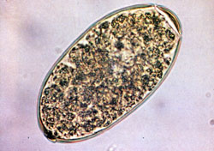
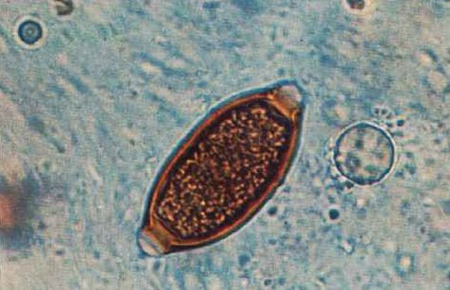
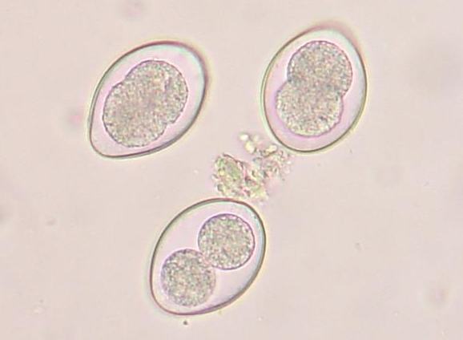
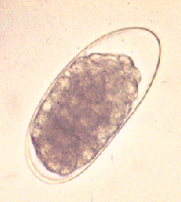
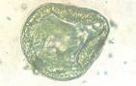
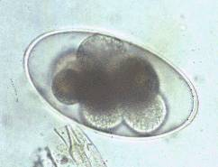
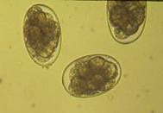
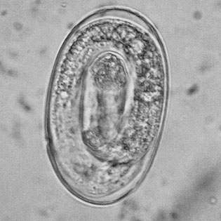
Egg Identification Sheet
The images on this page were sourced from:
1. www.stanford.edu/class/humbio103/ParaSites2005/Trichostrongyliasis/agent.htm
2. www.sheepandgoat.com/HairSheepWorkshop/parasitism.html
3. commons.wikimedia.org/wiki/Image:Coccidia.JPG
4. www.medata-systems.co.uk
5. w3.ufsm.br/parasitologia/arquivospagina/ovosdebovinos.htm
6. www.stanford.edu/class/humbio103/ParaSites2005/Trichostrongyliasis/agent.htm
7. cal.vet.upenn.edu/projects/parasit06/website/lab6.htm
8. www.medicalvetonline.com.br/atlas.php
7. Fasciola (Liver Fluke)
5. Trichuris (Whipworm)
3. Coccidia
1. Trichostrongylus (Black scour worm)

4. Moniezia (Tapeworm)
6. Nematodirus (Thin necked Intestinal worm)
2. Haemonchus (Barbers Pole worm)

9. Dictyocaulus (Lungworm)

- Use the results from the calculation in question 4 to enter into “Ask the Boss” on WormBoss.
- Record the key points from the WormBoss report below.

Name/property:

Exercise 3 work sheet
Name/Property:

- Using the information provided below complete the calculations for a FECRT.
  - Control group = 500 epg
  - Drench 1 = 10 epg
  - Drench 2 = 25 epg
  - Drench 3 = 100 epg

% efficacy = (control – treatment) / control x 100

Drench 1: % efficacy =

Workings:

Drench 2: % efficacy =

Workings:

Drench 3: % efficacy =

Workings:

