Project 1 – Queensland

Summary of the Project

Let science teachers improve their knowledge, enthusiasm and understanding of the high-level science underpinning the Australian wool industry. Use real life demonstrations, experiments and workshops presented by experts in the field. Equip teachers with raw data, information and hands on field and laboratory experiences to stimulate development of curriculum resources based on contexts explored during the workshops. A ‘train the trainer’ approach where participants are encouraged to further the education of peers and students through development of local and regional professional development sessions.
Produce usable and fully resourced teaching, learning or assessment tasks for use in Queensland senior science and mathematics subjects.

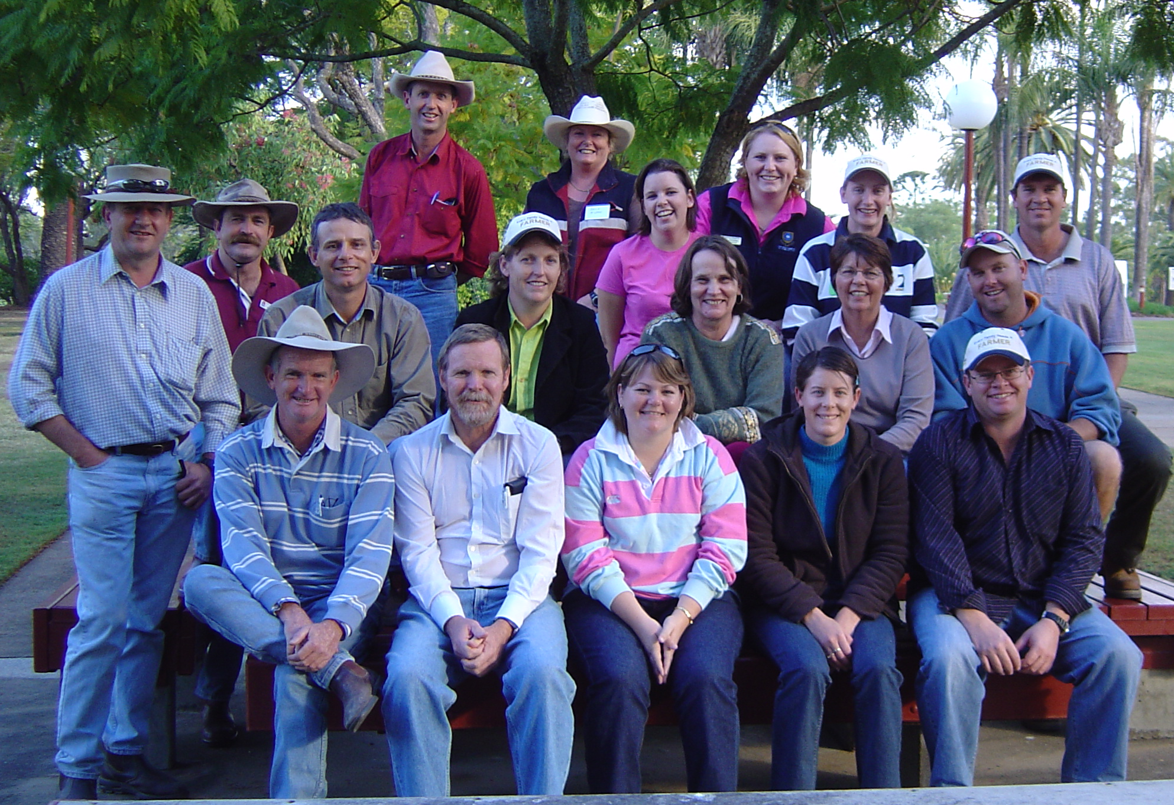

Contact
Erica McLearn
mcler@somerville.qld.edu.au

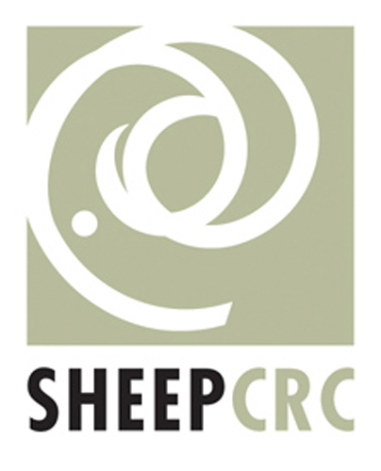 |  | 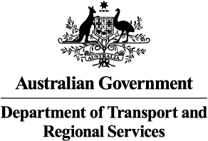 |  | 

