‘The Science Behind Wool’

Workshop

Friday 26th May  Session 1  Participating in a class lesson with Senior Lecturer in SHEEP SCIENCE  - Sheep nutrition and handling  - Ethical issues  - Breeds for meat or wool  - Yard design  - Management for prime productivity | 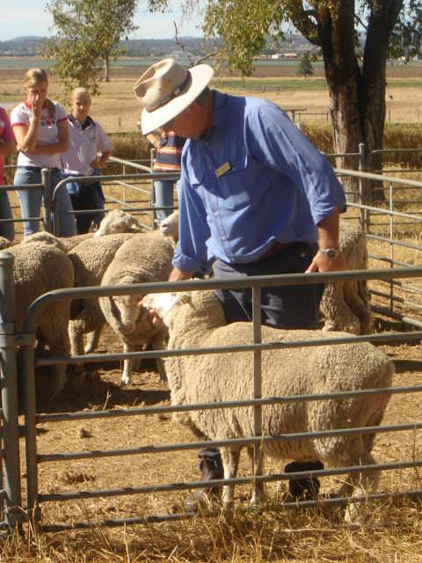
Session 2  Working sheep and shearing  - The use of different sheepdogs  - Natural predator prey behavior with sheep, dogs and humans  - Shearing  - Fleece trimming  - Worming | 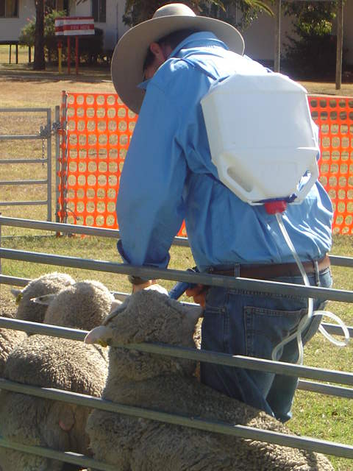
Session 3  An overview of the wool industry  - Wool types  - Staple length, micron, colour  - Factors affecting wool growth  - Breeds and wool type  - Chemical and physical features of wool  - Manufacturing process | 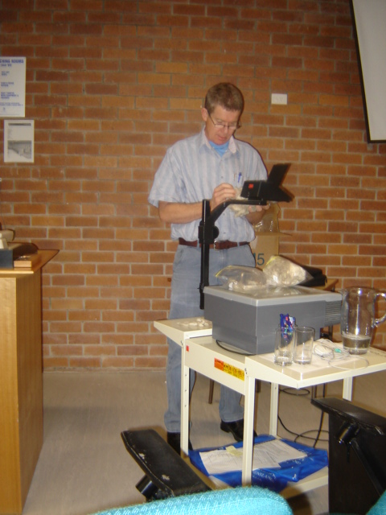
Saturday 5th May  Session 4  Pasture management  - Grass types  - Nutrition  - Supplementary feeding  - Improved pastures  - Affect of grass type on wool clip quality  - Demographics of sheep types and numbers | 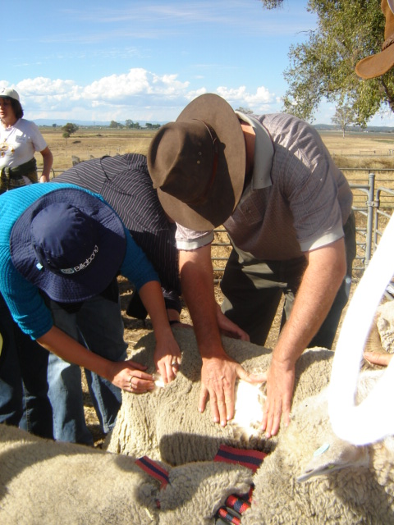
Session 5  Sheep and Parasitology  - Sheep anatomy internal and external  - Hands on sheep  - Sheep parasites  - Worm counts  - Worm breeding techniques  - Laboratory safety | 