Project 2 – New South Wales (Wagga Wagga)

Participants
The Seven High Schools in Wagga Wagga

Summary of the project

This was a competition, also run by colleagues at Taree TAFE. A booklet and CD were provided, aimed at stage 5, year 10 students and aligned with syllabus outcomes. We focussed on an important aspect of the sheep industry, Artificial Insemination, and outlined a research scenario where students were asked to establish whether a sperm additive, “Go Sperm”, actually enhanced the longevity and motility of sperm in vitro. Students were asked to define terms, construct a hypothesis, count live and dead sperm from images, fill in missing data, draw graphs and draw conclusions. The CD contained a copy of the competition plus additional information including details of careers in Agriculture. Microscope slides of sheep sperm were also provided as a class resource with a practical exercise to follow. Teachers said they will adopt the competition as an ongoing class exercise. Thirty three students participated, which was encouraging considering the short time frame and other competing school activities. Questionnaires indicated that the competition increased awareness of the High Tech. aspects of the Sheep Industry with some students keen to know more.

Contact
John Harper
jharper@csu.edu.au

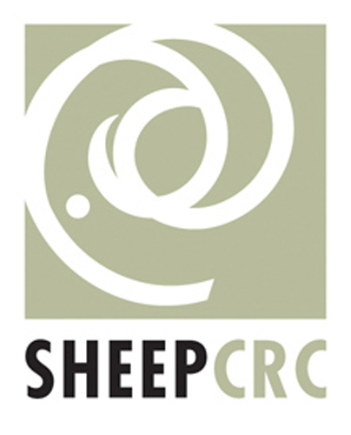 |  | 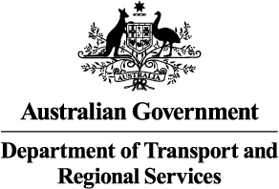 |  | 

