Teacher and Student Activities

SAS – SHEEP AND SCIENCE

Stage 5 Year 10 Science

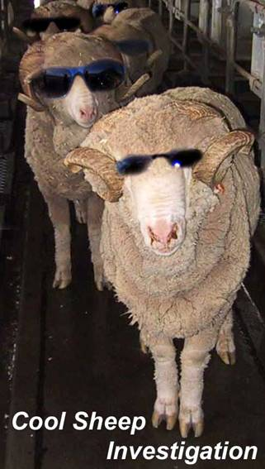

Contact  Dr John Harper  Senior Lecturer  Locked Bag 588  Charles Sturt University  School of Agricultural and Veterinary Sciences  Wagga Wagga, NSW 2678  Phone: 6933-2837  Email: jharper@csu.edu.au | Date Due: Friday 9th June 2006  Participants will be notified of results two weeks after the due date through their Head teacher.
Background

Thank you for the interest you have shown in the ‘Cool Sheep Investigation’ competition for Schools. The competition is part of a pilot program of activities currently being trialled across Australia funded by the Sheep CRC through the University of Tasmania’s School Industry Links Project. Resources are also being provided by the EH Graham Centre for Agricultural Innovation and The School of Agricultural and Veterinary Sciences, Charles Sturt University. The purpose of the project is to raise awareness of the importance of science and technology in Australian agriculture, particularly the sheep industry and to raise the profile of careers in that industry.

There are seven High Schools in the Wagga Wagga district taking part in this competition based on aspects of the Stage 5 Science syllabus that deal with scientific method, applications of science and reproduction.

Your school will receive a set of resources for use in the classroom. The set contains:
- • A class set of prepared ram sperm slides stained with a vital dye that can be used in reproductive studies. Practical exercises aligned with syllabus outcomes will be provided at a later date.
- • A competition based on research in the sheep industry. Information is provided in this document and on CD.
- • The CD will also contain information on careers in key areas of primary industry.

The competition will be judged by Professor Peter Chenoweth, a Veterinarian Reproductive Physiology expert from Charles Sturt University’s School of Agricultural and Veterinary Sciences.

Students can work individually or in groups of two.

Prizes
- ⇒ First prize $300 to student/s & $300 to the School to be used towards resources
- ⇒ Second prize $200 to student/s & $200 to the School to be used towards resources
- ⇒ Third prize $100 to student/s & $100 to the School to be used towards resources
- ⇒ Lucky Door Prize $50 to one person from a draw of entries from anyone who has a fair go at the competition

Check List for Teachers
- Please make sure students have attempted all of the questions as they will be penalised for questions that are left blank.
- Please make sure students have written their name, and school name, on every sheet of paper they hand in.
- Please make sure students write their answers in pen in the spaces provided. No additional pages will be accepted.
- Please leave all entries with the front desk office staff. A CSU staff member will be collecting all entries on Friday 9th June.

STAGE 5 SYLLABUS OUTCOMES ASSESSED IN THIS TASK

Prescribed Focus Area
Outcome 5.3: A student evaluates the impact of applications of science on society and the environment
Student learns to:
- discuss using examples, the positive and negative impacts of the applications of recent developments in science
- identify and describe examples where technological advances have impacted on science
- give reasons why society should support scientific research

Skills
Outcome 5.16: A student accesses information from a wide variety of secondary sources
Student learns to
- use a range of sources, including databases, CD-ROMs and the internet, to access information
- extract information from visual resources
- summarise information from identified oral and written secondary sources

Outcome 5.17: A student explains trends, patterns and relationships in data and/or information from a variety of sources
Students learn to:
- organise data using a variety of methods including diagrams, tables, spreadsheets and databases

Outcome 5.19: A student uses critical thinking skills in evaluating information and drawing conclusions
Students learn to
- justify inferences in the light of gathered information
- identify data which supports or discounts an hypothesis, a question being investigated or a proposed solution to a problem
- predict outcomes and generate plausible explanations directly related to observations made

Outcome 5.20: A student selects and uses appropriate strategies to solve problems
Students learn to
- identify the nature of a presented problem
- describe different strategies that could be employed to solve an identified problem
CRITERIA FOR ASSESSING THIS TASK: WHAT WILL ATTRACT MARKS

- Demonstrate research skills
- Demonstrates the application of science through an understanding of artificial insemination and its use in breeding programs
- Demonstrate an extensive knowledge of the process and techniques involved in experimentation
- Represent data clearly and accurately
- Communicate succinctly using their own words
- Use precise biological terms extensively and correctly in a wide range of contexts
INSTRUCTIONS FOR STUDENTS
- Please make sure your name(s) and school are written on the top of EVERY sheet of paper you hand in.
- Answer all question in the spaces provided. Do not use additional paper.
- Fill in the missing data in Tables 1 & 2 using the images and information provided.
- Draw graphs of your data with appropriate titles.
- Provide definitions of the bold terms using your own words.
- Complete the questionnaire.

COOL SHEEP INVESTIGATION
Introduction
TASK 1
In the space provided write a paragraph in your own words about the Australian Sheep industry and its importance to the Australian economy.
________________________________________________________________
________________________________________________________________
TASK 2:
In the space provided write a paragraph in your own words about Artificial insemination (AI) and its importance in sheep breeding programs.
________________________________________________________________
________________________________________________________________
The Investigation
Sperm carry the male half of the genetic information (DNA) needed to make a new sheep. The other half resides in the Ewe’s egg or ovum. In a normal mating sperm need to swim a long way through the female reproductive tract until they find the female ovum. Although billions of sperm are produced by the ram only a few will reach the ovum and only one will fuse with each ovum resulting in fertilisation and the development of an embryo to produce a lamb.
Sheep AI programs in Australia are now using a technique called Intrauterine Laparoscopic AI to insert sperm from genetically prized rams as close as possible to the place in the ewes where the ovum is produced. The sperm is stored frozen in liquid nitrogen and then thawed for AI. These sperm can run out of energy before they reach the ovum. Therefore compounds, such as growth hormones, that can prolong the life and motility of the sperm are much sought after in AI because they further increase the chances of fertilisation.
In the Cool Sheep Investigation a company called Genewe has produced a recombinant sheep growth hormone they call Go-Sperm, which they claim will prolong the life of sperm and keep more swimming for longer so that the chances of fertilisation are increased.

TASK 3:
Provide a hypothesis based on what you have read so far.
________________________________________________________________
_____________________________________________________________________________
The Experiments and Your Role
You have joined a laboratory that is testing Genewe’s Go-sperm in vitro.
Two experiments have been completed as described in the Materials and Methods, Experiment 1 and Experiment 2, below.
Materials and Methods
Fresh samples of high quality ram sperm were collected using an artificial vagina (AV) whilst rams attempted to mount a receptive Ewe.
Semen was diluted in a suitable medium to simulate the dilution factor likely to be encountered if they had entered the ewe’s reproductive tract.
Samples were split for ‘control’ and ‘Go-Sperm’ treatments and incubated at 30 C for the duration of the experiment.
Samples were taken at the times indicated and tested for viability (Table 1), by staining with Eosin-Nigrosin or progressive motility (Table 2) by analysis with a CASA(Table3).
Experiment 1:
The first has used a vital dye called Eosin-Nigrosin to compare Ram sperm survival in a test-tube kept at 30°C, with and without Go-Sperm added. The dye crosses the sperm head membrane of dead sperm and stains them purple when viewed under white light microscopy (Bright field). Living sperm do not take up the stain and appear blue-grey under the light microscope (see CSI PowerPoint on the CD provided or look at the hard copy images provided).
The dye also fluoresces when exposed to UV light and viewed with a fluorescence microscope. Under UV the sperm heads of living cells does not stain but the dead-heads label bright red or golden and can be easily counted in sperm samples taken, stained then spread on a slide for examination.
TASK 4:
The person you have been assisting with the sperm counts and data analysis has called in sick and it is left up to you to finish the counting and analysis of the data.
The 24 hour time point in the sperm survival experiment (Table 1) has not been filled in and it is up to you to assess living and dead sperm in the images provided, fill in the table and draw the graph.
So you need to identify the missing data within Table 1.
Experiment 2:
The second experiment is also missing one piece of data (Table 2). You will need to determine this missing information from the readout provided below in Table 3 or from the movie on the CD (Called CASA_24h).
This experiment used the same sperm as in Experiment 1 but did not stain them and looked at living sperm to determine what percentage of sperm were progressively motile. That is, what percentage were moving in a way that indicated they would be likely to move towards, and eventually fuse with, an ovum?
Some sperm move, but in a non-progressive way; in circles for instance. A special machine, called a CASA (Computer Assisted Sperm Analyser) was used to determine progressive motility. You can use the example of motile sperm being analysed with a CASA as shown on the CD or the readout provided below to determine what percentage of sperm were progressively motile at 24h in the Go-Sperm treatment.
TASK 5:
As in the previous task, you need to identify the missing data within Table
RESULTS
As described above, data for the spaces left blank in the tables below can be found on the CD and in the images of sperm provided below.
Table 1: Sperm in vitro survival over time
 | 0 hrs | 4 hrs | 24 hrs | 36 hrs
Control  (Percentage survival) | 95% | 87% |  | 40%
‘Go-Sperm’  (Percentage survival) | 95% | 90% |  | 45%
Table 2: Sperm in vitro progressive motility over time
 | 0 hrs | 4 hrs | 24 hrs | 36 hrs
Control  (% Progressive motility) | 79% | 60% | 43% | 33%
‘Go-Sperm’  (% Progressive motility) | 79% | 73% |  | 40%

Table 3: CASA Readout: Count Summary

Category | Cells Counted | Concentration  (M/mL) | Percent
Total | 217 | 2358 | 100
Motile | 186 | 2022 | 86
Progressive | 108 | 1174 | 50

GRAPHS
Draw graphs of the data from Tables 1 & 2 with appropriate titles
Title:____________________________________________________________

Title:__________________________________________________________________
What can you conclude from each of the graphs?
________________________________________________________________
________________________________________________________________
________________________________________________________________
Would you recommend Go-Sperm as an additive to prolong sperm longevity and modality for AI? Justify your answer:
________________________________________________________________
________________________________________________________________
________________________________________________________________

TASK 6:
In your own words, provide definitions for the following that have been bolded in the sections above.
1. Artificial insemination
________________________________________________________________
2. Artificial vagina
________________________________________________________________
3. Billions
________________________________________________________________
4. Cervix
________________________________________________________________
5. DNA
________________________________________________________________
6. Egg
________________________________________________________________
7. Embryo
________________________________________________________________
8. Eosin-Nigrosin
________________________________________________________________
9. Fertilisation
________________________________________________________________
10. Fluoresces
________________________________________________________________
11. Fluorescence microscope
________________________________________________________________
12. Growth hormones
________________________________________________________________
13. Hypothesis
________________________________________________________________

14. Laproscopic AI
________________________________________________________________
15. in vitro
________________________________________________________________
16. Membrane
________________________________________________________________
16. Natural Mating
________________________________________________________________
18. Ovum
________________________________________________________________
19. Recombinant
________________________________________________________________
20. Reproductive tract
________________________________________________________________
21. Sires
________________________________________________________________
22. Sperm
________________________________________________________________
23. Viability
________________________________________________________________
24. Vital Dye ________________________________________________________________

Sheep and Science Competition – Questionnaire

Please fill out this questionnaire either individually or as a team and return it to your teacher.

- What did you enjoy most about the activity?
________________________________________________________________
- What did you enjoy least about the activity?
________________________________________________________________
- What did you learn about the sheep industry (list the top three)?
________________________________________________________________
- What science skills do you now have that you didn’t have before?
________________________________________________________________
- What was the best thing that you learned about AI in sheep and what makes it the best?
________________________________________________________________

Note: In the sperm images, of the control and GoSperm treatments, dead sperm heads stain red or golden. Living sperm are dull with a line of yellow stain at the tip of the sperm head. All sperm, living and dead stain yellow along the first half of the sperm tail.
Control 24 h
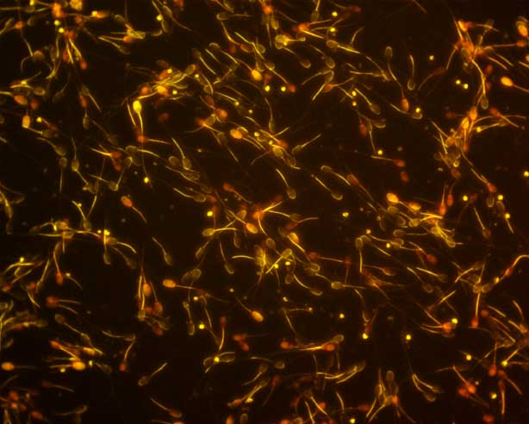

Go-Sperm treatment 24 h
