Note: In the sperm images, of the control and GoSperm treatments, dead sperm heads stain red or golden. Living sperm are dull with a line of yellow stain at the tip of the sperm head. All sperm, living and dead stain yellow along the first half of the sperm tail.
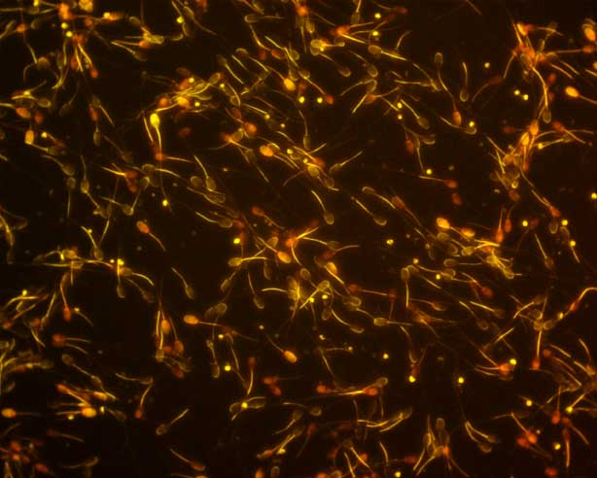
Control treatment 24 h
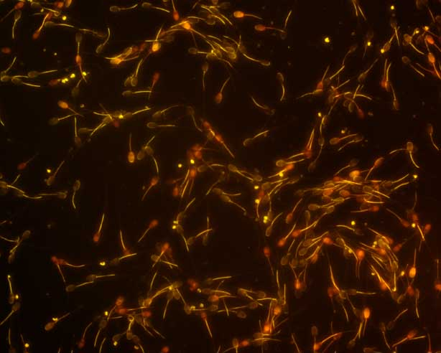
Go-Sperm treatment 24 h

