Project 3 – New South Wales (Taree)

Participants
Gloucester High School, Manning Valley Anglican College,
St Clare’s High School, Wingham High School

Summary of the project

During Term 2, 2006 five Year 10 teams from four high schools in the Manning Valley participated in the Sheep and Science competition. Run in conjunction with Charles Sturt University the competition introduced the students to the importance of the sheep industry to Australia, the use of artificial insemination in sheep breeding programs and career prospects in agricultural science. In this coastal location many of the students have no association with the sheep industry and they were fascinated by the use of technology to improve flocks.

The competition had both research and practical components. A hypothetical research scenario was posed where students were required to measure and compare the survival rates of sperm with and without the additive ‘Go-sperm’. The students used coloured micrographs, supplied by Charles Sturt University, to count, calculate, graph and analyse sperm survival. The competition was judged by the District Veterinarian from the Gloucester Rural Lands Protection Board who was impressed by the quality of the entries.

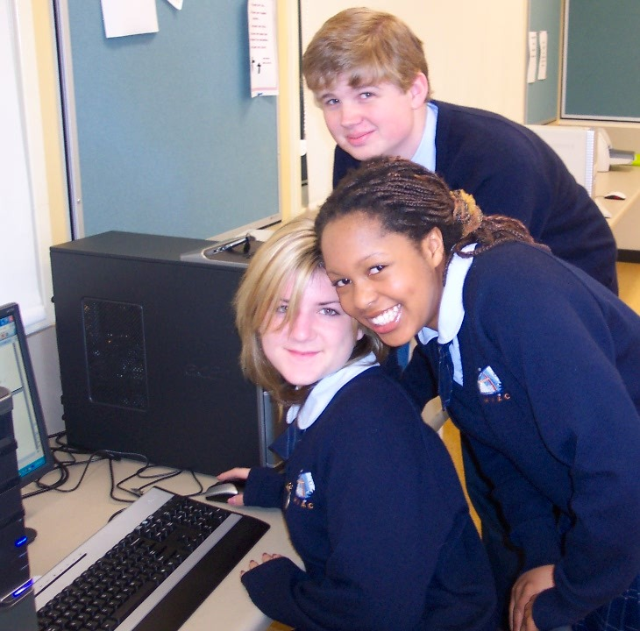

Contacts
Kim Billingham
kim.billingham@tafensw.edu.au
Peter Ruprecht
peter.ruprecht@tafensw.edu.au

 |  |  |  | 

