Teacher and Student Activities

SAS – SHEEP AND SCIENCE

A Science Competition for Schools

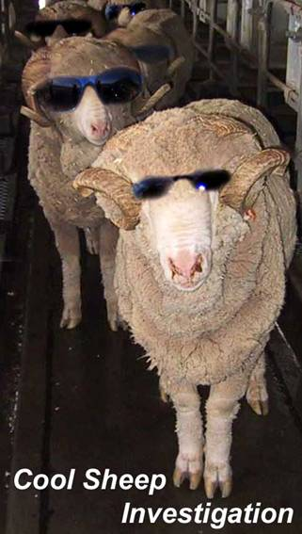

Hosted by  TAFE NSW – North Coast Institute  Taree Campus | In partnership with  Local Manning District Schools  Charles Sturt University  University of Tasmania  Sheep Industry CRC
ENTRY DETAILS
SCHOOL DETAILS | Name
SCHOOL DETAILS | Address
SCHOOL DETAILS | Phone
SCHOOL DETAILS | Fax
SCHOOL DETAILS | Email
SUPERVISING TEACHER | Name
SUPERVISING TEACHER | Phone
SUPERVISING TEACHER | Email
YEAR 10 TEAM | Names

Check List for Teachers

ٱ Please ensure that students have completed all of the questions.
ٱ Please ensure that students have written their school name on every sheet of paper they hand in.
ٱ Please ask students to write their answers in pen in the spaces provided. Additional pages should be clearly marked with the school name and page and question number.
ٱ Please post entries to the address below to arrive at Taree Campus of TAFE no later than Friday 16 June 2006.

Contact Details  Kim Billingham and Peter Ruprecht  Agriculture Section  North Coast Institute of TAFE, NSW  Taree Campus  PO Box 669  Taree NSW 2430  Ph: 02 65926053  Mobile 0408 685654  Email: Kim.Billingham@tafensw.edu.au  Email: Peter.Ruprecht@tafensw.edu.au | Date Due: Friday 16 June 2006  Participants will be notified of the results within two weeks of the due date through their Head Teacher.

STAGE 5 SYLLABUS OUTCOMES ASSESSED IN THIS TASK

Prescribed Focus Area

Outcome 5.3: A student evaluates the impact of applications of science on society and the environment

Student learns to:
- discuss using examples, the positive and negative impacts of the applications of recent developments in science
- identify and describe examples where technological advances have impacted on science
- give reasons why society should support scientific research

Skills

Outcome 5.16: A student accesses information from a wide variety of secondary sources

Student learns to
- use a range of sources, including databases, CD-ROMs and the internet, to access information
- extract information from visual resources
- summarise information from identified oral and written secondary sources

Outcome 5.17: A student explains trends, patterns and relationships in data and/or information from a variety of sources

Students learn to:
- organise data using a variety of methods including diagrams, tables, spreadsheets and databases

Outcome 5.19: A student uses critical thinking skills in evaluating information and drawing conclusions

Students learn to
- justify inferences in the light of gathered information
- identify data which supports or discounts an hypothesis, a question being investigated or a proposed solution to a problem
- predict outcomes and generate plausible explanations directly related to observations made

Outcome 5.20: A student selects and uses appropriate strategies to solve problems

Students learn to
- identify the nature of a presented problem
- describe different strategies that could be employed to solve an identified problem

CRITERIA FOR ASSESSING THIS TASK: WHAT WILL ATTRACT MARKS

- Demonstrate research skills
- Demonstrates the application of science through an understanding of artificial insemination and its use in breeding programs
- Demonstrate an extensive knowledge of the process and techniques involved in experimentation
- Represent data clearly and accurately
- Communicate succinctly using their own words
- Use precise biological terms extensively and correctly in a wide range of contexts

INFORMATION AND INSTRUCTIONS FOR STUDENTS

Thank you for taking part in the ‘Sheep and Science’ Competition for Schools. The competition is part of a pilot program of activities currently being trialed across Australia funded by the Sheep Industry CRC (Cooperative Research Centre) through the University of Tasmania’s School Industry Links Project. The purpose of the project is to raise awareness of the importance of science and technology in Australian agriculture, particularly the sheep industry and to raise the profile of careers in that industry.

In New South Wales Year 10 students in the Manning and Wagga districts are taking part in a competition based on aspects of the Stage 5 Science syllabus that deal with scientific method, applications of science and reproduction. Two separate competitions are being run, in the Manning hosted by North Coast Institute of TAFE, Taree Campus and in Wagga hosted by Charles Sturt University.

The Manning competition will commence on Monday 29 May, 2006. Completed entries are to be posted to North Coast Institute of TAFE, Taree Campus by Friday 16 June, 2006. Your Head Teacher of Science will be notified of the results within two weeks of the due date.

The competition will be judged by the district veterinarian from the Rural Lands Protection Board. Prizes will be presented to the Science Departments of the winning schools as follows:
- First Place - $400
- Second Place - $200
- Third Place - $100
Each member of the winning team will receive a CD voucher. All participating schools will also receive a set of resources for use in the classroom.

The team of four Year 10 students from each school will complete components of a scientific report based on a sperm motility experiment and a small research section on the use of technology in sheep reproduction. A tutorial will be provided for the competing teams at Taree Campus of TAFE, K Block on Monday 29 May (4pm to 6pm). Afternoon tea will be provided.

Students and their supervising teacher will also be asked to complete a questionnaire on their awareness of science-based career opportunities in the sheep industry.

  - To complete this competition you will need the CSI CD, laminated micrograph and access to the internet.
  - Please make sure that the name of your school is written on the top of EVERY sheet of paper you hand in.
  - Answer all questions in pen in the spaces provided. If you need extra space make sure that any additional pages are clearly marked with the school name and the page and question number.
  - Research and answer questions 1 to 4.
  - Fill in the missing data in Table 1 using the images and information provided.
5. Draw the graph from your data with an appropriate title and make conclusions.
6. Answer the questions relating to the hypothesis
7. Provide definitions for the glossary in your own words.
5. Provide definitions of the bold terms using your own words

Cool Sheep Investigation

Introduction

- Answer the following questions about the Australian Sheep Industry. Use figures from 2004/2005.
- Which is the world’s largest producer of wool?
________________________________________________________________________
- How many sheep are there in Australia?
________________________________________________________________________
- What is the most common breed of sheep in the Australian flock?
________________________________________________________________________
- How much greasy wool does Australia produce each year?
________________________________________________________________________
- What is the annual value of Australian wool exports?
________________________________________________________________________

- Summarise the importance of the Australian Sheep Industry to the development of our country’s economy.

______________________________________________________________________________
Reproduction and Artificial Insemination

Sperm carry the male half of the genetic information (DNA) needed to make a new mammal. The other half resides in the female’s egg or ovum. In a normal mating, sperm need to swim a long way through the female reproductive tract until they find the female ovum. Although billions of sperm are produced by the male only a few will reach the ovum and only one will fuse with each ovum resulting in fertilisation and the development of an embryo to produce a newborn.

Artificial insemination (AI) is used in many livestock industries as an alternative to natural mating. The first historical record of AI dates from the Middle Ages. Artificial insemination as we know it today was developed in the early 1900’s. By the 1930’s mass breeding of cows using AI was taking place.

- Briefly describe the process of artificial insemination.

______________________________________________________________________________________Explain the importance of Artificial Insemination to livestock breeding programs.

______________________________________________________________________________________
Artificial insemination through the cervix, although very successful in cattle, proved to be more difficult in sheep. The cervix of the sheep is very corrugated making it difficult for the inseminator to place the semen accurately. Laproscopic AI was discovered in the early 1980’s and is now routinely used in sheep AI programs in Australia. Sperm from genetically prized rams is placed directly in the uterus as close as possible to the place in the ewes where the ovum is produced.

Sperm that is collected from donor sires is stored frozen in liquid nitrogen to maximise its use over a long period of time and great distances. It is thawed when needed for the AI process. These sperm can run out of energy before they reach the ovum. Therefore compounds, such as growth hormones, that can prolong the life and motility of the sperm are much sought after in AI because they further increase the chances of fertilisation.

The Investigation
In the Cool Sheep Investigation a company called Genewe has produced a recombinant sheep growth hormone they call Go-Sperm. They claim Go-sperm will prolong the life of sperm and keep more swimming for longer so that the chances of fertilisation are increased.

Your team has joined a laboratory that is testing Genewe’s Go-sperm in vitro.

Materials and Methods
Fresh samples of high quality ram sperm were collected using an artificial vagina (AV) whilst rams attempted to mount a receptive ewe. Semen was diluted in a suitable medium to simulate the dilution factor likely to be encountered if they had entered the ewe’s reproductive tract. Samples were split for ‘control’ and ‘Go-Sperm’ treatments and incubated at 30°C for the duration of the experiment. Samples were taken at the times indicated and tested for sperm viability.

A vital dye called Eosin-Nigrosin was used to compare ram sperm survival in a test-tube kept at 30°C, with and without Go-Sperm added. The dye crosses the sperm head membrane of dead sperm and stains them purple when viewed under white light microscopy (Bright field). Living sperm do not take up the stain and appear blue-grey under the light microscope. The dye also fluoresces when exposed to UV light and viewed with a fluorescence microscope. Under UV the sperm heads of living cells do not stain but the dead-heads label bright red or golden and can be easily counted in sperm samples that are taken, stained and then spread on a slide for examination.

Your Task
The person you have been assisting with the sperm counts and data analysis has called in sick and it is left up to you to finish the counting and analysis of the data. Use the Power point on the CD that has been provided to learn how to count living and dead sperm.

The 24 hour time point in the sperm survival experiment (Table 1) has not been filled in and it is up to you to assess living and dead sperm in the images provided. Fill in the table and draw the graph. Give the graph an appropriate title.

Results

Table 1: Sperm in vitro survival over time

Time | 0h | 4h | 24h | 36h
Control  (Percentage survival) | 95% | 87% |  | 40%
‘Go-Sperm’  (Percentage survival) | 95% | 90% |  | 45%

Graph 1

Title: ____________

What can you conclude from this graph?
______________________________________________________________________________________
When you start to write the report for this experiment you find that the colleague who called in sick never wrote a hypothesis before he started. This is not good scientific method but you will need to develop a hypothesis for the experiment based on the information you now have. Write it in the space below.

______________________________________________________________________________________

Why is writing the hypothesis at the end of the experiment poor scientific practice?

______________________________________________________________________________________

Just for Interest

To be viable, sperm need not only to be alive but must also be progressively motile. That means, they are moving in a way that indicates they would be more likely to move towards, and eventually fuse with, an ovum. Some sperm move in a non-progressive way – in circles for instance. A special machine, called a CASA (Computer Assisted Sperm Analyser) is used to determine progressive motility. An example of the CASA system is shown on the accompanying CD.

Glossary of terms

This glossary contains scientific terms from the above pages. Write a definition for each term, in your own words.

1. Artificial insemination
______________________________________________________________________________
2. Artificial vagina
______________________________________________________________________________3. Billions
______________________________________________________________________________4. Cervix
______________________________________________________________________________5. DNA
______________________________________________________________________________6. Egg
______________________________________________________________________________7. Embryo
______________________________________________________________________________8. Eosin-Nigrosin
______________________________________________________________________________9. Fertilisation
______________________________________________________________________________10. Fluoresces
______________________________________________________________________________11. Fluorescence microscope
______________________________________________________________________________12. Growth hormones
______________________________________________________________________________13. Hypothesis
______________________________________________________________________________14. Laproscopic AI
______________________________________________________________________________15. in vitro
______________________________________________________________________________16. Membrane
______________________________________________________________________________
- Natural mating
______________________________________________________________________________18. Ovum
______________________________________________________________________________19. Recombinant
______________________________________________________________________________20. Reproductive tract
______________________________________________________________________________21. Sires
______________________________________________________________________________22. Sperm
______________________________________________________________________________23. Viability
______________________________________________________________________________24. Vital Dye ______________________________________________________________________________

Note: In the sperm images, of the control and GoSperm treatments, dead sperm heads stain red or golden. Living sperm are dull with a line of yellow stain at the tip of the sperm head. All sperm, living and dead stain yellow along the first half of the sperm tail.

Control 24 h
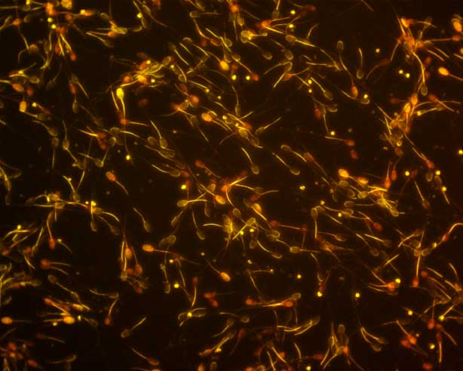

Go-Sperm treatment 24 h
