Project 4 – Victoria (Kyneton)

Participants
Kyneton Secondary College

Summary of the project

Teachers collaborated to develop a three week unit that incorporated VELS (Victorian Essential Learnings) and provided a novel approach to learning using Gardener’s Multiple Intelligences and PoLT (Principles of Learning and Teaching). The project included team teaching, excursions, guest speakers, practical investigations and games. Some of the activities undertaken by students were the investigation of the economics of the wool industry, examination of the properties of wool and comparison with other materials and design and creation of a woollen product. The unit was launched with a Quiz and at the conclusion students celebrated their achievement by cooking a lamb lunch with sheep marshmallows for dessert. Student assessment was based on a visual diary that was a record of all work undertaken, the design and creation of a woollen product and an oral presentation of one aspect of the unit. This employed self and peer assessment as well as teachers working together to assess some work.

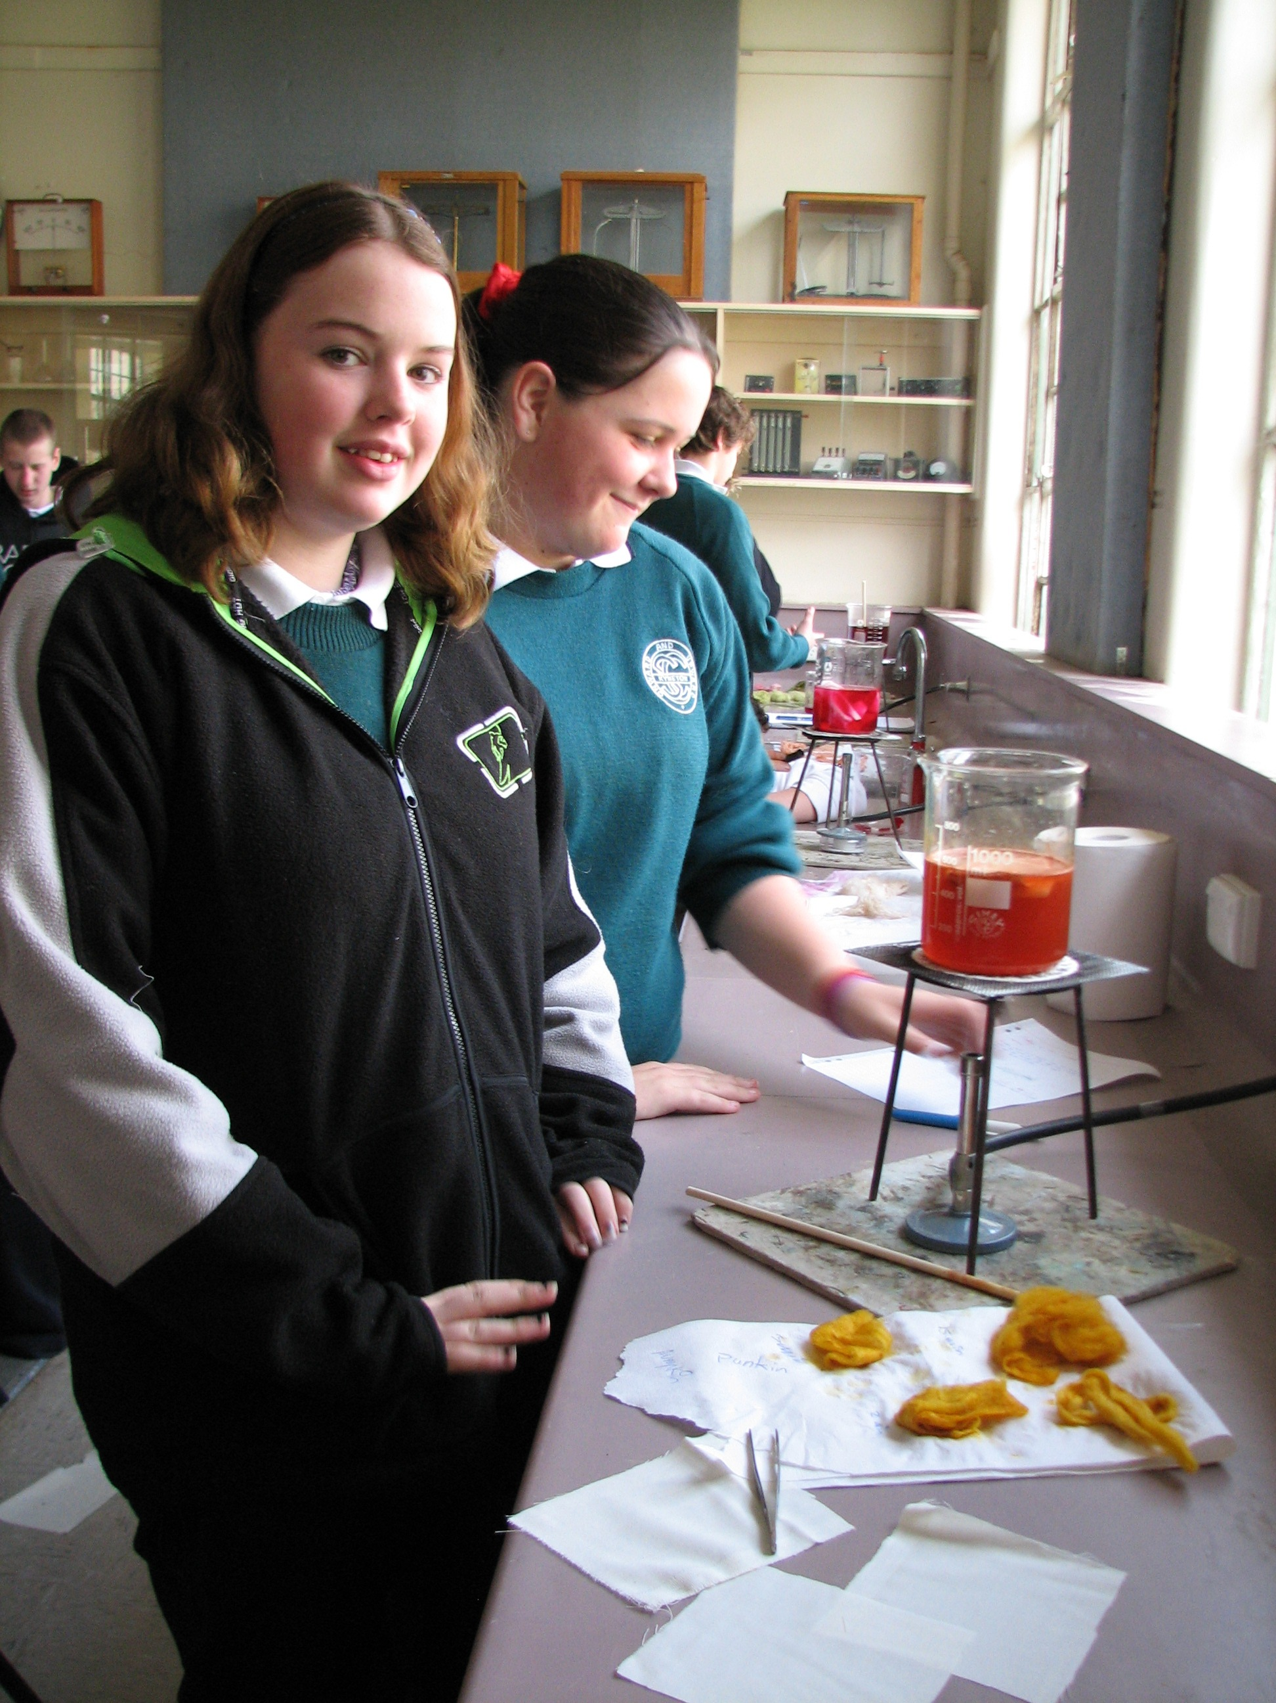

Contact
Cate Burton
cburton@kynsec.vic.edu.au

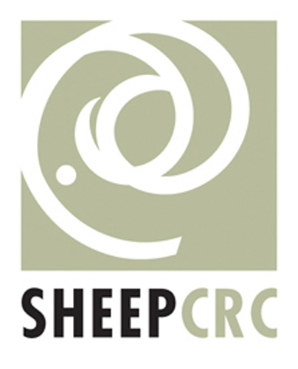 |  | 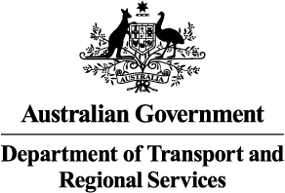 |  | 