Project 5 – Victoria (Warrambeen)

Participants
LandLearn, Elisabeth Murdoch College, Padua College, Woodleigh College

Summary of the project

As part of the Sheepy Science project in Victoria students attended a successful two day sheep science camp. Students stayed on a commercial farm ‘Warrambeen’ where they were up close with common sheep husbandry practices such as drenching, inoculation and shearing and discovered the science behind these practices. A visit to the National Wool Museum at Geelong was a highlight of the camp as students were given the opportunity to research various aspects of the wool industry including the history of wool in Australia, changes in technology over time and the science of wool. Students also visited the DPI research farm at Werribee where they observed real life, practical examples of sheep-related research and learnt about careers in the associated industries. Other activities on the camp included student participation in a wool processing activity as if they were real farmers ‘Fabric to Yarn’, and conducting faecal egg counts.

As a result of the project, sheep industry fieldwork now exists for schools in Victoria. In addition teachers can access a sheep industry resource list and teaching resources produced during the project (including the ‘Fabric to Yarn’ activity).

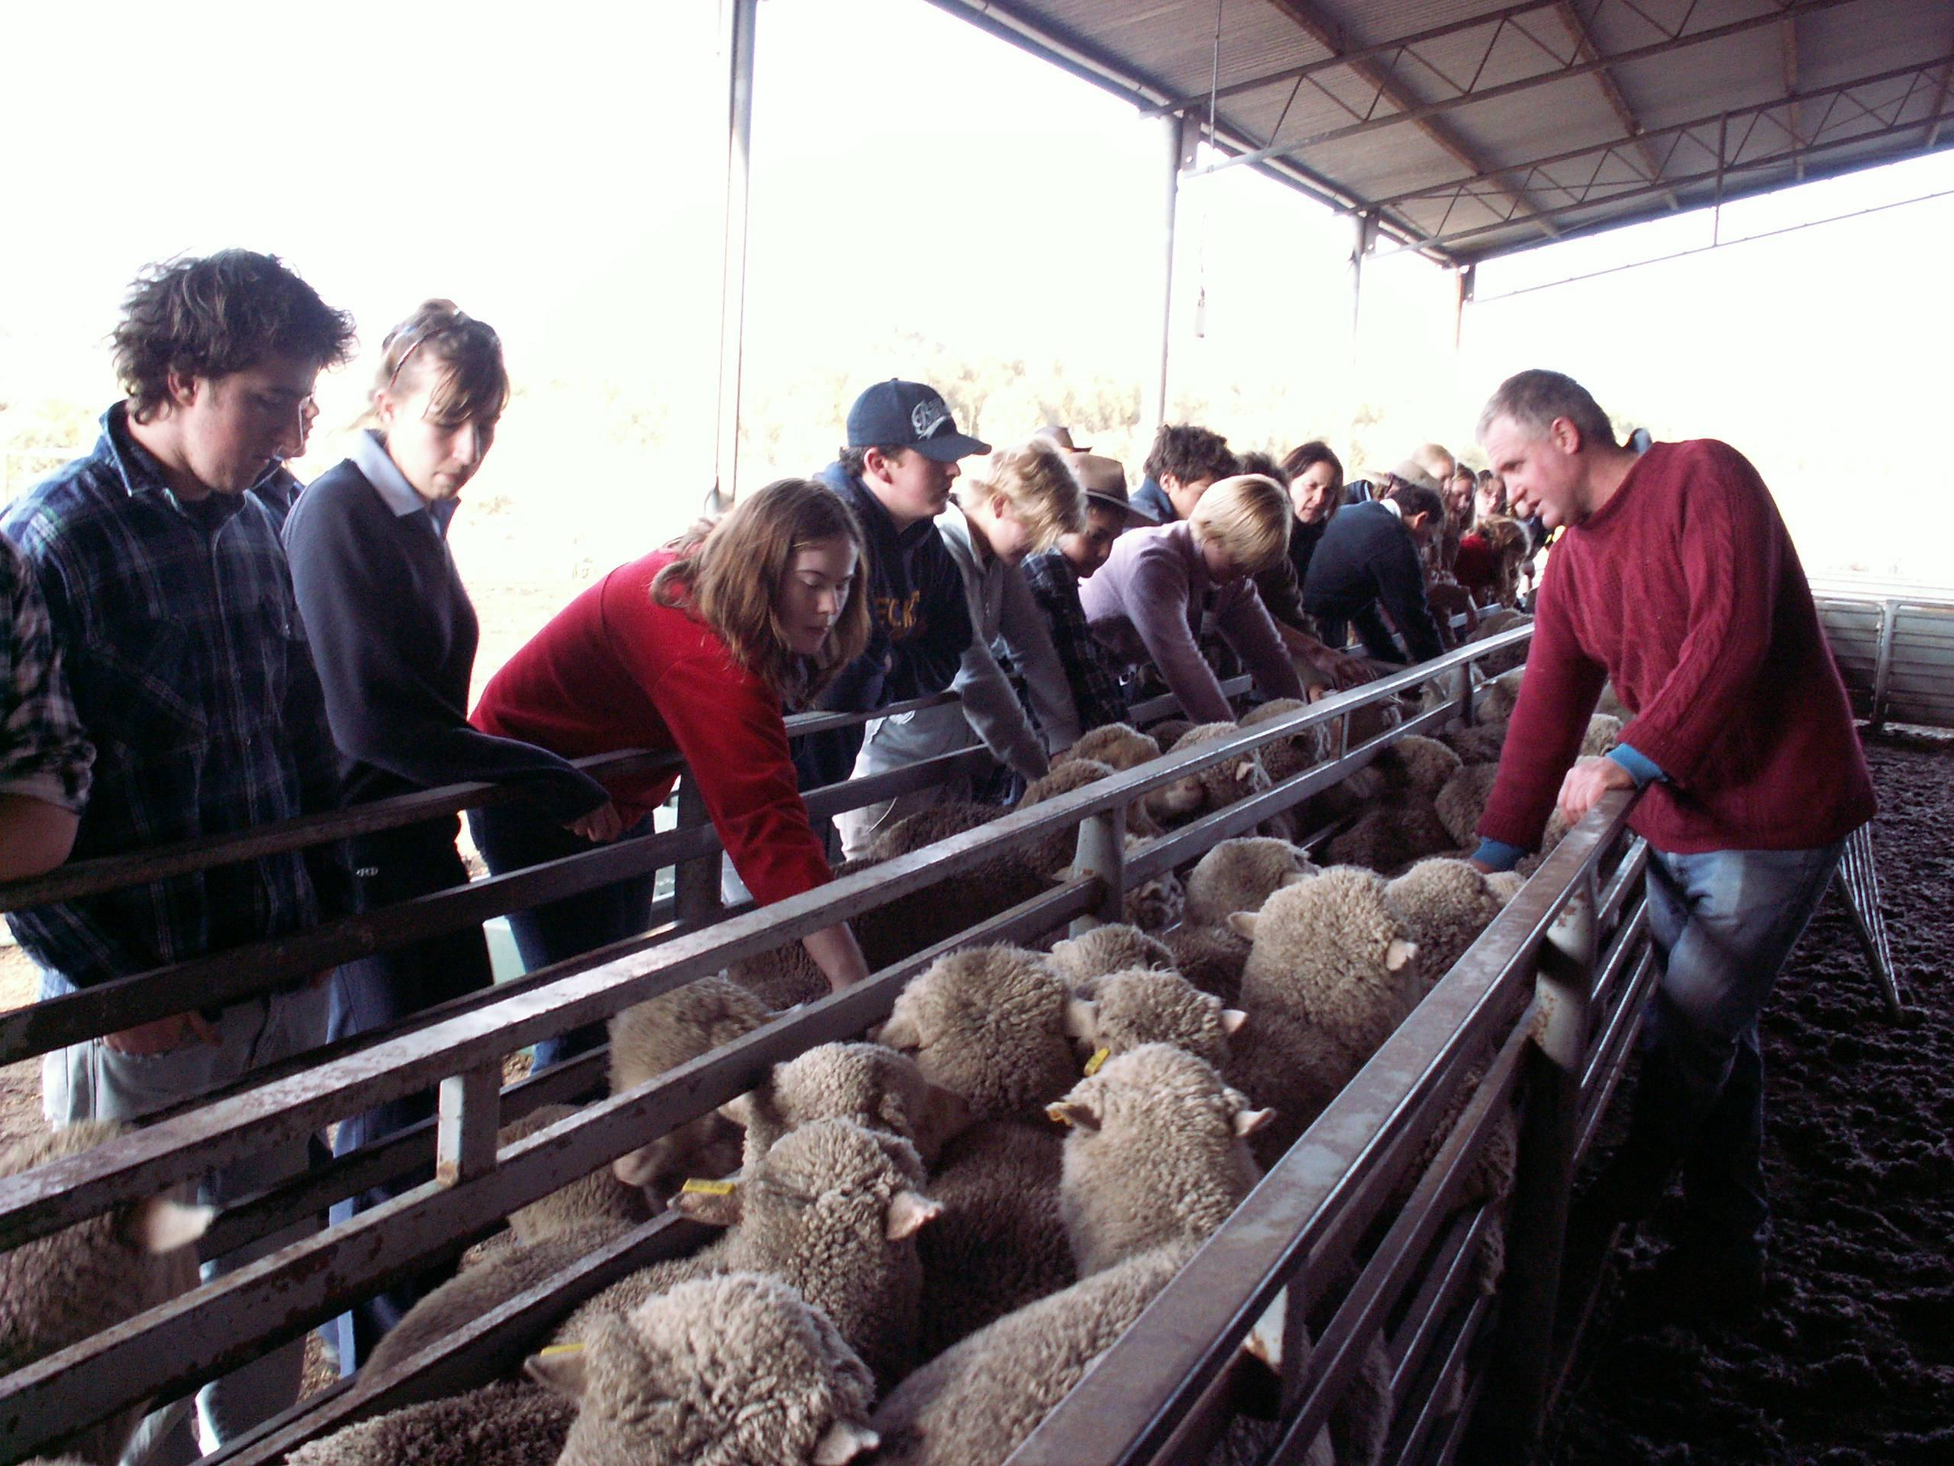

Contact
Jessica Connor
jessica.connor@dpi.vic.gov.au

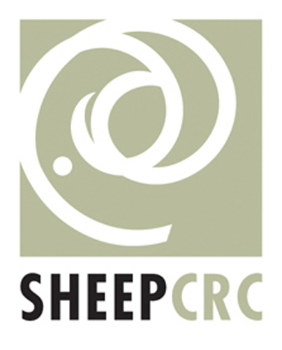 |  |  |  | 

