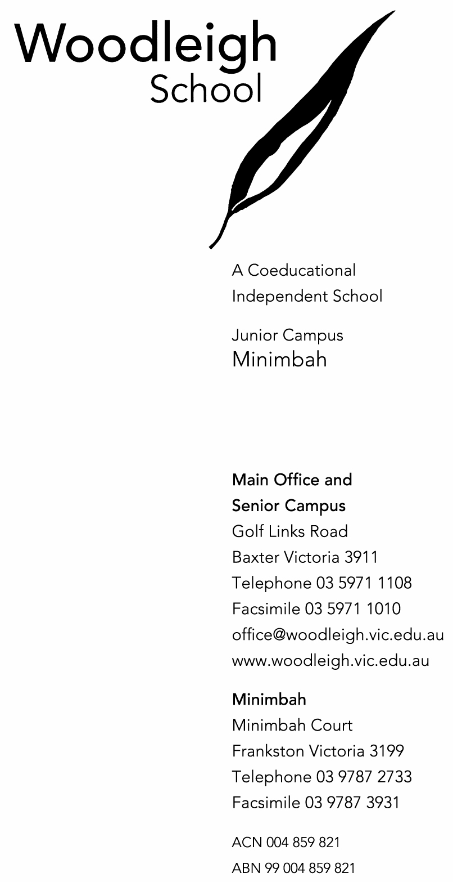

28 July 2026

PERMISSION TO ATTEND A SCHOOL EXCURSION

Dear Parents,

Below is a brief description of the excursion planned for your son/daughter.

Date: Thursday 25th May & Friday 26th May 2006

Year Level or Group: Selected Students from Years 8 – 10

Description: Science in the Sheep Industry Camp

Times: The students will travel by school bus, departing EMC’s Farm at 8.00am on Thursday and return to EMC’s Farm at 6:00pm on Friday.

Transport: Coaster (driven by Andrew Cosby)

Costs: $20 (charged to student accounts)

Supervising Staff: Jo Hellard, Andrew Cosby & Emma Beckworth (EMC) & Seleena Nichols (Padua College)

Teacher-in-charge: Jo Hellard

Science in the Sheep Industry Camp – 25 & 26 May 2006

Student’s Name: ______________________________________________ Year Level: ________

I give permission for my child to attend the excursion and authorise the teacher-in-charge to consent, if it is impracticable to communicate with me, to the child receiving such medical or surgical treatment at my expense, and to administer such first aid, as may be deemed necessary. I also support the staff in imposing such rules as relate to safety and good behaviour.

Parent’s Signature: ___________________________ Parent’s Name: ______________________

Contact Phone No: Home: _____________ Business: _____________ Mobile: _____________

Please return to Jo Hellard or Reception by Friday 19th May

