Project 6 - Tasmania
Participants
Grant Suttar, Kings Meadows High; Bradley Ennis; St Mary's District High; Sue Bennett, Queechy High; Rob Fleming, Brooks High; Richard Bassano, Scottsdale High; Christine Storey, Kim Stones & Shawn Smith, OPCET.

Summary of the project

Science & Wool is a 1.5 day professional development session for science teachers and career planners to showcase the science behind the Australian wool industry. Participants had the opportunity to speak with leading wool industry scientists, undertake practical procedures in the laboratory and experience the enthusiasm and passion of those who have careers in the wool industry. Science & Wool enabled the primary industry sector to showcase one of its commodities, address skill shortages and promote a professional image, and the education sector to broaden teacher’s which will in turn flow through to the schools and students.

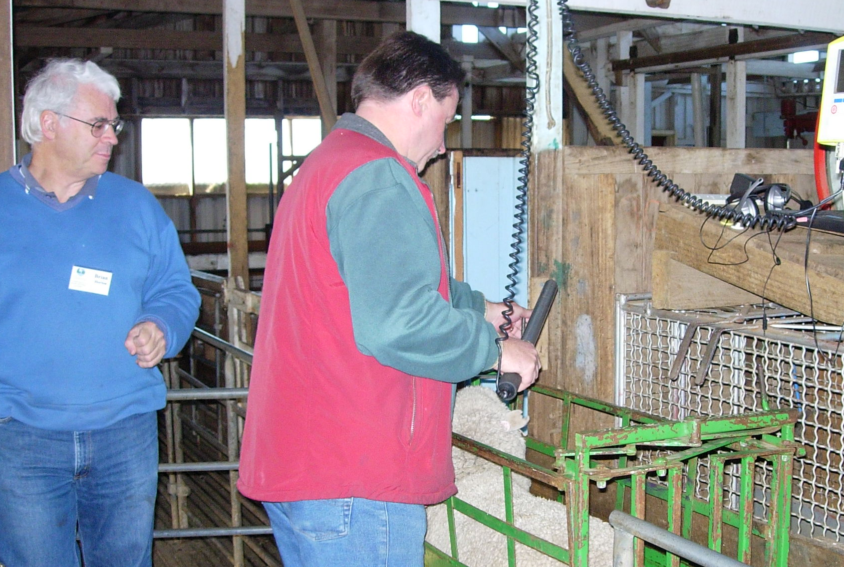

Contacts
Tracey Taylor
Tracey.Taylor@dpiw.tas.gov.au

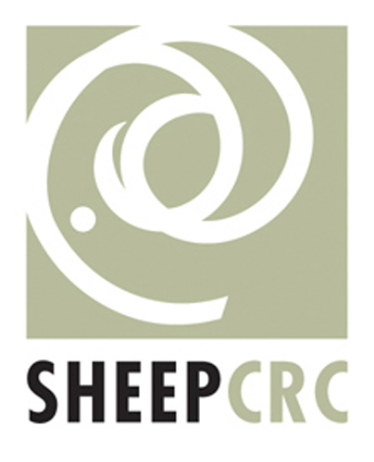 |  | 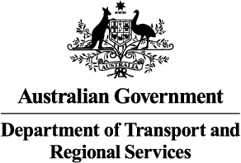 |  | 

