Careers in Science

3 Day Science Camp

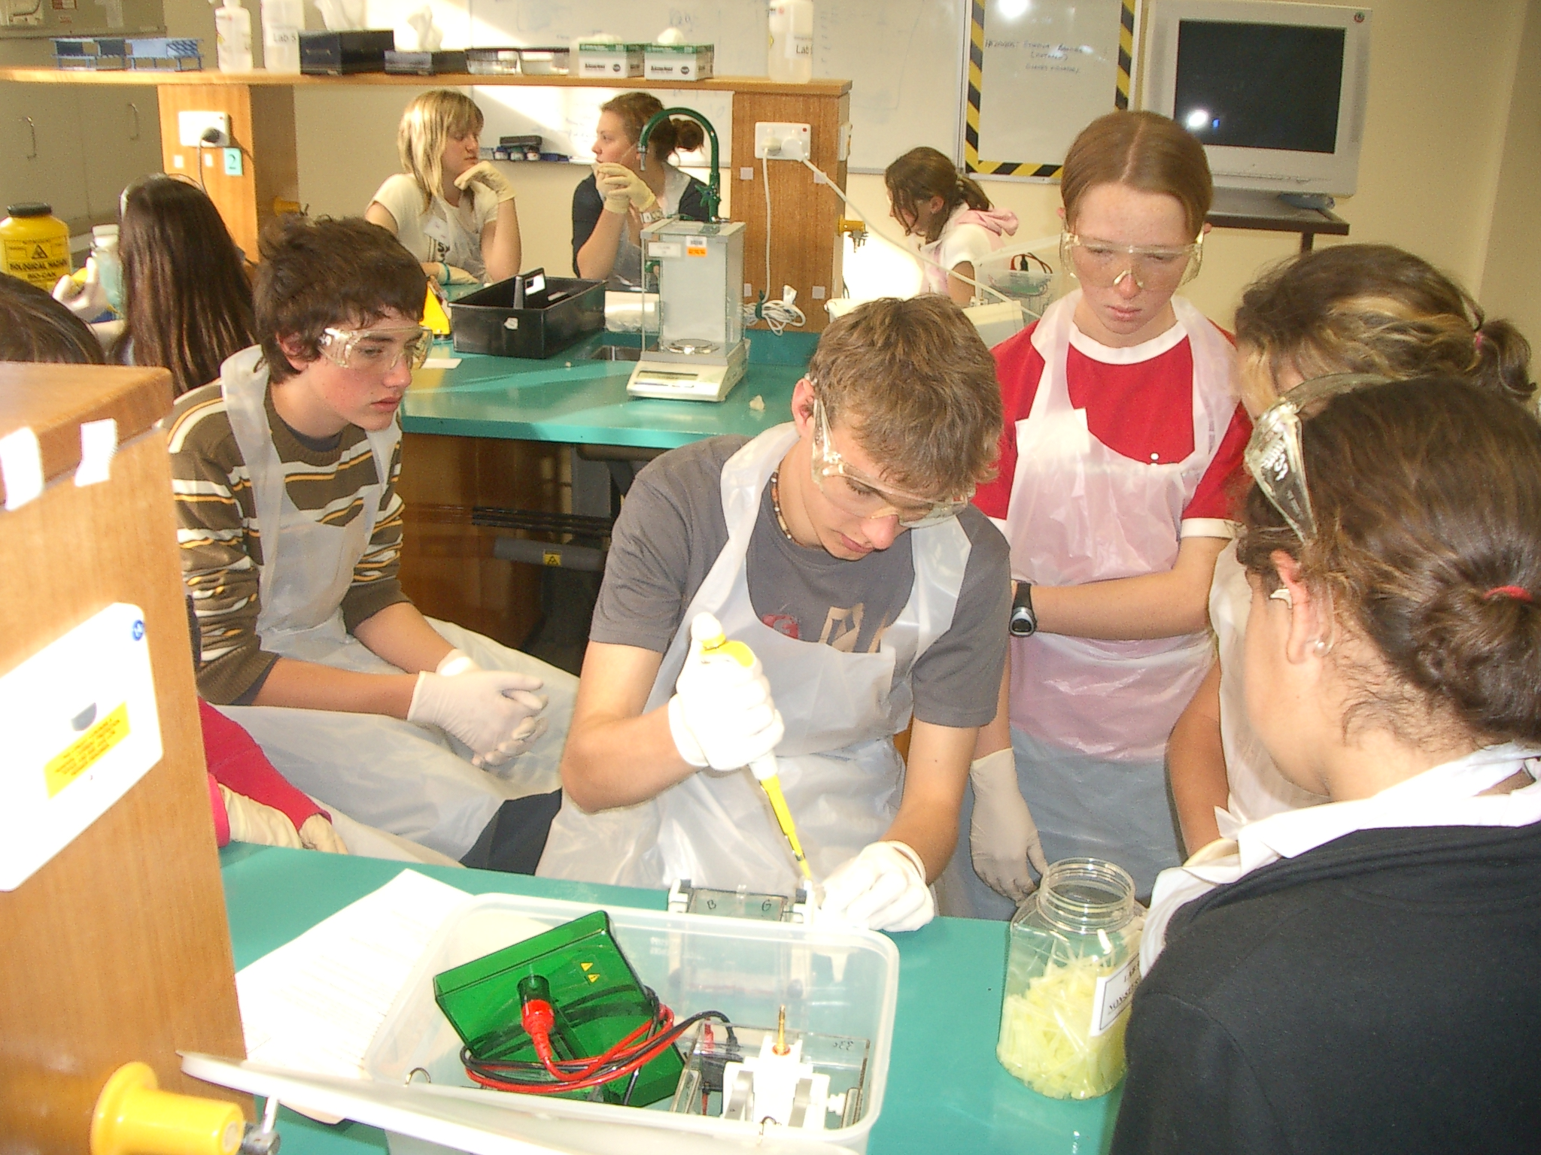

Dear Parent/caregiver,

The GrowSmart Careers in Science project is designed to show students the interesting career pathways available in the agriculture and horticulture industries for students who study science. We are trying to encourage students to study science and consider entering the agriculture and horticulture industries to fill the shortages of trained graduates these industries are experiencing.

As part of the project we are holding a three day Science Camp for up to 20 year 9 & 10 students from the Riverland and Mallee schools. The camp will be held from Monday June 19th to Wednesday June 21st and is related to the sheep industry.

The intended program is

Day 1
- Collect students from the Riverland/Mallee areas and visit properties that demonstrate the science related to the sheep industry
- Travel to Yookamurra wildlife reserve and study science involved in wildlife monitoring and protection. Includes a night walk spotting native animals

Day 2
- Travel to Adelaide and set up in cabins in the Marion Holiday Park
- Work with scientists at Flinders university looking at wool and soils

Day 3
- Travel to Roseworthy (Agricultural college attached to Adelaide University) to look at research in the sheep industry
- Travel to Turretfield (Adelaide Uni and PIRSA research centre) and do activities including looking at embryo and breeding technologies.

Through participation, students will gain an understanding of the role of science in these industries, experience some research in agriculture based science and see some of the possible careers available for science students in Agriculture.

Cost of the camp will be covered by the sheep industry. Your student has been invited to apply to attend the camp. If you are interested in him/her attending please fill in the expression of interest form and return it to the GrowSmart coordinator in your school. When all schools have been visited and forms returned a final selection of students to attend the camp will be made.

The camp will be supervised by three qualified teachers from the area. For more information I can
be contacted on 0429231946.

Peter Haines
Science Education Officer
GrowSmart Project
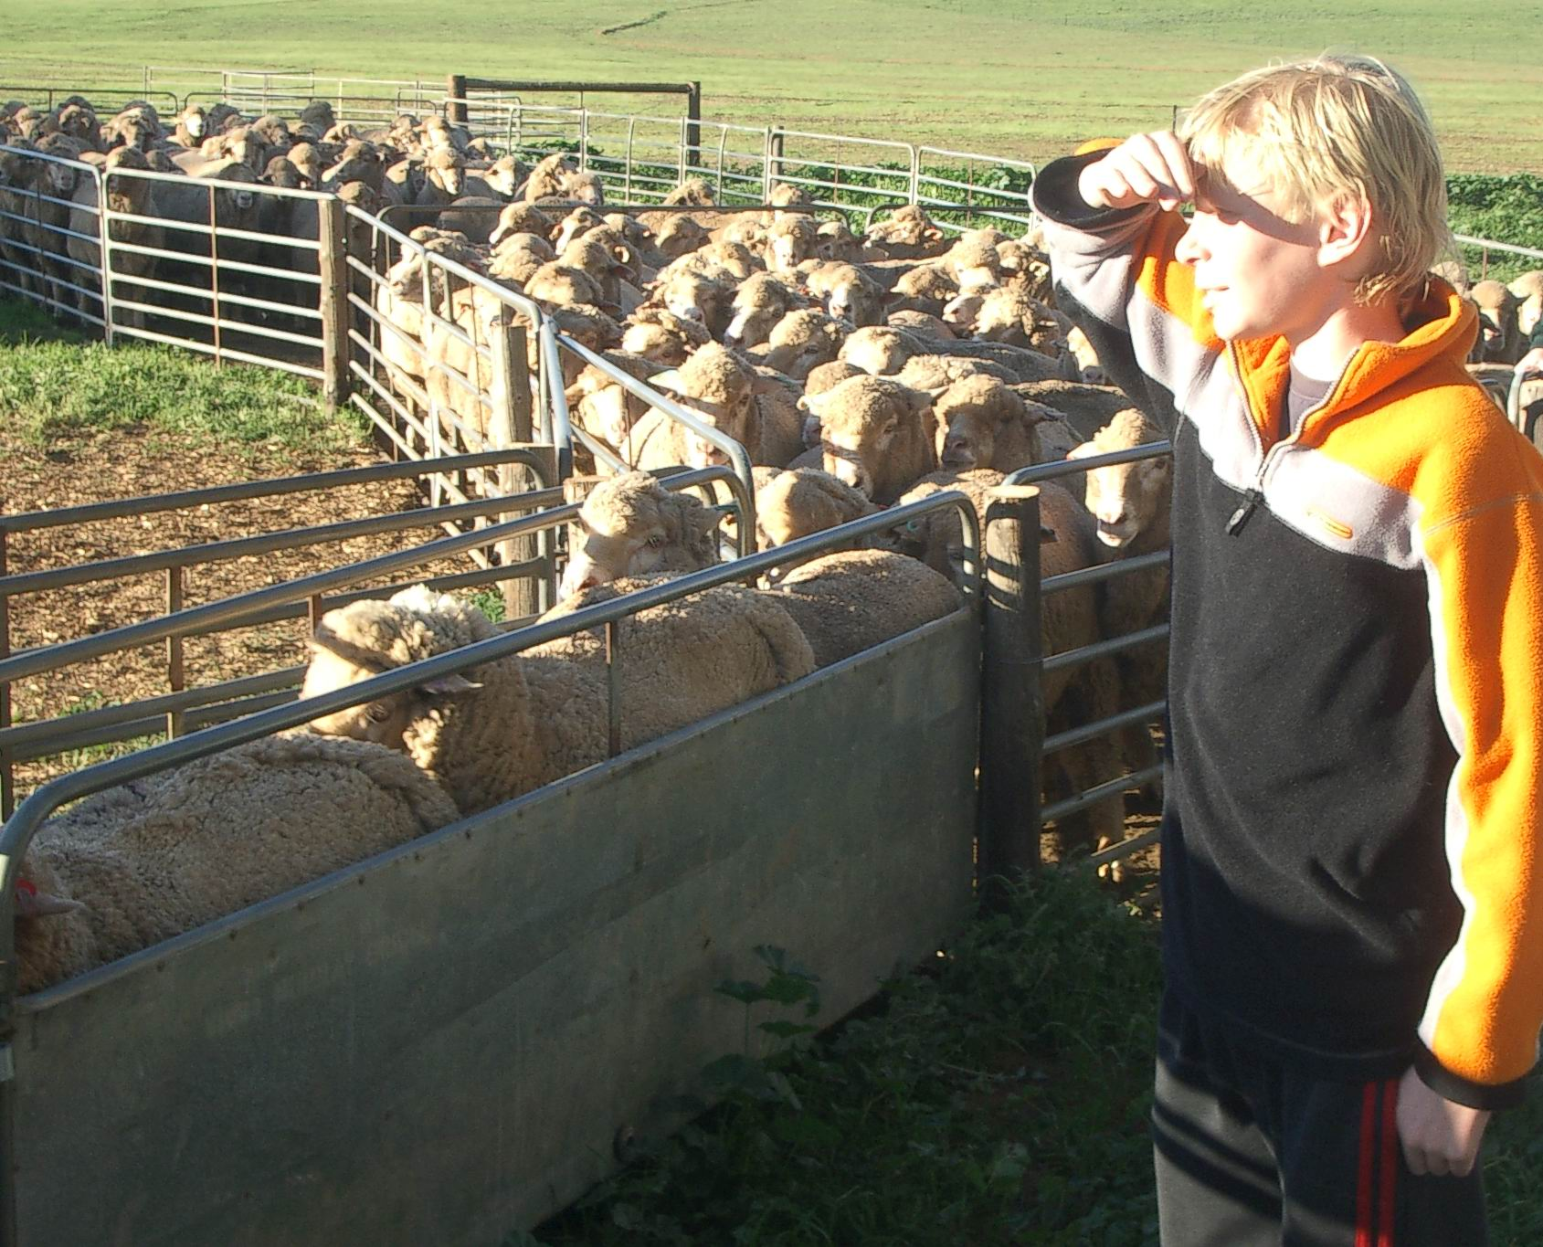

------------------------------------------------------------------------------------------------------------------------

Student Name: _______________________________________________ Year Level:___________

School: _______________________________________________________________________________________

I wish to apply to attend the science camp because:
_______________________________________________________________________________________

_______________________________________________________________________________________

_______________________________________________________________________________________

_______________________________________________________________________________________

Parent Signature __________________________________________________________

