Project 8 – Western Australia

Participants
Shenton College Students, University of WA and industry partners

Summary of the project

Shenton College students had a real taste of the country life when they were greeted by flocks of sheep on the school oval.

Farmers, sheep and dogs all visited the school as part of the ‘Sheep at School’ program aimed at increasing students’ knowledge and understanding of science and primary industry.
Students saw demonstrations from sheep dogs, met Fyfe the 150kg stud ram, listened to information sessions from farmers and participated in a range of learning activities. Learning activities included observing and interacting with farmers and industry representatives including sheep dog trials, White Suffolk Sheep and Bioclip wool harvesting. At UWA they met Professors and PhD students and participated in laboratory activities,

The day provided students with the opportunity to broaden their knowledge about primary industries and to put learning into a real context.

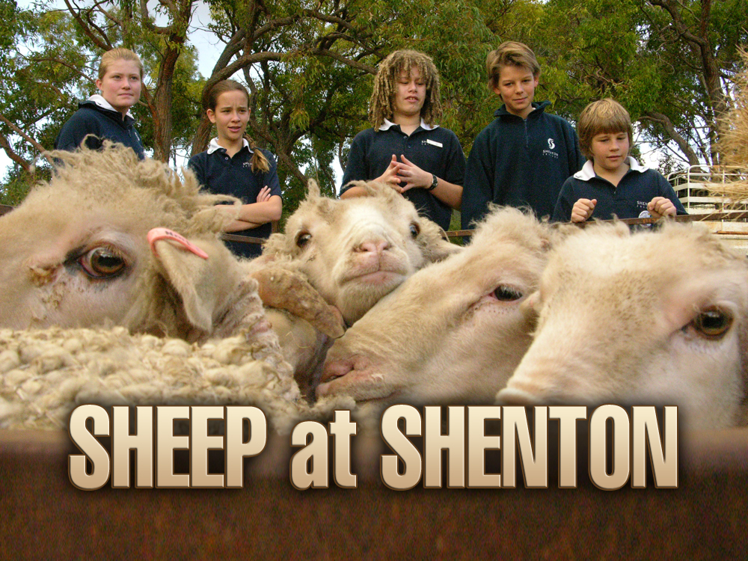

Contact
Warwick Mathews
warwickmat@gmail.com.wa

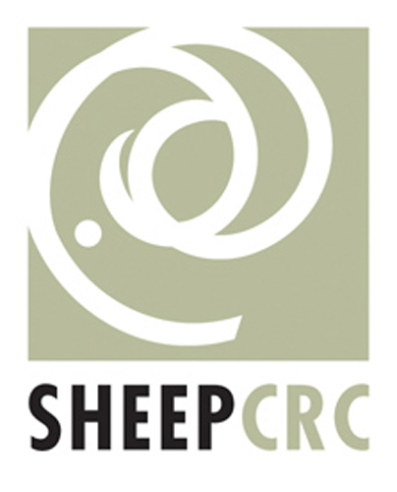 |  |  |  | 

