Sheep turn up in city classroom
By Jane Grieve
Thursday, 10/08/2006
In amongst the heavy peak hour traffic, it's a sight you don't normally see: a mob of sheep being rounded up by a couple of kelpies on the sports oval of a city school! But high school students at Shenton College in Perth have spent a whole day with this flock, to learn more about life on the land and primary industry.
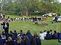
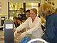
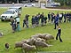
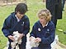
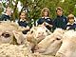
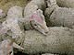

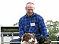

Every class incorporated learning about sheep and wool production and industries. High school teacher Warwick Mathews says he's always had an interest in primary industry and farming. He came up with the idea of bringing sheep to school after attending a forum in Tasmania, which was looking at employment opportunities in primary industry and promotion of the rural sector.
Mike Naisbitt from Lake Grace trucked a mob of bioclip sheep to Perth and showed students how sheep are injected, the nets are removed and how the wool breaks away from the sheep skin.
Peter and Heather Dowall run a white suffolk stud in Narrogin and wanted students to learn more about the breed of sheep they've chosen to run. Both agreed a day like this was very worthwhile and helped city students learn more about farm life.
Sheep dog trainer Simon Leaning drove into the school with a ute full of barking and excited border collies and kelpies and showed the students how dogs are trained and used in sheep work.
The students loved the day, with many keen to know more about bioclip and the biology of sheep. And "making" sheep in art was a highlight!
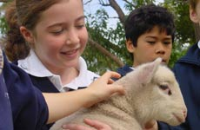

The lambs, brought to Perth from Narrogin, were a favourite! (courtesy Shenton College)

http://www.abc.net.au/rural/content/2006/s1711463.htm

