13. Wool Top Measurement

Bob Couchman

Learning objectives

By the end of this topic, you should have:

- an understanding of the measurements of fibre shape
- have an understanding of top measurement principles, the differences that accompany different systems and the effect these have in respect to spinning and trading in tops
- understand the underlying basis of the current system along with the principles of calculating results
- appreciate the importance of prediction technology to top length measurement.

Key terms and concepts

Topmaking, Wool Combing, Capacitance, Length Biases, Hauteur, Barbe, K and L Values, TEAM, Processing Prediction, Almeter, OFDA 4000, Comb Sorter, LAC (Length After Carding)

Introduction to the topic

This topic looks at the measurement of top length and length distributions. It discusses different technologies used in the measurement of this important commercial parameter and the effect these have on defining different top lengths.

This topic also provides a more in-depth understanding of the current base measurement system; the Almeter and its measuring principle – capacitance. This has a specific set of biases that require understanding in light of the development of new technologies based on different measuring principles.

Advances in technology have enabled the development of a new instrument, the OFDA4000. It uses different measuring systems, and introduces its own set of measurement biases. As per IWTO requirements, technical equivalence with the Almeter was demonstrated (Marler, 2010).

The topic also discusses the connection top length measurement has on the prediction of early stage processing performance.

13.1 Importance of Top Length

About 90% of the value of a wool top is derived from diameter and Hauteur (length biased average fibre length in top) or fibre length in the top (Bell, Charlton & Rottenbury 1988). Certainly, the maintenance of fibre length during the combing process is an extremely important feature of that part of the wool processing pipeline.

The percentage of fibres that break during the carding and combing process depends on a number of factors including fibre length, level of tenderness, processing route and entanglement introduced in scouring. Fibre breakage may reach 65% in extreme cases (e.g. when the wool is long or tender or the distance between the card rollers is minimal) however, according to Aldrich, Kruger and Turpie (1970) fibre breakage varies between 10 to 35% depending on the original length of the wool. Thus, the procedures implemented by a comber to maintain fibre length are financially important. Short fibre combed out of the sliver (noil) is considered a waste product of the combing process and is severely penalized financially. To be able to measure top length is therefore imperative.

Outside of diameter, mean top length or Hauteur is therefore the most important feature of a top. Traders and processors alike focus on this attribute to such an extent that it is, along with core:comb diameter comparisons, the most important of the raw wool to top prediction equations used in the industry today. The second of these equations is for CVHa or the coefficient of variation of Hauteur; a description of the fibre length variation in the top.

Spinners use ‘length’ and distribution parameters to set spinning frames. There are, in total, 40 different ‘length’ parameters provided by current technology, most of which are used to differing degrees commercially.

13.2. Relationship between Raw Wool and Top Length

Bernardin and Delfosse (1996) showed a good relationship (r²= 0.925) between single fibre measurements of raw wool with that of the Atlas instrument. The Atlas is used routinely to test staples of raw wool for commercial trading of greasy wool. They also found the relationship between staple length and top length to be high (r²= 0.941) but in the latter case the staple length was shorter than the Hauteur. This is primarily due to the straightening or de-crimping of fibres during the topmaking process along with the removal of a proportion of the short fibres in topmaking as noil, thus increasing the average length of fibres in the top.

13.3 Measuring Systems

A number of instruments have been developed to measure fibre length.

WIRA Single Fibre Length Instrument. This is the most basic of instruments. This is a semi automatic instrument that allows an operator to select single fibres with tweezers and mechanically draw them through a pressure plate until the end of the fibre is released and then the distance travelled is noted. This is very painstaking and is now only used for basic metrology research.

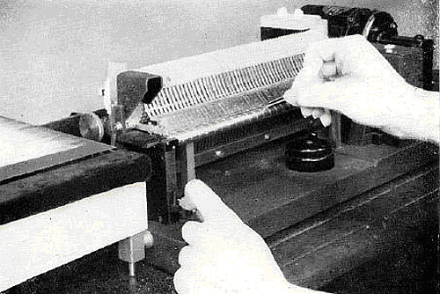
Figure 13.1 WIRA single fibre length instrument Source: Anderson and Palmer (1952).

Comb Sorters. To increase the speed of length testing in commercial applications a number of different comb sorters were then developed. The principle of a comb sorter is to prepare a fibre alignment or beard with all the ends of the fibres closely aligned at one end and to then withdraw fibres from the fringe in order of either increasing or decreasing fibre lengths. Because of the relationship between fibre length and diameter; longer fibres tend to be coarser, the calculation of average fibre length using this method tends to be weight biased.

Indeed this is the basis for the barbe measurement. To speed up the process bundles of fibres within specific length ranges are removed and weighed. These "weight" bins of specific length are then used to calculate a weight biased average length.
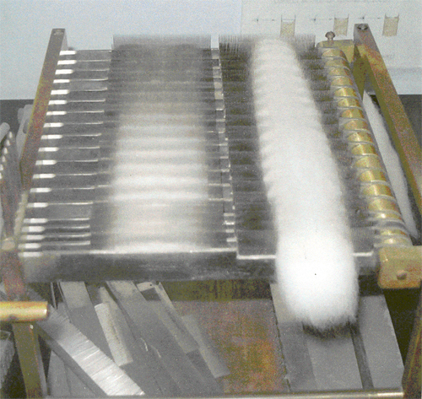
Figure 13.2a Suter comb sorter source. Source: Turk, J. (pers. comm. 2005).

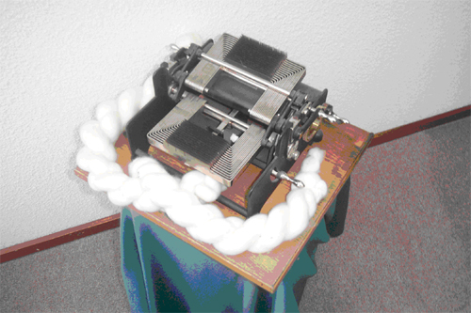
Figure 13.2b Schlumberger comb sorter. Source: Turk, J. (pers. comm. 2005).

An important step at the end of the 1940's was the introduction of a partially automated comb sorter produced by Schlumberger. The weighing and the calculating operations were not included in this machine, but the controlled comb sorter improved the precision in a significant way. After some improvements, the final version called "Analyseur Schlumberger MAE" was introduced in 1950 (Monfort 1950). About 80 units were installed in nearly all the main wool combing and spinning mills, mostly in Europe. The Technical Committee of I.W.T.O. thus organized inter-laboratory trials in 1952 and 1953 (Monfort 1953) and an IWTO Standard for the measurement of wool fibre length on the Schlumberger comb sorter (appareil a peignes - in French) was approved in 1959 (Monfort 1953). In the operating manual of the instrument, Schlumberger had introduced the names: HAUTEUR for mean length biased by cross-section (a, I R) and BARBE for mean length biased by weight (w, I R).

At WIRA in Leeds, Anderson and Palmer developed the WIRA Single Fibre Length Machine, a partially automated instrument which applied a standardized tension to the fibres, used in IWTO-DTM 5-97. On a numerical sample of fibres, this machine measures the numerical mean length of fibres in an extended state or (1, I E).

WIRA Fibre Diagram Machine
The next step was the introduction of electronic instruments, and the IWTO Standards DTM-16-2002 for the WIRA Fibre Diagram Machine and IWTO 17- 67, superseded by IWTO 17-2011, for the Almeter.

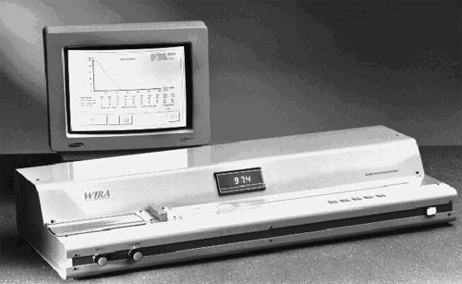
Figure 13.3 The WIRA fibre diagram machine. Source: Auer (1999).

The Almeters
The introduction of the Almeter in the mid 1960's with its automated system then dominated the fibre length measuring system to the point that it became the accepted norm and all other machines virtually disappeared from commercial use. Along with the introduction of the Almeter came easy to obtain length distribution statistics such as % short fibres (K Values) and length of fibres at x% (L Values) that spinners commenced to use as indicators of top quality and to set spinning frame settings (see later).

With the advent of staple measurement of raw wool it was the Almeter values of hauteur and CVHa that were used as the most commercially relevant top measurements to predict.

This history and dominance has had implications for the prediction technology used today as well as the development of new length measuring instruments.

The Almeter system is in fact 2 instruments:
- A fibre preparation machine - the Fibroliner which prepares a thin beard of fibres in a screw gill mechanism with a series of fine embedded pins. The machine then allows for the manual transfer of this beard with all the fibre ends roughly aligned (see Figure 14.4), and
- The Almeter - This is the measuring instrument which scans the fibre beard between 2 electrodes and measures the electrical resistance between them; the capacitance. Its software corrects for the slightly uneven fibre end alignment and then calculates the mean and distribution parameters for both hauteur and barbe (see Figure 14.5 and Table 14.2).

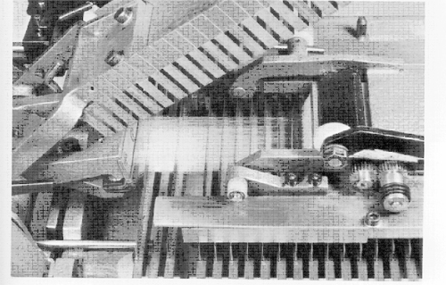
Figure 13.4 Fibre beard sample in the Fibroliner. Source: Auer (1999).

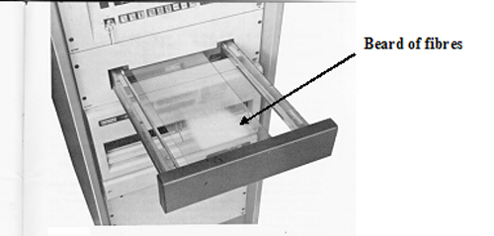
Figure 13.5 Almeter beard in the Almeter AL100 sample belt ready for measurement. Source: Auer (1999).

The first Almeter instrument developed, the analogue instrument, relied on valves and integration circuits and this was replaced in 1978 by a digital computerised system the AL I00. This instrument became the industry standard.

13.3 Relationship between Length Measuring Systems
Morton and Hearle (1986) describe the Almeter as providing a lower mean fibre length reading in comparison to the WIRA fibre diagram instrument because of the different tension at which the fibres are measured. Whilst the Schlumberger comb sorter results are lower there is a good correlation. Grignet (2003) reported that the shorter Schlumberger Hauteur was a consequence of lower fibre tension during measurement. Both the WIRA and Almeter instruments use capacitance.

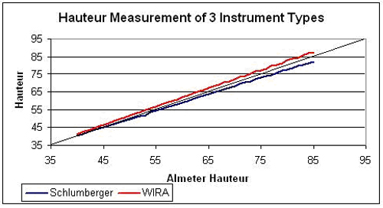
Figure 13.6 Comparison of Hauteur Results from the Almeter, Schlumberger comb sorter and WIRA Fibre Length Machine.

Morton and Hearle (1986) describe the origin of the term Hauteur and suggest that it is a term referred to by European processors to describe the mean length of a length biased sample.

Grignet (2003) provided a brief history of "length" measurement and accredits the use and introduction of the term Hauteur to the Schlumberger comb sorter. He reported that the term Hauteur was described as the mean length biased by cross-section and barbe as the mean length biased by weight.

It is clear therefore that Hauteur is a defined term and one that has wide commercial acceptance but it has a somewhat loose definition.
Discussions with Grignet (pers. comm. 2005) reveal that his team of researchers were well aware of crimp effects on hauteur measurement but as a consequence of processing trials, considered them to be of little commercial relevance.

The weight biased length (barbe) measured by the Suter Comb Sorter was on average about the same as the Almeter Barbe (Morton & Hearle 1986).

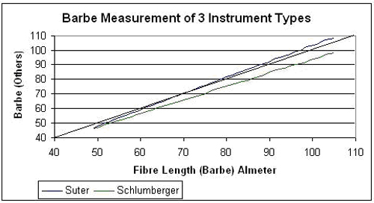
Figure 13.7 Comparison of Barbe results from the Almeter, Suter Comb Sorter and the Schlumberger Fibre Length instrument.

13.4 Understanding Capacitance
The Almeter uses 'capacitance' to measure fibre length and its distribution. In simple terms, it measures the electrical resistance of the material that passes through two electrodes spaced slightly apart. It then translates these di-electric changes into numbers of fibres at any single point in the fibre array. It thus assumes that the mass of the fibres in the array at any one point of measurement is equal for all the fibres at that point. In reality, that is not strictly correct as we know that wool fibres are not perfectly spherical and that they also alter in diameter along each fibre. Capacitance measurement therefore only provides a good approximation of the number of fibres in the array at any one point. Because the Almeter measures something like 30,000 fibres there is considerable averaging and thus these 'capacitance translation errors' are minimal and provide a reasonably stable basis of measurement.

The term hauteur is linked to the capacitance values generated by the analogue Almeter, which was replaced by the digital version of the instrument in 1978.

Hauteur, after 40+ years of commercial use, therefore must be viewed as a definition resulting from the capacitance, as measured by the Almeter and it's associated sample preparation system.

Capacitance is influenced by:
- Sample preparation – Delfosse and Longree (1996) showed differences as a consequence of preparation methods
- Fibre tension –differences between aged and fresh tops affect capacitance and therefore hauteur
- Fibre diameter - translating capacitance at any given point along a fibre beard into the number of fibres present assumes that all fibres are of the same diameter and that all fibres are running parallel to the long axis. This is clearly not the case. To achieve such a state the fibres would have to be under a degree of tension just sufficient to remove any crimp effect. Again this is not the case in the Almeter as fibres are measured in a semi-relaxed state. The capacitance "diameter" of every fibre therefore has the potential to be slightly higher than it actually is due to the angle of deflection from the longitudinal axis of the fibre beard. The higher the crimp frequency and amplitude the higher this difference will be.
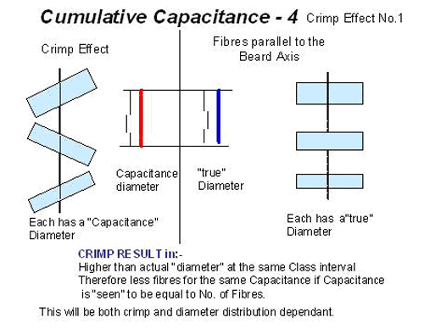
Figure 13.8 Crimp effect (1).
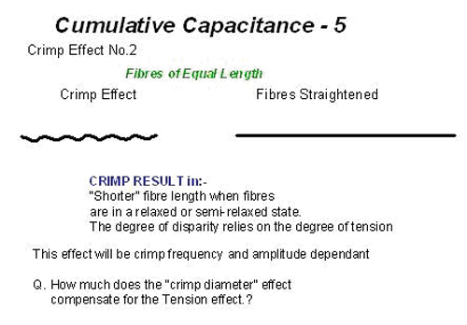
Figure 13.9 Crimp Effect (2).
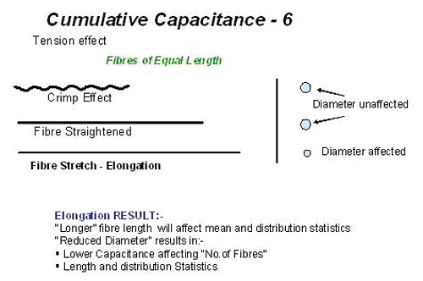
Figure 13.10.Tension effect.

Fibre tip and crimp - Morton and Hearle (1986) clearly identified fibre tip diameter differences as affecting the capacitance but regarded any consequent error as negligible as "fibres of any length will be pointing in either direction" They also understood the effect of length: diameter interaction "in some instances (where) the shorter fibres are finer than the coarser ones, the measured hauteur will tend to be slightly exaggerated". They went on further to suggest that "Any such error, however, will be small by comparison with that arising from crimp, which always tends to diminish the hauteur". This is particularly so with the Almeter in comparison to the WIRA Fibre Diagram instrument because of the lower degree of fibre tension in the Almeter.

Morton and Hearle’s belief that the effect of fibre ends on mean fibre length is negligible is in fact incorrect in respect to the diameter profile of the top as it can be shown that the fibre length distribution will influence diameter profile of the top. In addition, it is understood that there is a fibre diameter: fibre length interaction; the longer fibres being different diameter to shorter fibres.

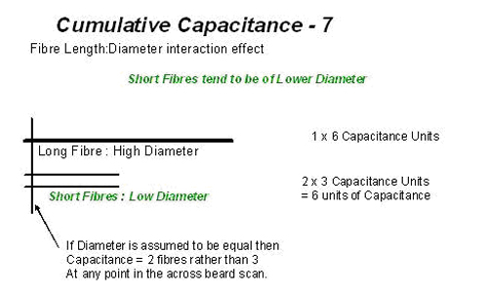
Figure 13.11 Length:Diameter interaction.

Conditioning and fibre diameter - is known to affect diameter measurement. To re-produce hauteur from measured "length" and diameter distributions measured under different preparation and fibre management conditions requires certain assumptions or conditions to be met to allow for accurate mathematical calculations to be made to generate a value that can be adequately described as hauteur.

The values generated by the Almeter rely on calculations based on class interval and capacitance, there is no intermediate measurement step such as occurs with the OFDA 4000. The OFDA 4000 has to also measure diameter to convert "OFDA length" into a "calculated capacitance value" before calculating hauteur and its distribution statistics. Precision of the intermediate measurement; diameter, therefore is an issue in relation to the measurement of hauteur by non-capacitance methods.

There are differences between the OFDA 4000 hauteur values and those generated by the Almeter from the cumulative capacitance values; the basis for the Almeter calculation methods. Similarly, there are a number of questions regarding these same effects on the OFDA technology:
- tension effects of fibre elongation if it occurs
- crimp straightening
- fixed beard adjustment effects
- diameter calibration.

13.5 Instrument Developments
In the late 1990's there was a need to re-develop the Almeter to overcome electronic componentry redundancies. This was undertaken and in 2003 an upgraded Almeter (AL2000 series of instrument) was accepted as demonstrating 'equivalence' for IWTO purposes.
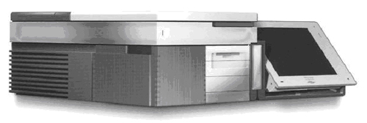
Figure 13.12 The Almeter (AL2000). Source: Anon (2003).

At the same time it became apparent to the developers of the OFDA technology that an opportunity existed to extend the development of this optical measuring system to incorporate 'length' measurement into the one instrument and thus provide the industry with a single diameter and length measuring technology (IWTO-62-2010).
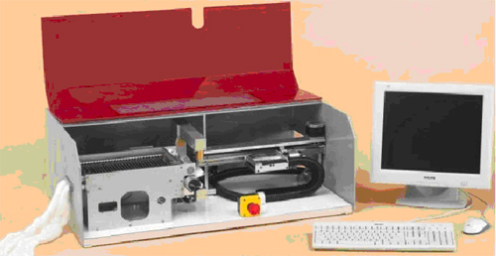
Figure 13.13 The OFDA4000 instrument. Source: Brims (2003).

Unlike the Almeter, the OFDA 4000 has a screw gill assembly to provide a sliver sample direct to a gripper mechanism which then pulls a thin beard of fibres through an optical (image analysis) measuring head.

It controls the density of the beard in such a way as to:
- Count the number of fibres in the beard at 5mm length intervals
- Measure the average diameter across the beard in 5mm steps.

It then takes these base optical length values and along beard diameter profiles and calculates an 'equivalent" hauteur, barbe and the distributions of these values along with the optical length and its distribution values. The OFDA 4000 measures 4,000 fibres compared to the Almeter's 30,000 fibres. The OFDA research group has reported that they are regularly observing tops with a fine ends diameter profile; indeed in theory they should be.
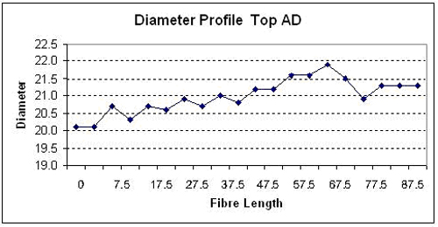
Figure 13.14 Diameter profile.

Some reasons for fine ends include the length:diameter relationship, fibre breakage effects and the distribution of finer fibre ends interaction throughout the length distribution of fibres in the sample.

This assumes:
- only the fibre tips are finer, or
- the point of break is at the finest point in the profile and that breakage occurs randomly within a sample.

A biased breakage model will affect the degree to which the effect is observed but the principle remains the same.

13.6 Calculation Methology

Table 13.2 Worked example of the method of calculation of the Hauteur and Barbe for top.

As a general rule of thumb the barbe value is approx 1.25 times the hauteur.

The CVHa is also related to a relationship between hauteur and barbe in the following way:

CVHa =√ ((Barbe – Hauteur) /Hauteur)

This relationship is important when used in the LAC (length after carding) context. Commercial interests especially in New Zealand, where LAC measurements are predominately used, rely on this relationship to assist them in interpreting changes or differences in short fibre content. For example, a K30H value (from the hauteur distribution) of 15% becomes about a K15B (from the barbe distribution) of 3%. Any small change in the barbe value (K15B) is magnified when the hauteur measurement is used. This is purely a mathematical artefact but small changes in barbe values are easier to observe if the hauteur is used.
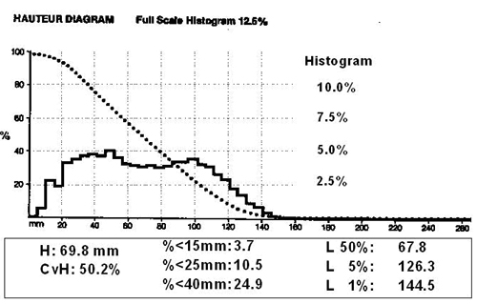
Figure 13.15 Hauteur plot.

13.7 What do the measurements mean?
There is a belief in industry that 'desirable' length frequency distributions result in better spinning performance. There is a general belief that bi-modal shapes are deleterious in spinning. Top parameter data have been analysed against spinning performance but to date no firm relationships have been established.

Perhaps what is more important is the use of hauteur and CVH plus the use of specific K (short fibres) and L (long fibre) values along with the cumulative distribution curve.

It is difficult to be prescriptive as to what parameters and values should be used as each spinner has different machines, settings and experiential values that are used in the setting of spinning frames.

There is considerable evidence to demonstrate the importance of hauteur in spinning, less in relation to CVH and almost nothing is written about the distribution parameters.

What does seem to be important is short fibre content, which depending on user will be the H15 - K30H region of the distribution, as it affects the evenness and hairiness of the yarn. It is important as these short fibres tend to be not well controlled in the cone area between the last drafting roller of the spinning frame and the point where twist starts to take affect.

The other area of distribution values is the long fibre end, especially the L5 to L1 areas i.e. L5 is the length of fibres at 5% of the distribution. These values are important as they affect the distance between the front and back rollers of the drafting mechanism.

The back roller is running slower that the front roller. If a fibre is longer than this 'ratch setting' distance then it is held in the back roller whilst the front roller is trying to pull it through. The result is that it breaks and causes yarn unevenness and this results in a poorer quality of yarn. It can therefore be seen why such values are important to a spinner.
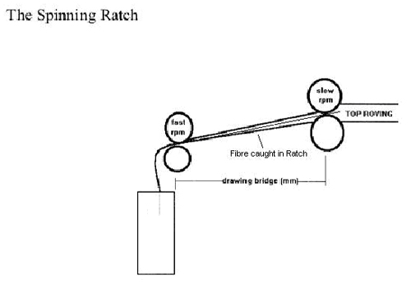
Figure 13.16 Effect of long fibres in the drafting area.

The K30H value is often used by combers to determine the efficiency of their combing operation. Similarly, the K30 barbe value can be used, as being a weight biased measurement, it relates directly to noil (short fibre) removal.

Readings 
The following readings are available on web learning management systems

- Anderson, S.L. and Palmer, R.C. 1953 ‘A machine for measuring the length of single fibres,’ J. Text. Inst. Vol. 44, pp. T95.
- Grignet, J. 2003, ‘Foundations and metrology of the Almeter wool fibre length measurement,’ Proc. of IWTO, Technology and Standards Committee meeting, Istanbul, Report No. SG02.
- Hadwich, P. 1971, ‘Factors influencing fibre length measurement in wool tops,’ Melliand Textilberichte, vol. 52(6), pp. 626.

Summary

This topic discusses the measurement of “length” and length distributions in Tops. It looks at the history and principles of measurement and the role top length plays in commercial transactions for wool tops.
It provides an in-sight into the importance of existing technology in the development and use of length parameters in early stage processing prediction. The Almeter results provide the basis for the TEAM 2 and 3 prediction suites.

References
Aldrich, de V, Kruger, P J and Turpie, D W F, 1970, ‘The carding and combing of wools of different fibre lengths,’ SAWTRI Technical Report No. 136.
Anderson, S.L and Palmer, R.C. 1952, ‘A machine for measuring the length of single fibres,’ Textile Institute, Manchester UK, Report No. T95.
Anon, 2003, AL2000 product advertising brochure, Proc. of IWTO, Sliver Group committee meeting, Report No. SG03, Debrovnik.
Auer, P. 1999, ‘The measurement of Hauteur (H) and CVH,’ Wool CRC PowerPoint Presentations.
Brims, M.R. 2003, ‘The OFDA4000 Instrument,’ Proc. of IWTO, Sliver Group committee meeting, Report No. SG02, Nice.
ASTM D519 – 90, 1995, Standard Test Method for Length of Fiber in Wool Top, publ. ASTM, 100 Barr Harbor Drive, West Conshohocken, PA 19428-2959, United States of America.
AS/NZS 4175, Australian/New Zealand Standard for Length after Carding, publ. Standards Aust. Sydney.
Bell, P.J.M., Charlton D. and Rottenbury, R.A. 1988, ‘Processing studies on clip preparation - Valuation of the resultant tops and noils,’ Wool Tech. Sheep Breed., vol. 34(4), pp.125.
Bernardin, C. and Delfosse, P. 1996, ‘Measurement of Fibre Lengths distribution on Raw Wool,’ Melliand International.
Delfosse, P. and Longre, M. 1996, ‘Investigation of the Effect of Sample Preparation Procedure on the Almeter Fibre Length Distribution,’ Proc. of IWTO, Sliver Group committee meeting, Capetown.
Grignet. J. 2003, ‘Foundations and Metrology of the Almeter Wool Fibre Length Measuremen,’ Proc. of IWTO, Sliver Group committee meeting, Dubrovnik, Report No.SGO2.
IWTO 17-85, Determination of Fibre Length Parameters by Means of the Almeter Technology & Standards Committee Specifications, International Wool Textile Organisation test method.
IWTO-17 -04, Determination of Fibre Length and Distribution Parameters Technology & Standards Committee Specifications, International Wool Textile Organisation test method.
IWTO-62-2010, Determination of Fibre Length, Length Distribution, Mean Fibre Diameter and Fibre Distribution of Wool Top & Slivers by the OFDA4000. Technology & Standards Committee Specifications, International Wool Textile Organisation test method.
Lamb, P.R. 2004, ‘Staple strength and its relevance to worsted processing,’ Wool Tech. Sheep Breed., vol. 52(2), pp. 171.
Marler, J.W. (2010) Proposed Changes to DTM-62-05 and the IWTO Regulations for the Testing of Wool Slivers. Proc. Of IWTO Tech. & Standrads Committee, SG Submission No 1.
Morton, W.E. and Hearle, J.W.S. 1986, Physical Properties of Textile Fibres - Student Edition, Publ. Textile Inst. Manchester.
Monfort F. 1950, Les longueurs de la laine, L'ingenieur textile, Verviers, 377, Fevrier-Mars, pp. 208.
Monfort, F. 1960, Aspects scientifiques de l'industrie lainiere, Dunod, P. (ed.).
Monfort, F. 1952, ‘Rapports concernant les mesures interlaboratoires,’ de longueur des fibres sur analyseur Schlumberger, Proc. of IWTO, Technical Committee meeting, Report No. 14, London.
Monfort, F. 1953, ‘Mesures interlaboratoires,’ Mesures interlaboratoires 1953 de longueur des fibres sur analyseur Schlumberger, Proc. of IWTO, Technical Committee meeting, Report No. 18, Lisbon.
Monfort F. 1957, ‘L' Analyseur Schlumberger,’ Textilis, Gent, Belgium.
Morton, W.E. and Hearle, J.W.S. 1986, Physical Properties of Textile Fibres, publ. Textile Institute.
Palmer, R.C. 1947, ‘Fibre length measurement: the present position,’ Proc. of IWTO, Technical Committee meeting, Report No. 1, Paris.
Palmer, R.C. 1948, ‘Application de la statistique á la mesure des fibres,’ L'ingenieur Textile, Verviers, 370.

Glossary of terms
Almeter | An instrument for measuring fibre length. It measures capacitance and translates that into Hauteur (length biased) and Barbe (weight biased) length
Capacitance | An electrical signal generated between 2 electrodes. This alters as the density and length of fibres are measured
Comb Sorter | An instrument for measuring weight biased length distributions
Hauteur, (H) mm | Mean length biased by cross-section (or linear density) of the fibres and capacitance  Note: In the Almeter this is calculated from the capacitance values derived from the Almeter scan
K and L Values | K Values are the % of fibres which are <x mm. L Values are the length of fibres >y%
LAC | Length after Carding. A test on carded sliver using a woollen card and an Almeter to determine the average length of fibres after carding
Length bias | See Almeter
OFDA 4000 | An instrument for measuring fibre length and diameter. It then takes these base optical length values and along beard diameter profiles and calculates an 'equivalent’ Hauteur, Barbe and the distributions of these values along with the optical length and its distribution values. Optical length is biased by the length and optical scanning process
TEAM | Trials for Evaluating Additional Measurement
Topmaking | The process of combining greasy wool lots to meet a top specification
Wool Combing | Converting greasy wool into top

