14. Wool Dyeing Principles and Techniques

M T Pailthorpe and E J Wood

Learning objectives
On completion of this topic you should be able to:
- Compare the features of the four main classes of dyestuff used for dyeing wool
- Explain the roles of dyeing auxiliaries and assistants
- Describe what occurs at the molecular level during the five phases in the dyeing process
- List the factors that affect the effectiveness of dyeing and explain the reasons
- Describe the machines used for the dyeing of loose fibre, tops, yarns and fabrics, and compare their advantages and disadvantages

Key terms and concepts
Dye, dyestuff, affinity, levelness, fastness, dyeing auxiliaries and assistants, temperature/time profile, approach, adsorption, diffusion, migration, fixation, polar groups, dye liquor, interchange, flow reversal, pH, exhaust dyeing, continuous dyeing, goods-to-liquor ratio, loose stock dyeing, hank dyeing, top dyeing, package dyeing, winch dyeing, jet dyeing, jig dyeing, beam dyeing, colourfastness

Introduction to the topic
The physical and chemical properties of wool vary greatly between breeds, the environment in which the wools are grown and the diet and health of the sheep. The physical properties vary in terms of fibre diameter, length and crimp whereas the chemical properties exhibit variety in terms of amino acid content. In addition, wools also vary in their base colour and have differences between the tip and root that affect both the dyestuff diffusion rate and mechanical properties. It is common to blend wools with different physical and chemical properties, and these blends may display markedly different dyeing properties. Therefore, careful selection of dyestuffs and auxiliary dyeing chemicals is important if the desired, stable colour is to be achieved on completion of the dyeing process.
Dyeing can occur at a number of stages in manufacturing – ie, in loose stock form, or as yarn, sliver or fabric. Wool dyeing, like all forms of textile dyeing, has become more standardised and exact. Instruments such as spectrophotometers to measure and specify colour have become commonplace in dye houses and consequently, the dyer often has to use a wide range of dyes in order to achieve a satisfactory shade match under various illuminants (ie, standard light sources). Environmental requirements are becoming more stringent too with regard to effluent disposal etc. and safe working practices are essential.
This topic provides an overview of wool dyeing, the principles of dyeing and the machinery used to dye wool in loose stock, sliver, top, yarn and fabric forms. The general references for are (Parton, 2002) and (Lewis, 1992). The latter is a very comprehensive book on the subject of wool dyeing with contributed chapters from ten experts in the field.

14.1 Dyestuffs and dyeing chemicals
Textile colorants are either water-soluble dyes (or dyestuffs), or insoluble pigments. Dyestuffs, which are intensely coloured compounds used for colouring textiles, are made as powders, granules, or liquids. Most dissolve in water to form solutions. Water-insoluble pigments can be used in powder form, or as fine dispersions, but these are not used with wool and are not discussed in this topic.
Dye molecules have the special property of absorbing light from certain parts of the visible light spectrum, due to the way in which their atoms are bonded together. For example, the azo dye molecule called “Yellow 6” (Figure 14.1) produces a yellow colour because it selectively absorbs light from other parts of the visible spectrum.
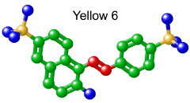
Figure 14.1 Azo dye molecule. Source: Wood, 2010

For effective dyeing, the attractive force between the fibre and a dye molecule must overcome the attraction that the water molecules have for the dye molecule. This can only occur if the dye molecule has certain arrangements of atoms that give it an affinity (ie, strong attraction) for the fibre.
The dye, either dissolved or in a finely dispersed form, must penetrate into the fibre to dye it. Some dye molecules form a true chemical bond with the fibre, while others are held in the fibre by physical forces (eg, electrostatic attraction). Fastness is the term used to describe the stability and permanence of the colour of dyed textile material when it is washed, exposed to sunlight, rubbed, etc.
Dye that is not evenly applied gives a ‘skittery’ or an unlevel appearance.

Types of dyes
(This topic is covered in more detail in the reading Dyestuff classes for wool)
Wool dyes are classified according to the method of application and their chemical type. The main classes of dyes currently used in the dyeing of wool are:
- Acid dyes (acid levelling to acid milling)
- Metal complex dyes (2:1 and 1:2 premetallised dyes)
- Chrome dyes
- Reactive dyes
Other types of dyes, such as direct dyes, sulphur dyes, disperse dyes, vat dyes and basic dyes are generally unsuitable for wool.
Acid dyes
Acid dyes are water-soluble dyes that are applied to fibres in a neutral to acidic solution (ie, pH ≤ 7). They have average to good fastness properties with wool. Some acid dyes are also suitable for dyeing polyamide (nylon). Two different acid dyes are available that exhaust on to the fibre:
1. From a weakly-acid bath, using weak acids such as acetic acid buffered with sodium acetate or ammonium sulphate; or
2. From a strongly-acid bath, using strong acids such as sulphuric acid or formic acid.
Chrome dyes
Chrome dyes are water-soluble dyes that are very fast to washing, perspiration, and sunlight. Chrome dyes tend to give rather dull shades, so they tend to be used for darker colours such as navy and black. However, they have very good wet fastness and light fastness properties.
Chrome dyeing is a two-stage process. The dye is first applied much like an acid dye is applied. Secondly, a chrome compound is applied to the fibre. Chrome molecules combine with both dye and fibre, making the dye very fast.
Because of the environmental effects of chromium residues in the dyeing effluent, many countries now prohibit the use of chrome dyes.
Metal complex dyes
Metal complex dyes, also called premetallised dyes (or premets) give very good fastness on wool and nylon fibres (though not as fast as chrome dyes). Metal complex dyes differ from chrome dyes because the complex-forming metal ion is put in the dye molecule when it is made. This makes the after-chroming step unnecessary.
Metal-complex dyes are in two groups:
1. 1:1 metal complex dyes must be applied in a strongly acid bath. The 1:1 means that one dye molecule is combined with one metal molecule.
2. 2:1 metal complex dyes are to be dyed in a neutral to weakly acid bath. The 2:1 means that two dye molecules are combined with one metal ion.
Reactive dyes
Reactive dyes are water-soluble dyes with brilliant shades and very good all round fastness properties. They give very good fastness because they become chemically bonded to the fibre, but levelling agents must be used. Two kinds are made, one for dyeing cellulosic fibres, and the other for dyeing nylon and wool.
Table 14.1 summarises the properties of the various dye types that are suitable for wool.

Table 14.1 – Summary of dye properties. Source: Wood, 2010

Dye type | Shade range | Levelling ability | Wash fastness | pH range | Relative cost
Acid levelling | Bright pastels | Excellent | Poor | 2 – 3.5 | Cheap
Acid milling | Bright pastels | Poor | Very good | 6 – 7 | More than levelling
1:1 Metal complex | Dull, dark | Good | Good | 2 | Moderate
1:2 Metal complex | Dull dark | Poor | Very good | 6 – 7 | More than 1:1
Reactive | Bright pastels | Poor | excellent | 3 then 6-7 | Expensive

Chemicals used during dyeing
Textile auxiliaries (or chemicals) are widely used in textile wet processes, including dyeing. Chemicals that help to apply the dyestuff are usually called dyeing assistants. This term is more specific than the general term auxiliary. Dyeing assistants are chemical compounds that help produce dyed textiles that are:
1. The correct shade;
2. Level;
3. Colour fast;
4. Economical in use of time, energy, and dye; and
5. Free of damaged fibres.
Various chemicals may be added to the dye bath to assist the dyeing process. For example, if a dye dispersing agent is added, it breaks down the dye into smaller particles that are more easily absorbed into the fibre.
Other types of chemical may be added during the dyeing process for reasons other than colouration. These are the dyeing auxiliaries. Many auxiliaries and dyeing assistants are mixtures of compounds designed to serve more than one function. To explain the classification of auxiliaries and dyeing assistants, dyehouse processing may be divided into three stages:
1. Pretreatment prepares the fibre substrate for applying the dyestuff.
2. Dyestuff application involves the approach, adsorption, diffusion, and migration of dyestuff. (These terms will be explained later.)
3. Aftertreatments fix the dyestuff, improve the fastness, modify handle, add specific properties, such as an antistatic agent to assist subsequent processing, etc.
A dyer must select dyeing assistants and auxiliaries that are compatible with the fibre, the dyestuffs, and other chemicals in the dyebath.

Dyestuff application treatments
These treatments help the uniform uptake of dyes by fibres. Dyeing is divided into 5 stages: approach, adsorption, diffusion, migration, and fixation. Firstly, some terms need to be defined. Here are some examples of dye application treatments.
- Antifoam agents reduce foam produced by turbulence in dyebaths. Foaming of the dye liquor can lead to non-uniform wetting, poor penetration, or unlevel dyeing. Antifoam agents are often used in jet dyeing machines, in the winch dyeing of carpets, and in the printing of fabrics and carpets.
- Buffer agents are chemicals that keep dyebaths at the optimum pH for best results. The pH controls the overall electrostatic charge possessed by the wool. In general, the lower the pH the greater the attraction for anionic dyes. Table 14.1 shows the optimum pH range for the various wool dyes.
Buffered solutions resist changes in pH when an alkali or acid is added or diluted. It is necessary to keep solutions at the correct pH level to avoid poor dyeing results or damage to the fibre.
For example, acid dyes on wool need an acid pH so that absorption and fixation can take place. However, some acid dyes are absorbed very rapidly, unless the pH is close to neutral. Rapidly absorbed dyes, called fast-striking dyes, tend to dye unlevel unless the pH is buffered at the correct level.
- De-aerating agents: Water contains dissolved air, which is gradually released from solution as minute bubbles as the temperature is raised. These air bubbles can cling to fibre surfaces, thus obstructing the approach and adsorption of dye in localised areas. The air bubbles also create liquid/fibre surface friction, and so the dye liquor tends to flow to areas where air is not collecting. This is a cause of the ‘channelling’ of liquor flow. De-aerating agents release air bubbles from fibre surfaces and prevent fibres from clinging together due to the force of surface tension surrounding the air bubbles. These agents therefore enable the dye liquor to flow uniformly to all fibre surfaces. De-aerating agents are often used in the dyeing of wool.
- Dispersing agents disperse the dyestuff into its smallest possible particles, so that it is more easily absorbed and able to migrate. They also prevent the fine particles from forming clusters that could cause spots of dark colour. Dispersing agents are essential to achieving a uniform and consistent shade.
- Exhaustion assistants reduce the time needed to get dye onto the fibres. Dyestuff is very costly, and so it is highly desirable to get as much dye on to the fibre as possible, so that the least amount goes down the drain. In many dyeings, the dye in the dyebath is almost completely exhausted, as is the case with wool.
- Levelling agents give level dyeings in several ways:
- They hold off dyestuff molecules from the textile material. Dye should be absorbed slowly, especially during the early stage of dyeing. As the dyebath is heated, the auxiliary/dye complex breaks down, releasing the dye so that it is absorbed gradually. This is called dye retarding.
- They are adsorbed on to the fibre surface so that the dye is adsorbed less. As dyeing progresses, the auxiliary diffuses into the fibre or migrates to the liquor so that the dye can be absorbed gradually. This is called dye blocking.
- They increase the migration of the dyestuff. Retarding and blocking agents usually don't reduce the final amount of exhaustion, whereas migrating agents may cause some dye to remain in the liquor.
A combination of (a) and (b), (a) and (c), or (b) and (c), gives level dyeing.

14.2 The Dyeing Process
Textile fibres are composed of large numbers of long-polymer molecules, which are arranged in strands. Between the strands are minute spaces and the average diameter of these spaces is called the mean pore size. Large differences occur in the mean pore size of different fibres. Man-made fibres, especially synthetics, have smaller pores than natural fibres.
If wool fibres are immersed in water, they swell because water molecules are small enough to penetrate the pores. For dye molecules to enter fibre pores, they must also be small.
Dyeing depends on the dye molecules penetrating into the fibre, and then fixing them within the fibre pores to make the colourfast to washing.

The dyeing process follows a time/temperature profile that is appropriate for the fibre, selected dyestuff and dyeing auxiliaries. A typical time/temperature for the dyeing of wool is given in Figure 14.2

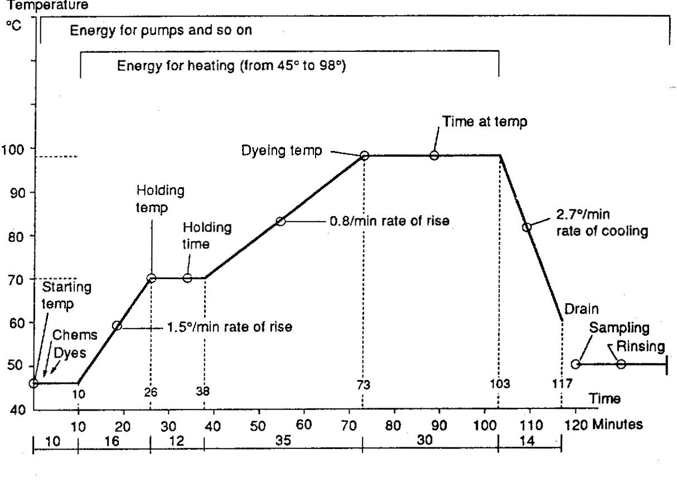
Figure 14.2 Temperature/time profile for wool dyeing. Source: Wood, 2006.

The dyeing sequence usually begins at about 30-45ºC with the addition of the dyeing auxiliaries including wetting agent, acid, salt, levelling agent, etc. The liquor is circulated for around 10-15 minutes to allow sufficient time for the dyeing auxiliaries to be uniformly absorbed by the wool. Not only has the wool absorbed the dyeing auxiliaries, but also water from the dyebath, causing the wool to swell. The swelling of the wool fibres makes it much easier for dyestuffs to penetrate the molecular structure of wool.

Once the dyer is satisfied that equilibrium has been reached, the pre-dissolved dyestuff is added to the dyebath from a separate mixing tank. At this stage the dyebath is still at about 30-45ºC. The dye molecules now approach and interact with the wool fibre surface, and the temperature of the dyebath is now slowly raised to the boil (100ºC) during which time the dye diffuses into the body of the wool fibres.

The dyes may diffuse directly through the scales of the wool into the cortex (transcellular diffusion). Alternatively the dye may diffuse through the intercellular cement between the scales (intercellular diffusion).

Boiling is continued for a further 30-60 minutes, subject to dye type, to achieve migration of the dye both within and between fibres, thereby achieving a level dyeing.

The phases of dyeing
The dyeing process is divided into the following five phases:
1. Approach is the movement of dye from the solution to the fibre surface.
2. Adsorption is the taking up of dye at the fibre surface.
3. Diffusion is the movement of dye from the surface to the interior of the fibre. Adsorption and diffusion together are called absorption.
4. Migration is the movement of dye from one part of the material or fibre to another.
5. Fixation is the bonding of the dye to the fibre to complete the process.
The first three phases are known as the exhaustion of a dye, and migration is known as levelling. Figure 14.3 illustrates these phases.

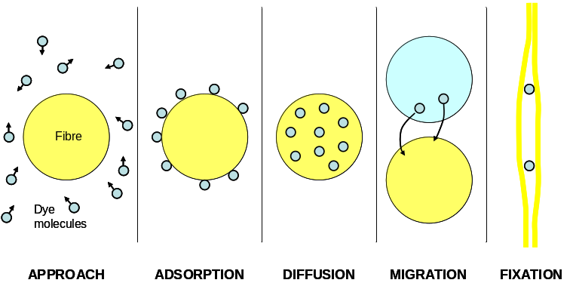
Figure 14.3 The five phases of dyeing. Source: Wood, 2006

1. Approach
The wool is immersed in water containing dissolved dye. When dyes dissolve in water they split into positive and negative ions. Depending on the dye class, the coloured ion may be cationic (positive) or anionic (negative). Ions are like magnetic poles in the way they are attracted by opposite charges, or repelled by the same charges.
Anionic dyes, as used with wool, are repelled by the fibre surface, and this would inhibit dyeing. This repulsion is overcome by adding neutral electrolytes such as sodium sulphate or sodium chloride (NaCl) to the dye bath, enabling the dye to approach the fibre.
Water consists of charged ions and therefore attracts oppositely charged dye ions. For dyeing to take place, the fibre and dye must overcome the mutual attraction between water and dye. If this is to happen, the dye must be attracted to the fibre more strongly. This attraction is called affinity.
Once the dye gets close to the fibre surface, the attraction between dye and fibre overcomes the attraction between dye and water and the dye is then held on the fibre surface.
2. Adsorption and diffusion
The attraction between dye and fibre results in the formation of bonds, which temporarily attach the dye to the fibre surface. As dyeing proceeds, further dye is adsorbed by the fibre surface, and molecules start to be attracted into the interior of the fibre. Once inside the fibre the molecules tend to move away from the more concentrated surface layer to the less concentrated inner regions of the fibre. This is the diffusion phase.
3. Migration
Even after bonding to fibres, dye molecules can move from one site to another. Because they can move through tiny gaps, small dye molecules usually migrate better than large dye molecules.
When diffusion is complete, dyes continue to move within the fibre, out into the dyebath, and from the dyebath back into the fibres. In this way, dye moves from darker to lighter areas of fibres and consequently gives a level dyeing.
4. Fixation
Once migrations have ceased, fixation causes the dye to remain permanently in the fibres, either by chemical bonding or by physical means. Changes such as pH, temperature, and electrolyte concentration cause the change from the migration phase to the fixation phase.
For wool, cooling and draining the dyebath, and then rinsing in cold water, stops the migration and fixes the dye.

Factors that Influence Dyeing
The following are the key factors that affect the phases of dyeing:
Fibre swelling
Fibres must swell in order to absorb water and the dye. Natural fibres such as wool and cotton take up about half their own weight of water when they are immersed.
Fibre swelling is roughly proportional to water uptake, and mostly increases the fibre diameter. The length increase is relatively small. The ability of textile fibres to be dyed depends mainly on how well their surface and internal structure allows the dye solution to penetrate. Fibres that swell considerably, such as wool, are usually easier to dye than fibres that swell by only a small amount.
Polar groups in fibres
A polar group is a molecule (or part of a molecule) with opposite charges at each end. Thus it will be electrically attracted to other polar groups. Polar groups allow dye fixation by chemical means. Without polar groups, dyes must be fixed by physical means. The presence of polar groups in fibres such as wool, cotton, and viscose rayon makes these fibres hydrophilic because water molecules are also polar in nature. Hence these fibres readily absorb water and thus are readily dyed with water-soluble dyes.
Dye liquor interchange
All dyeing machines have liquor agitation facilities to bring dye and fibres into contact. They operate by:
1. Keeping the goods still, while pumping the dye liquor around the goods; or
2. Moving the goods through a stationary dye bath; or
3. Pumping the liquor and also moving the goods.
Dye liquor movement promotes an even absorption of dye into the fibres. Without such flow, dyeing would be uneven or patchy. At low flow rates, a static layer of dye liquor usually surrounds the fibres. The dye moves through this to the fibre surface. At high flow rates, dye molecules collide with the fibre surface and so integrate much better.
Temperature
Changes in temperature affect dyeing. Raising the temperature:
1. Speeds up the approach, adsorption, diffusion, and migration of dyes; and
2. Increases the fixation of reactive dyes, provided the pH is correct.
Other water-soluble dyes are fixed in the fibre when the temperature is lowered at the end of the dyeing process.
During the migration phase of dyeing, some dye goes from fibres back into the dyebath, before being re-absorbed by other fibres. Therefore, some of the dye that was on the fibre is in the dyebath during migration. The amount of dye in the dyebath during migration increases with higher temperatures. At the end of the migration phase, the dyebath conditions must be changed so that the mobile dye in the dyebath is re-absorbed and remains on the fibre. Otherwise, the dyebath won't be exhausted.
Affinity
A dye has an affinity for a fibre if it is attracted to it and absorbed by it when dye and fibre meet in the dyebath. Affinity exists because of attractive forces between dye and fibre. If these forces are strong in a dye, it has a high affinity. The dye will exhaust almost completely on to the fibre during dyeing.
If the attractive forces are weak, the dye has low affinity. A significant amount of dye will remain in the dyebath at the end of the process.
The affinity of a dye, therefore, affects the approach, adsorption, diffusion, and the degree of dyebath exhaustion.
Chemical conditions
All dyeing phases are affected by the following chemical conditions in the dyebath:
1. pH: For example, when dyeing wool with reactive dyes, fixation increases as the pH is raised from 4 to 8. However, the exhaustion and migration decrease as the pH is raised from 4 to 8.
2. Electrolyte concentration: For example, when dyeing cotton with reactive dyes, adding more salt increases the affinity and so exhausts more dye.
3. Auxiliary products: For example, a retarding agent may be used to temporarily combine with dyestuff molecules to slow down the rate of adsorption of dyes. This can be done with dyes that are adsorbed so quickly that dyeing is unlevel.

Level dyeing
A dye batch must be level and uniform. That is, all parts of all fibres should be dyed to the same depth and to the same shade. Variations in temperature and flow within a dyebath mean that dyeings are often unlevel at the end of the diffusion stage. Migration evens out an uneven dye distribution, and must occur to make and unlevel dyeing more level.
Factors that influence the levelness of dyeings include:
1. Inherent features of the dyestuffs — for example, dyes with small molecules migrate more readily than large ones;
2. Dyebath conditions — for example, the use of levelling agents, and pH and temperature control;
3. Mechanical features of the dyeing machine — for example, the rate of fabric circulation through the dyebath, and/or the circulation of dye liquor;
4. Devices used to control the dyeing cycle — for example, the automatic control and adjustment of pH; and
5. The uniformity of the substrate – for example, in loose stock dyeing the wool should not have variations in packing density in the dye vessel, otherwise the dye liquor will tend to flow through less dense channels.

14.3 Dyeing Methods and Equipment
Textile dyeing processes fall into one of two basic kinds. These are:
1. Exhaust dyeing, and
2. Continuous dyeing.
It is usual to dye wool in water, which acts as the solvent vehicle for the colorant, and also is a swelling agent for the fibre.

Exhaust dyeing
In exhaust dyeing the process begins with a set volume of dye liquor and the dye moves from the dyebath liquor on to the fibre in a set time. During that time it diffuses or migrates into the interior of the fibre, and is fixed. The dye liquor, with initially high dye content, becomes gradually exhausted while the dye accumulates in the fibre. The dyes preferred for exhaust dyeing are those with a high affinity for the fibre.
Exhaust dyeing is done with a given liquor ratio. The goods-to-liquor ratio is the weight of goods to be dyed, relative to the volume of dye liquor. This ratio can vary between 1:3 and 1:30 or more. For instance, 1 kg of goods is to be dyed in 3 to 30 litres of dye liquor or more. The amount of dye used in the liquor is calculated from a percentage of the weight of the dry goods.
Exhaust dyeing is used for loose stock, carded sliver, top yarns, and piece goods. Suitable equipment includes circulating liquor machines, winches, jigs, jet dyeing machines, and beam dyeing machines. Small to medium size batches are processed.

Continuous dyeing
In continuous processes, the goods pass through a trough of dye liquor, are sprayed with dye liquor, or have foam dye applied.
The important criterion for successful dyeing is the amount of dye liquor that the goods pick up as they pass through the machine. This quantity is a percentage of liquor pick-up. The lower the percentage liquor pick-up, the higher must be the dye concentration in the liquor.
In continuous dyeing, the goods are only in brief contact with the dye liquor. Where possible, the dyer selects dyes that have a low affinity for the fibre. This ensures that a batch of material is dyed to the same shade and depth from beginning to end.
The pick-up is usually quite low, being equivalent to a liquor ratio of 1:1 or less and this leads to substantial savings in water, energy and effluent costs. The fabric, which has become impregnated with dye, is then passed through a steamer to fix the dye to the fabric, followed by washing off.
Continuous methods are mainly used for piece dyeing large lengths of fabric for mass produced articles, such as carpets and are rarely employed for the dyeing of wool fabrics. Therefore they will not be considered further here.

Stages at which goods can be dyed
Textiles can be dyed at various stages of processing. The decision as to the kind of equipment in which the material is to be dyed depends on the stage of processing and the nature of the fibre.
Loose stock, such as loose wool, and other forms of loose fibre, is dyed in circulating liquor machines. The loose fibres are packed into perforated containers that are lowered into the vessel. This method of dyeing is also known as pack dyeing.
Although yarn hanks can be dyed like loose stock, they are generally dyed in hank dyeing machines. The hanks (or skeins) are suspended in the machines from rods or sticks mounted on frames.
Yarns and slivers can be dyed in circulating liquor machines, in the form of wound packages.
Fabrics may be dyed using a range of machines.

Dyeing machinery for fibres and yarns
Widely differing machines are used for dyeing and other wet treatments. Their use depends on the kind of fibre to be dyed, and its stage of processing. Modern dyeing machinery is electronically controlled, and made of chemical-resistant stainless steel.
The dyebath temperature is important. It varies with the dyeing method, the kind of goods to be dyed, and the class of dye used. Steam is commonly used for heating.
The goods are treated in the dyebath for typically one to two hours. During that time the dye moves progressively from the liquor into the fibre, until (ideally) the dyebath is exhausted and clear.
Two alternative approaches are used in exhaust dyeing:
1. Stationary material — circulating dye liquor
2. Stationary dye liquor — circulating material
In all circulating liquor dyeing, (ie, loose stock, hank and package dyeing), it is important to reverse the flow of liquor periodically. This ensures that the material is dyed evenly. If only one flow direction is used, the fibres that first encounter the flow will take up more dyestuff than fibres at the point where the liquor leaves the material. The direction of liquor flow can be made to circulate either from inside to outside, or from outside to inside to ensure even dyeing.

Loose stock dyeing
Loose stock dyeing is an example of the stationary goods - moving liquor dyeing method.
In this dyeing method the dye liquor is circulated through a stationary mass (or ‘cake’) of wool using pressure delivered by a powerful pump. Substantial quantities of wool are dyed in the form of loose stock for the spinning of both woollen and semi-worsted carpet yarns.
Figure 14.4 shows a typical machine. This machine can also be used for yarn packages, and for top sliver, but different frames or carriers are used for holding these. Loose stock forms a compact block of fibres through which the liquor is forced.

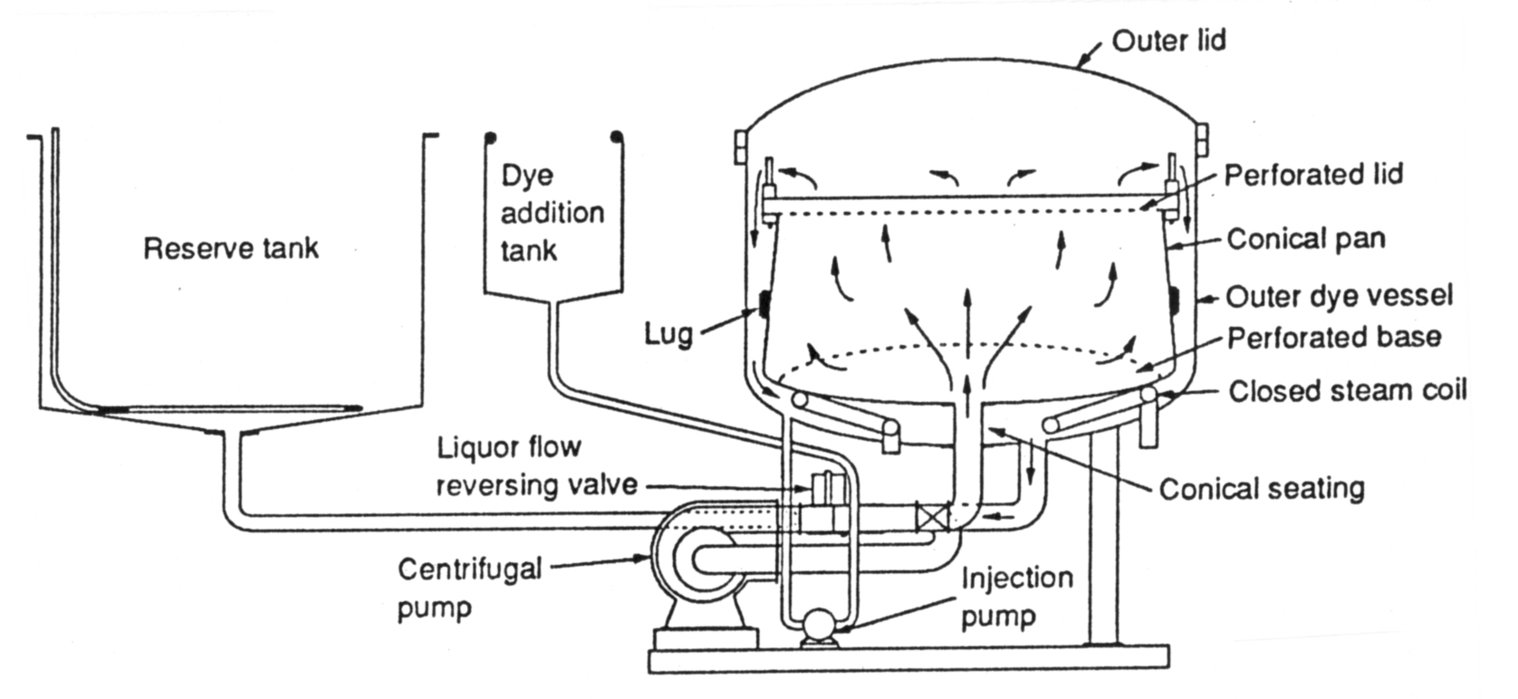
Figure 14.4 – Circulating liquor loose stock dyeing machine. Source: Wood, 2010

Loose stock dyeing is an economical process, but it is associated with some negative aspects of colour spinning, including causing lower yields than when spinning undyed wool. The decision to dye at an early stage in the manufacturing process may be made for one or more reasons:
- Level dyeing - When plain carpets are to be produced, considerable skill is required from the dyer if hank dyeings are to be sufficiently level as to provide carpet free from streaks and stripes. Blending after stock-dyeing contributes strongly to levelness of colour in the yarn.
- Large lots - When a very large quantity of yarn in exactly the same colour is required, this can be achieved by dyeing several lots of loose stock and blending them uniformly before spinning.
- Accurate colour matching - Supplementing (or replacing) the dyers' practice of making small additions to the dyebath, recipes for successive lots of the same colour can be progressively changed to improve the accuracy of the colour achieved. Blending of these lots averages the colour and can improve the accuracy of match for the whole blend.
- Economies at dyeing - Loose stock dyeing is carried out at lower liquor ratios than hank dyeing and is therefore more economical in terms of water, effluent and energy. Dye cycles are generally shorter, and fewer auxiliary products (as required to achieve level dyeing in hank form) are used.
However loose stock dyeing of wool has a number of disadvantages:
- Slow deliveries - Quick response to customers' orders cannot be achieved by early stage coloration. However, the woollen and semi-worsted spinning routes used for producing carpet yarns are relatively short so delivery times for stock-dyed yarns need not be excessively long.
- Production planning - Operating a colour spinning mill with a large number of dyed lots requiring isolation to avoid cross-contamination of colour is far more complicated than operating with a smaller number of undyed blends.
- Waste - Coloured waste (both loose fibre and yarn) is less valuable than undyed waste.
- Yields - Fibre damage sometimes occurs in stock dyeing, especially when high liquor flow rates compress the cake of wool excessively. As a consequence of this damage the yields in carding are reduced and there may be more end-breaks at spinning.
Fibre damage may be minimised and processing yields increased by controlling the flow of the dye liquor, maintaining the optimum pH level, or using low temperature dyeing or rapid dyeing.
Hank dyeing
Dyeing of wool at the yarn stage enables a quick response to be achieved to manufacturers' orders, and also facilitates production planning in the spinning mill. It is also more cost-effective to dye small quantities of yarns of different shades in this way.
Furthermore, carpet yarns are often dyed in hank form because the material is free to relax in this form, developing optimum yarn bulk. Because the twist of the yarn is set concurrently so there is no need for a separate setting process.
It is also convenient to clean the yarn while it is in hank form. The severity of the scouring process required depends largely on the spinning lubricant employed. The main alternatives are tape scouring, rinsing in the dyeing machine before dyeing, and directly introducing the dry yarn to the dyebath (where a fibre processing aid that is soluble at the boil has been used at spinning).
Because there is no downstream opportunity for fibre mixing, hank dyeing requires much more accurate control of shade and levelness. Otherwise, streaks and stripes of colour variation may appear in the fabric or carpet.
A typical hank dyeing machine, the single-stick type, is illustrated in Figure 14.5. This is most commonly used despite the technical advantages of double-stick machines. Machines of this type can be made in a variety of sizes up to 1000 kg capacity, whereas there is an upper limit to the size of the other types.

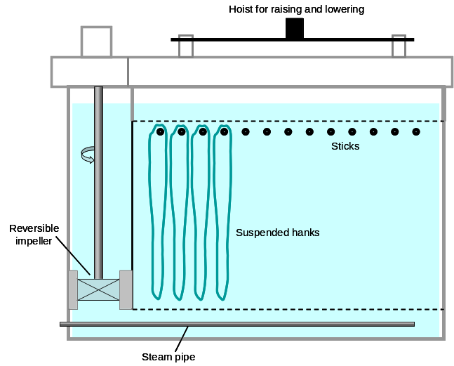
Figure 14.5 Single-stick hank dyeing machine. Source: Wood, 2010.

The hanks of yarn (eg, "jumbo" hanks of 3.5-5 kg when heavy counts of carpet yarn are to be dyed) are suspended from stainless-steel sticks mounted on a shallow frame constituting the lid of the machine. The body of the machine comprises a rectangular vat with a perforated bottom and an impeller at one end. Two impellers are provided on the largest (1000 kg) machines; and intermediate impellers under the false bottom may be added to improve the uniformity of circulation over the length of the machine. Heating is by a steam coil (closed or open) located under the false bottom.
Dyeing is carried out at goods-to-liquor ratios around 1:20. The yarn is placed in the dye vessel using an overhead crane, with the liquor flowing downwards towards the false bottom in order to help straighten the load while it is being wet out and to keep the packing uniform. During the dyeing cycle, the flow is usually upwards through the pack, lifting the hanks off the sticks, thus ensuring all parts of a hank have access to the dye liquor, and packing them together to preclude channelling.
The temperature cycle in a hank dyeing machine is preferably controlled by a microprocessor. Dyeing is usually carried out at 98ºC to avoid boiling the liquor, which brings the associated risk of cavitation at the impeller and a consequent loss of circulation.

Sliver dyeing
Sliver and top can be dyed in loose stock or similar machines. Figure 14.6 shows a typical dyeing sequence.
- Sliver is laid into a rotating carrier by a sliver coiler, with simultaneous wetting and stamping to compress the cheese.
- Wetting and stamping during carrier loading can damage wool fibres. Wool sliver should be compressed by a hydraulic press after loading into a different kind of carrier.
- Cheese removed from the press shown in (a). the cheese is supported by a perforated base.
- Three cheeses, each on an individual base plate are dyed in a high temperature vessel.
- A cheese is loaded into a hydroextractor after dyeing, to remove excess water by centrifugal action before drying.

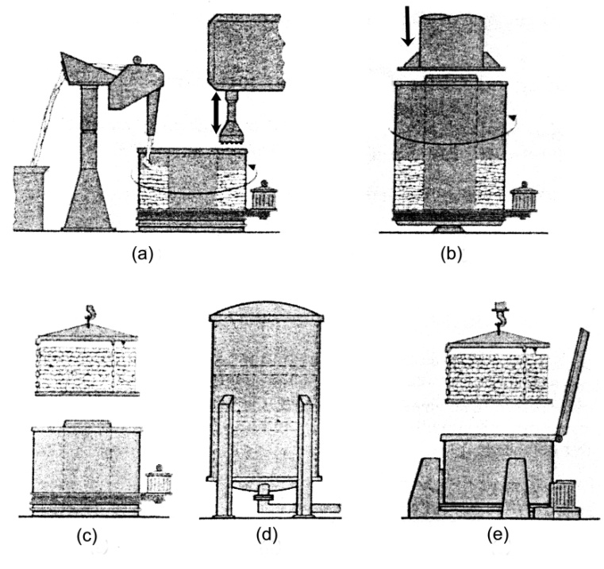
Figure 14.6 – Sliver loading and dyeing sequence. Source: Wood, 2010

Package Dyeing
Package dyeing has been a subject of intensive development so package dyeing machinery is now very sophisticated and offers a number of advantages over hank dyeing, eg,
- Reduced yarn handling
- High and uniform rates of liquor circulation, leading to more level application of dyes than is possible with hank dyeing
- Amenable to automatic control, leading to reproducible dyeings
- Low goods-to-liquor ratios, giving savings in water, effluent and energy
- Totally enclosed machinery, giving good working conditions in the dyehouse
- High temperature dyeing possible
- Large batches.
Sliver and top package dyeing
Sliver and top is often dyed in bump form. Bump tops are made as follows (Figure 14.7):
- Sliver coiled into rotating can;
- Transfer full can to hydraulic ram
- Compress sliver, and
- Tie coiled sliver to keep it compressed

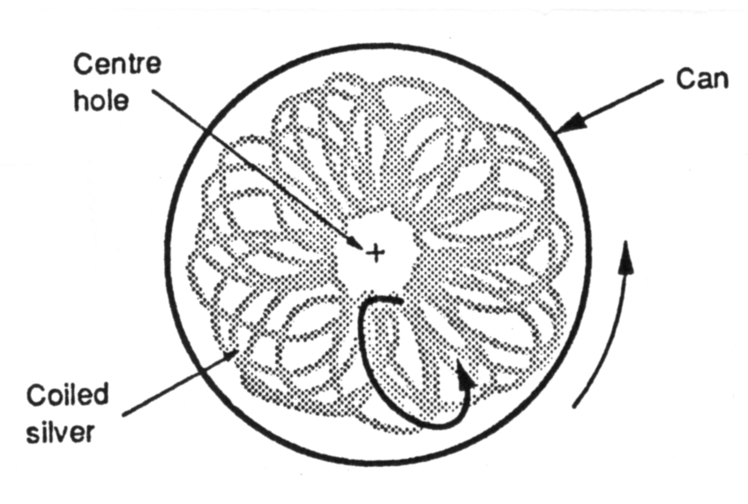
Figure 14.7 Coiling of sliver into a can to form a bump top. Source: Wood, 2010

Alternatively, the can is lined with a plastic bag and the compression ram is fitted with a suction device to draw air from the bag. Once compressed, the bagged sliver is tied and the bump top stored until needed for dyeing.
Figure 14.8 shows a top dyeing machine. It operates on the same principle as a loose stock dyeing machine, with the main difference being the means of supporting the goods during dyeing. The goods remain still while the liquor is moved by a pump. Most top dyeing machines are high temperature, pressurised machines which operate at relatively low liquor ratios of about 5:1.
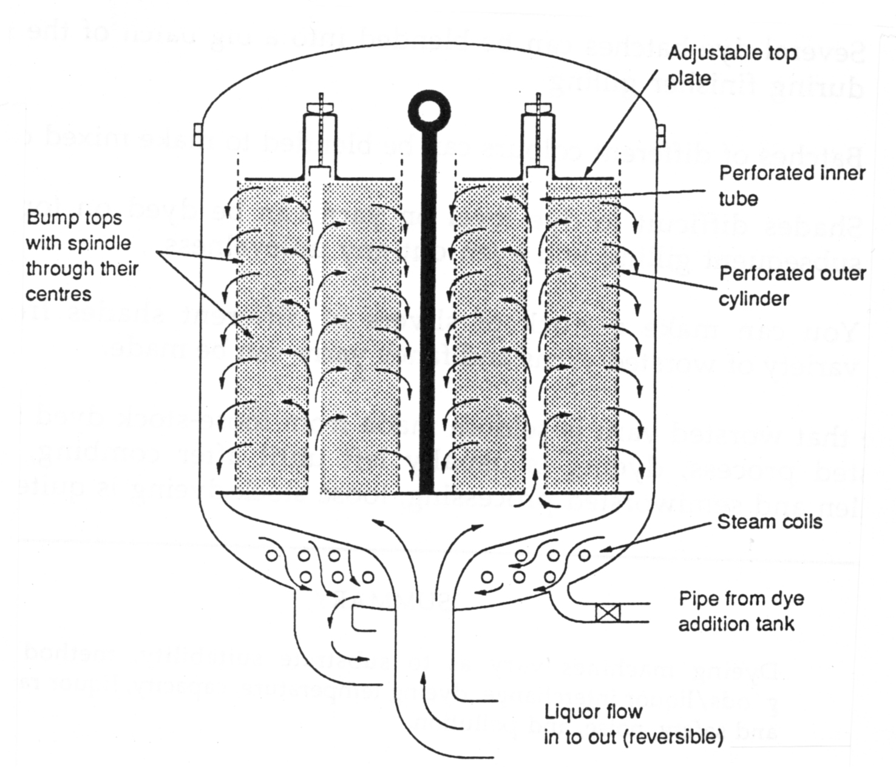
Figure 14.8 Bump sliver dyeing machine. Source: E J Wood, 2010.

Wool will be dyed in top form rather than in yarn form for the following reasons:
- Several dye batches can be blended into a big batch of the same shade during finisher gilling.
- Batches of different colours can be blended to make mixed colour yarns.
- Shades that are difficult to dye evenly on yarn can be dyed on top sliver; subsequent gilling will blend out any unevenness.
- A stock of slivers of different shades can be stored, from which a variety of worsted yarns and fancy yarns can be made.
Note that worsted yarn is very rarely made from loose-stock dyed fibres. In the worsted process dyeing is usually left until after combing, to ensure that the fibres have undergone the most severe mechanical processes before the weakening effect of dyeing occurs. In woollen processing, where the retention of good fibre length and strength is less critical to spinning efficiency and yarn quality, loose stock dyeing is common.
Yarn package dyeing
Package dyeing is advantageous for the finer counts of yarn which are less amenable to handling in large hanks.
Figure 14.9 shows a typical yarn package dyeing machine.

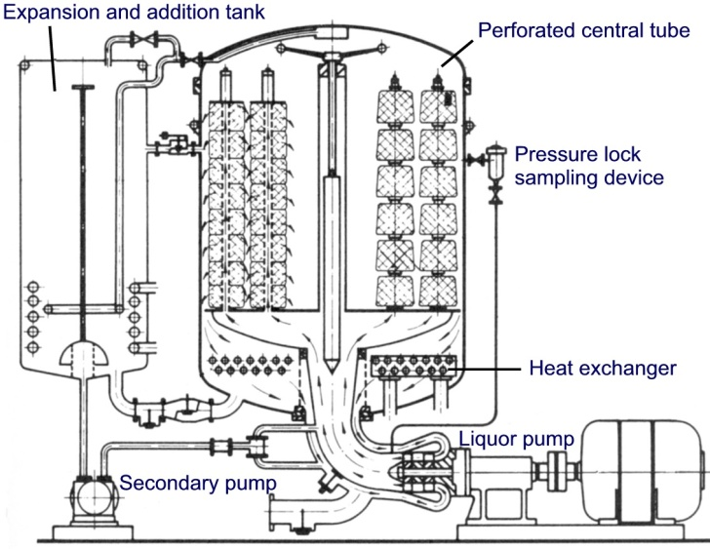
Figure 14.9 Yarn package dyeing machine. Source: Wood, 2010

For package dyeing, the yarn is wound on to a package centre. These cones or centres are perforated so that the liquor is able to flow from inside to outside, or from outside to inside of the package.
The packages are loaded on to spindles. Spindles are perforated pipes closed at the top end, and attached to a base plate that allows the liquor to flow through the spindles and packages.
In package dyeing there is no movement of the yarn during dyeing, so very fine yarns, high twist yarns and singles yarns can be dyed without damage. The yarn must be dyed perfectly level as there is no blending after dyeing as with loose stock and top dyeing. To achieve level dyeing of yarn packages:
- The packages must be of a consistent size and density, as can be achieved by using modern precision winding machines;
- The dye liquor must be free of particulate matter that could filter out in the yarn;
- Rapid strike of dye must be avoided;
- The flow times of out-to-in and in-to-out must be correct;
- Foam should be suppressed because it severely reduces the liquor flow and may result in undyed spots in the yarn.
Despite these stringent requirements, yarn dyeing is popular because it allows colouration to be done at the last stage before weaving or knitting. Thus it enables a quick response from the spinner to orders received from manufacturers.
Because the yarn is constrained in package dyeing, the dyed yarn tends to be less bulky (ie, lean) than the same yarn which had been hank dyed.

14.6 Fabric dyeing
Dyeing in fabric form minimises the time between shade selection and retailing for woven goods. However, it is limited to the production of plain shades.
Uniformity of shade is critical in piece dyeing and it is therefore essential to use dyes that are capable of producing a level dyeing result. These dyes generally do not have good fastness to washing or wet processes but this is not a serious problem, because most of the products that are manufactured from piece dyed material will require fastness to dry cleaning only.
Unlike yarn and fibre, fabric is dyed in machines in which the material is circulated through the liquor as a continuous loop. Fabrics may be dyed either in rope form or in open width.

Rope dyeing methods
Winch dyeing
Figure 14.10 shows the main features of a typical winch, one of the oldest dyeing machines. Pieces of fabric, sewn together at the ends to form very long loops, are dyed side by side. In an average-sized winch machine, about six pieces of wool fabric are dyed together. The fabric is moved through the liquor by the driven winch (also called a reel).
The winch speed varies to suit the fabric within a range of 30 to 80 metres per minute. Wool fabrics are dyed at low speeds to prevent felting. If cloth edges tend to curl up, or if the fabric surface is easily abraded, the pieces are bagged. That is, the selvedges are brought together and sewn to form a tube of cloth with the fabric face on the inside.

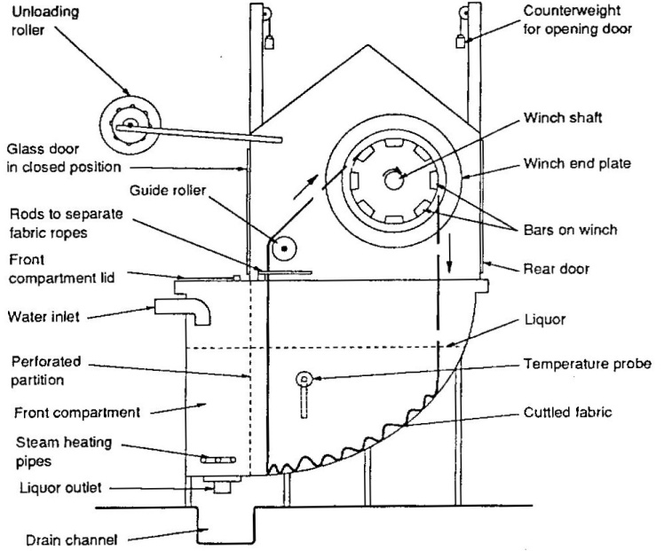
Figure 14.10 Winch. Source: Wood, 2010.

Steam, dyes, and chemicals are added to the front compartment to pass slowly through the perforated partition so that they don't come into contact with the fabric in a concentrated form.
Compared with loose stock, top, and package dyeing machines, winches require a high good-to-liquor ratio, of about 1:20 for shallow-draft machines to about 1:50 for the deeper machines traditionally used for dyeing wool cloths.
The drawbacks of winches, which led to the development of jet dyeing machines, are:
- High liquor ratio, which makes heating slow and expensive, and wasteful of chemicals;
- Long dyeing cycle because the dye/liquor interchange (goods move, liquor still) is poor, thus requiring gradual dyeing to get level results.
- Creasing, rubbing, and chafing can occur, especially if the fabric ropes entangle and slip against the winch bars. Thermoplastic fibres can have creases set in by the hot liquor if the folds in the fabric are not rearranged often enough during dyeing.
- Temperature variations can occur across the width of the machine. For example, it can be cooler at the sides, causing the outside pieces to dye lighter. This problem is overcome in winches fitted with a dye circulation pump and piping.

Jet dyeing
In jet dyeing machines, both the goods and the dye liquor are moved (Figure 14.11). The cloth in rope form is lifted out of the dye liquor by a small reel and, together with the circulating dye liquor, is drawn thorough the jet or venturi and passes to the back of the machine.
A venture (or nozzle) is a pipe that narrows and then widens out again. Dye liquor is pumped through the venture, and it flows faster through the narrow part, causing suction that moves the cloth forward.

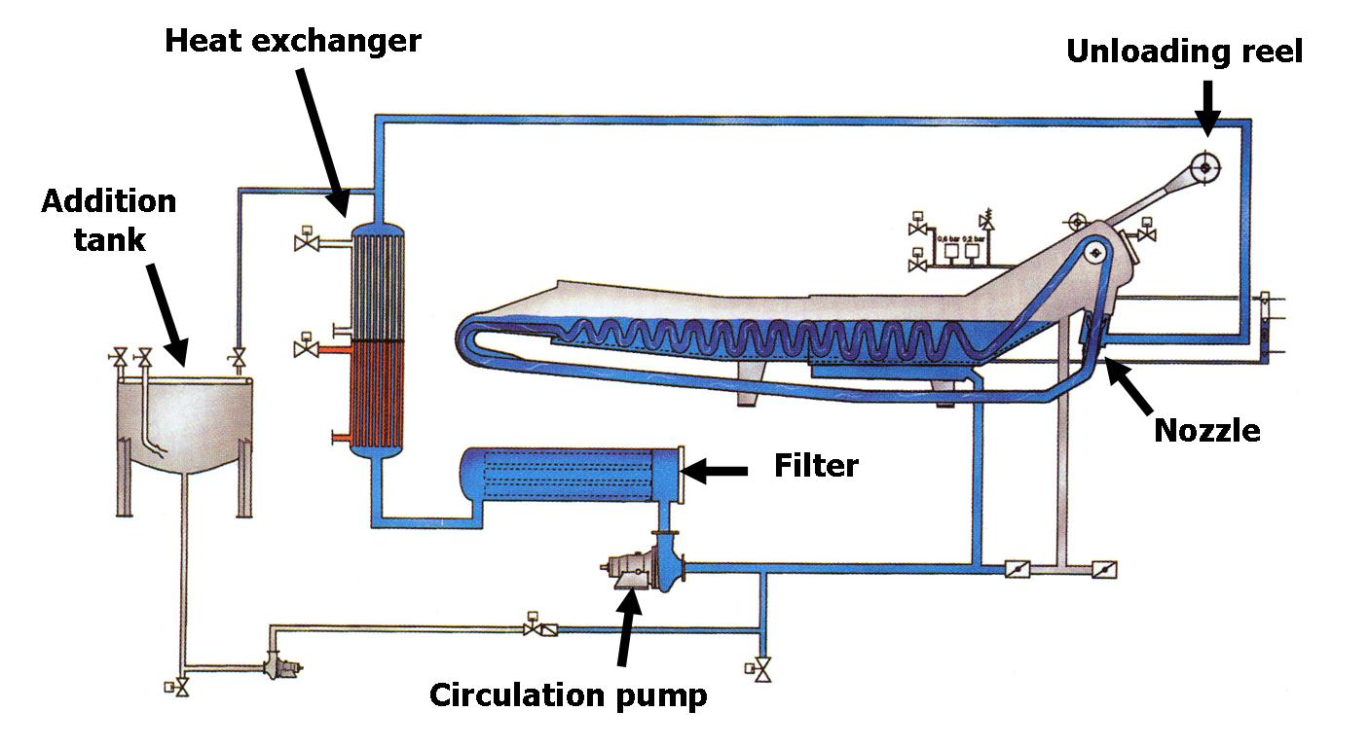
Figure 14.11 Jet dyeing machine. Source: Wood, 2010

The speed at which the cloth moves around the machine is varied by adjusting the amount of liquor flow to the venture, and may be as high as 400 metres per minute.

Open width dyeing methods
Some fabrics are dyed open width, either to prevent rope creasing or because the fabric does not process well in rope form. There are two kinds of dyeing machines for exhaust dyeing of fabric in open-width form: jig dyeing machines and beam dyeing machines.
Jig dyeing machines
Jigs are commonly used to dye woven fabrics of cotton, viscose rayon, and silk. These fabrics are not damaged by the backwards and forwards action, and their absorbency allows them to pick up dye liquor during the short immersion time. As Figure 14.12 shows, jigs achieve goods/liquor interchange by moving the fabric back and forth through stationary dye liquor, as occurs in winches. However, in jigs the fabric is out of the dyebath for most of the time. A pump circulates the dye liquor to keep its temperature uniform, and to ensure thorough dye mixing.

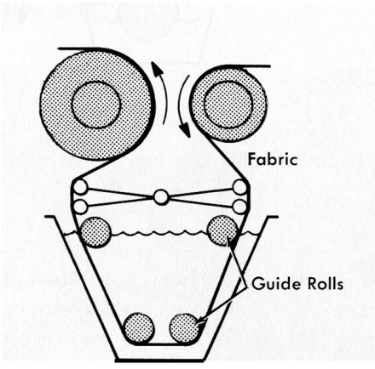
Figure 14.12 Atmospheric jig dyeing machine. Source: Wood, 2010

A number of fabric rolls are joined together while being wound on to a driven roller (detachable drive) mounted on a batching frame. The fabric is drawn off the batching frame on to one of the two main rollers in the jig dyeing machine.
During dyeing, the fabric is wound from the full main roller to the other roller, and then back again, for a set number of passages through the dye liquor. Each passage is called an end. Dye is usually added in stages over several ends to prevent tailing, where one end of the batch is dyed darker than the other end.
The greater the length of fabric being dyed, the faster the cloth speed needed to achieve a given end time. Small batch machines have a cloth speed of 10 to 60 in/min, and for larger machines, 20 to 120 m/min. Although the fabric is not immersed in the dye liquor for long in jig dyeing, the fabric is saturated with dye liquor on the rolls, and so dyeing takes place. Excess water is removed after dyeing by squeezing between rollers or by drainage while the whole batch is kept slowly rotating on a batching frame.
Beam dyeing machines
These machines are similar to the radial flow machines used for dyeing loose stock, tops, and yarn packages in that there are frequent reversals in liquor flow through the stationary goods (Figure 14.13).
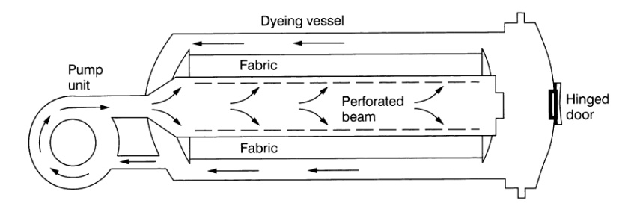
Figure 14.13 Beam dyeing. Source: Wood, 2010
Beams are especially suitable for dyeing fabrics that must be finished open width but cannot be dyed in jigs because, for example, the fabric is not dimensionally stable enough for repeated winding, or is so fine, and hence of such length, that ends in jig dyeing would take too long.
Beam dyeing machines are ideal for dyeing warp knit fabrics, and worsted woven fabrics that have a flat surface and firm handle, and so are not harmed by being tightly wound.

14.7 Assessment of colour fastness

Colourfastness to washing

It is common to clean textiles by washing, during which colour loss and staining should not occur. It is necessary to test dyed products to ensure that the colours are fast and will not be lost during washing.

For test purposes, a sample of white fabric is sewed onto the coloured test fabric. The white fabric is usually a piece of multifibre fabric, a special test cloth woven in bands of different fibres (cotton, wool, nylon, polyester, acrylic, and acetate). The composite piece is washed in a laboratory washing unit such as the wash wheel, and other suitable devices may be used.

Colourfastness to light

The damaging effect of sunlight on colourfastness varies with world location. In Australasia, sunlight conditions are said to be most severe. Therefore, a dyer must aim to achieve maximum lightfastness. The methods of lightfastness testing involve exposure to daylight for a fixed period or exposure to an intense source of ultraviolet radiation such as a xenon arc or a mercury tungsten filament lamp, and assessing the level of colour change that occurs.

Colourfastness to rubbing (crocking)

Too much dye, or poor clearing after dyeing, may leave loose dye on textiles, which can be removed by rubbing. Loss of colour caused by rubbing is generally slight, but staining of adjacent fibres can be a serious problem. For example, poor rubbing fastness of upholstery fabric or car seat covers may spoil light coloured clothes.
The laboratory device for testing rubfastness is called a crockmeter. This applied a standard rubbing action to a specimen of dyed fabric and the white rubbing fabric is assessed for the extent to which it colour changes.
The reading Colourfastness properties of wool fabrics provides more details about these aspects of fabric colourfastness and the tests widely used to assess them. This reading also discussed the standard grey scales that are used in colourfastness assessments.

Readings
CSIRO - The Coloration of Wool. Downloaded from www.csiro.org.au.
Pailthorpe, M.T. Dyestuff classes for wool.
Pailthorpe, M.T. Colourfastness properties of wool fabrics.

References
Lewis, D.M., 1992, Wool Dyeing, Society of Dyers and Colourists, ISBN 0 901956 53 8
Parton, K., 2002, Practical wool dyeing, Chapter 8 in Wool: Science and Technology, editors W.S. Simpson and G.H. Crawshaw, The Textile Institute / Woodhead Publishing Ltd / CRC Press, ISBN 1 85573 574 1.

Glossary of terms

Adsorption | A dye molecule attaches itself to the surface of a fibre
Affinity | The attraction between a dye molecule and a fibre
Approach | The dyeing phase where dye molecules move towards the fibres
Auxiliary | A chemical added to the dye liquor to assist in obtaining the desired dyeing outcome
Beam dyeing | An open width method of fabric dyeing where the fabric is wound onto a perforated beam and the liquor is pumped through the fabric.
Bump (or bump top) | A package of top or sliver, formed by coiling it into can and compressing it
Colour matching | A quality check in dyeing where the colour of a dyed material is compared with that of a standard, or a previously-dyed sample
Continuous dyeing | In contrast with exhaust dyeing, the goods pass through a trough of dye liquor, are sprayed with dye liquor, or have foam dye applied.
Diffusion | Movement of dye molecules from the surface of the fibre to the interior
Dispersion | Separation of clumps of tiny particles such as dyestuff which can then be spread throughout the liquid
Dye (or Dyestuff) | The active ingredient in the dyeing of textiles, usually a coloured powder
Dyebath | The vessel in which dyeing takes place, containing the goods to be dyed, and the dye liquor
Dye liquor | The dyeing solution comprising water, dissolved dyestuff and added chemicals
Dyelot | A single batch of material to be dyed
Exhaust dyeing | A dyeing process where all of the dye is taken up by the substrate, leaving no dye residue in the dye liquor at the end. A relatively large liquor-to-goods ratio is used and the fibres are immersed for some time, allowing the molecules to leave the dyebath and attach to the fibres.
Exhaustion | The leaving of the dye from the dyebath and becoming attached to the fibre being dyed.
Electrolyte | A substance such as common salt (NaCl) whose molecules break into positive and negative ions when dissolved in water. This makes it easier for a dye molecule to approach a fibre.
Fastness | The ability of a dyed material to retain its colour, despite the effects of sunlight, washing, rubbing, etc.
Fixation | The final step of the dyeing process when each dye molecule is firmly fixed in one site
Goods | The batch of material to be dyed
Hank dyeing | A dyeing method where hanks (or skeins) of yarn are suspended in the dye liquor
Interchange | Relative motion between the goods and the dye liquor, to ensure that all parts of the goods get the same opportunity to be dyed
Ion | An atom of molecule that has lost or gained one or more electrons, leaving it positively or negatively charged
Jet dyeing | A dyeing method where a rope of fabric is forced to circulate by a current of dye liquor
Jig dyeing | A dyeing method where a fabric in open width form, is wound back and forth on a pair of rollers while being briefly immersed in the dye liquor
Levelness | Even distribution of colour throughout the dyed substrate
Light fastness | The ability of dyed material to resist loss of colour in sunlight
Loose stock dyeing | A dyeing process where the loose fibre is packed in the dye vessel
Migration | The movement of dye molecules within a fibre and between fibres before they reach their final position
Package dyeing | A dyeing process where the liquor is pumped through and arrow of packages (or yarn, sliver or top)
pH | The chemical status of the hydrogen ion concentration of a solution, measured on a 1 – 14 scale, with 1 being strongly acidic, 7 is neutral and 14 is strongly alkaline. Pure water has a pH of 7.
Polar molecule | A molecule that has positive and negative charges on opposite sides (or at opposite ends)
Substrate | The undyed material (fibres, yarn, sliver, top, fabric, carpet) submitted to the dyeing process
Washfastness | The ability of a textile material to resist loss of colour as the result of a washing treatment
Winch dyeing | A loop of fabric, in rope form is cycled through the dye liquor by a revolving wheel, or winch

